A subnet can be associated ­­­with only 1 NACL at a time.

NACL -> Separate rule for inbound traffic & separate rule for outbound traffic.

I can say allow this or I can say deny this.

I cannot block this particular ip address

In-bound, Out-bound Allow & Deny

Security Group -> State-full -> There is an inbound rule in the security group, that rule is remembered even when the traffic goes out. If there is any traffic which has inbound access, the same is remembered when this traffic goes out.

NACL -> is state less -> If there is rule which accepts inbound traffic this rules is not remembered when this traffic goes out. Whatever coming in is not remembered when going out.

Using Security group can you block this IP address-> No because outbound traffic cannot be controlled.

VPC, Subnet & Security Groups.

**Regions & Availability Zone.**

**Region is the geographic location.**

**Availability zone is the data center in that region.**

**US-East there might be data-centers in the Atlanta**

VPC ->

Creating a VPC.

Oregon VPC.

CIDR Block -> 172.16.0.0/16

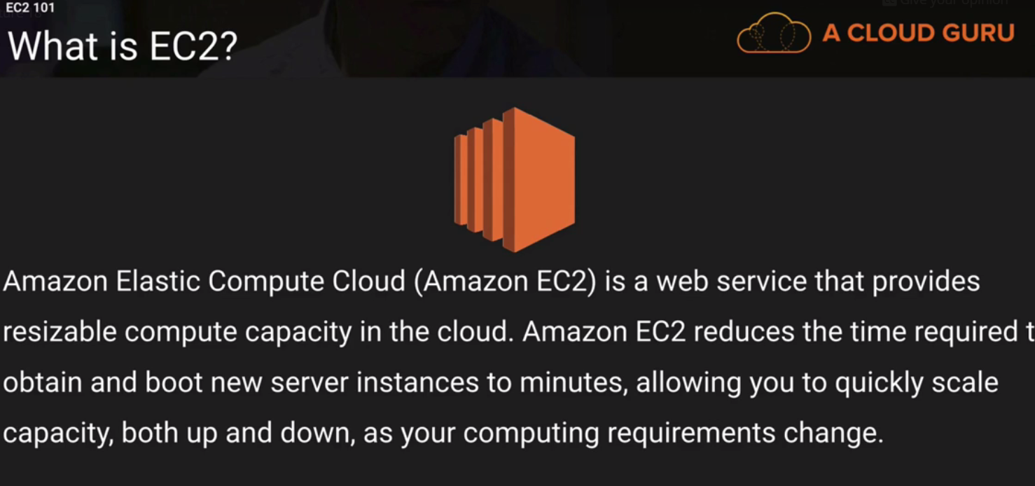

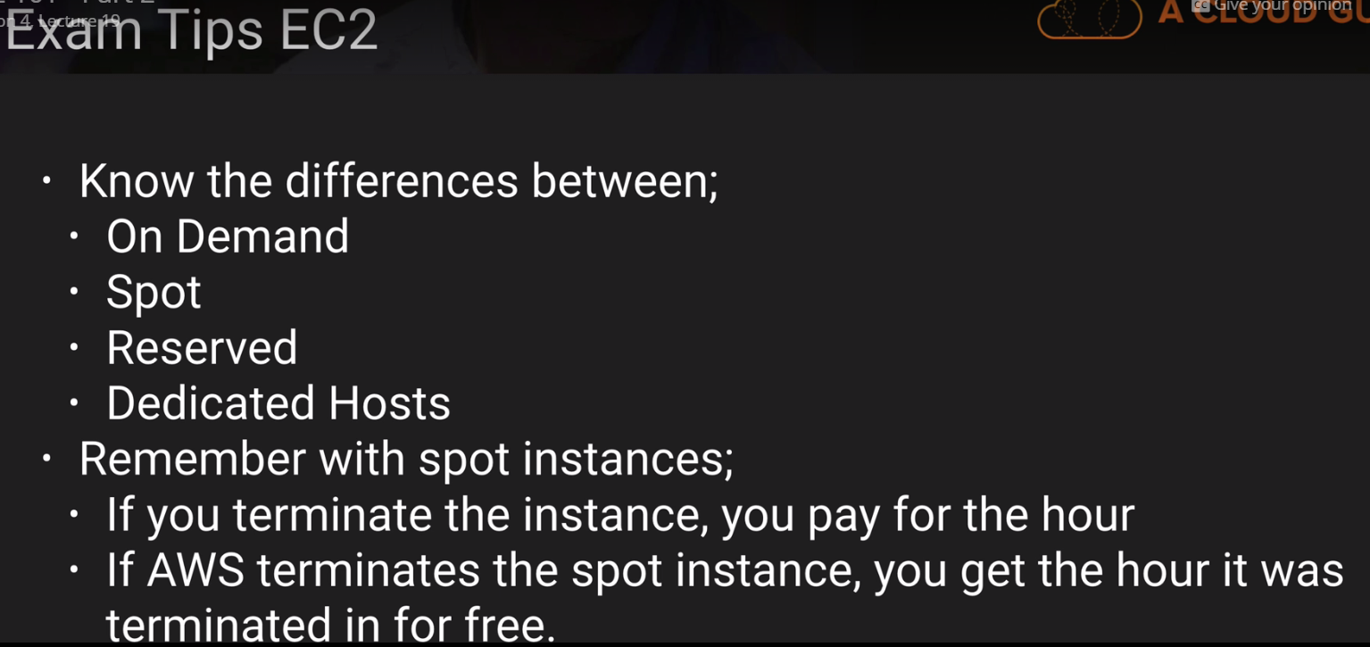

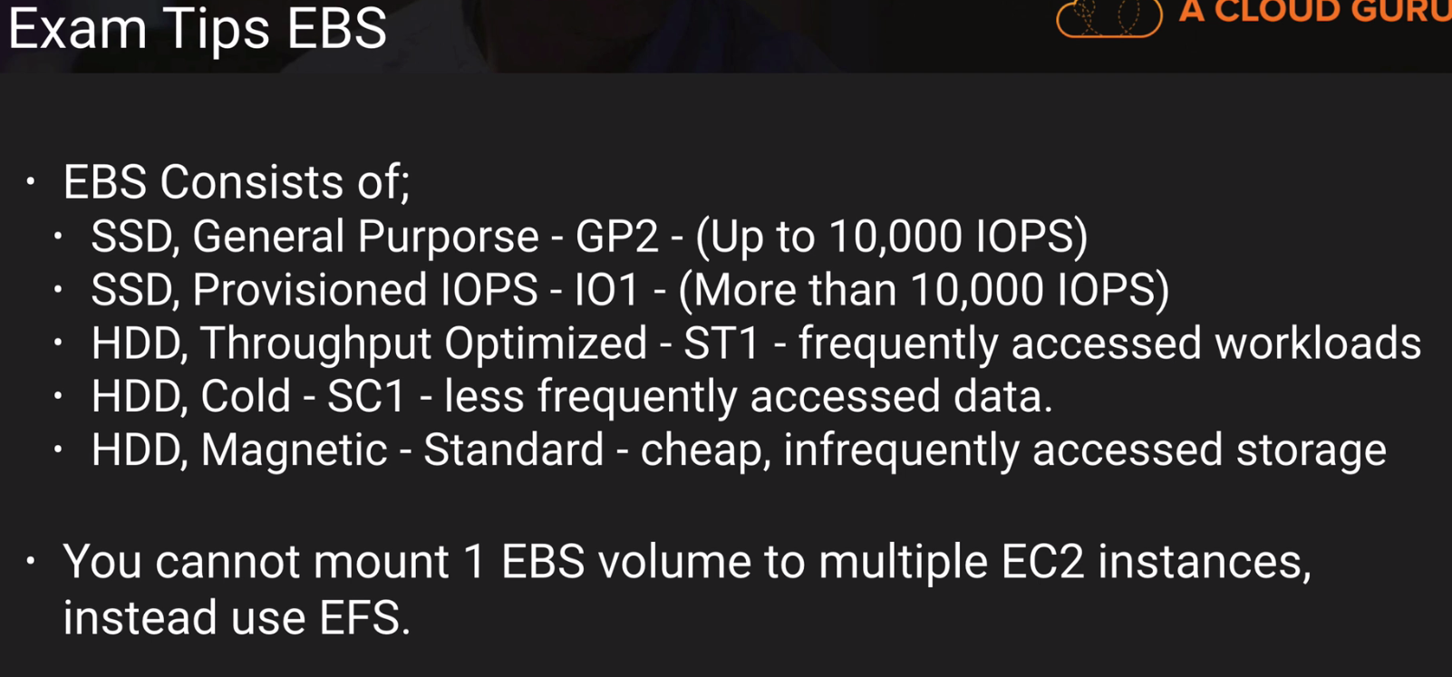

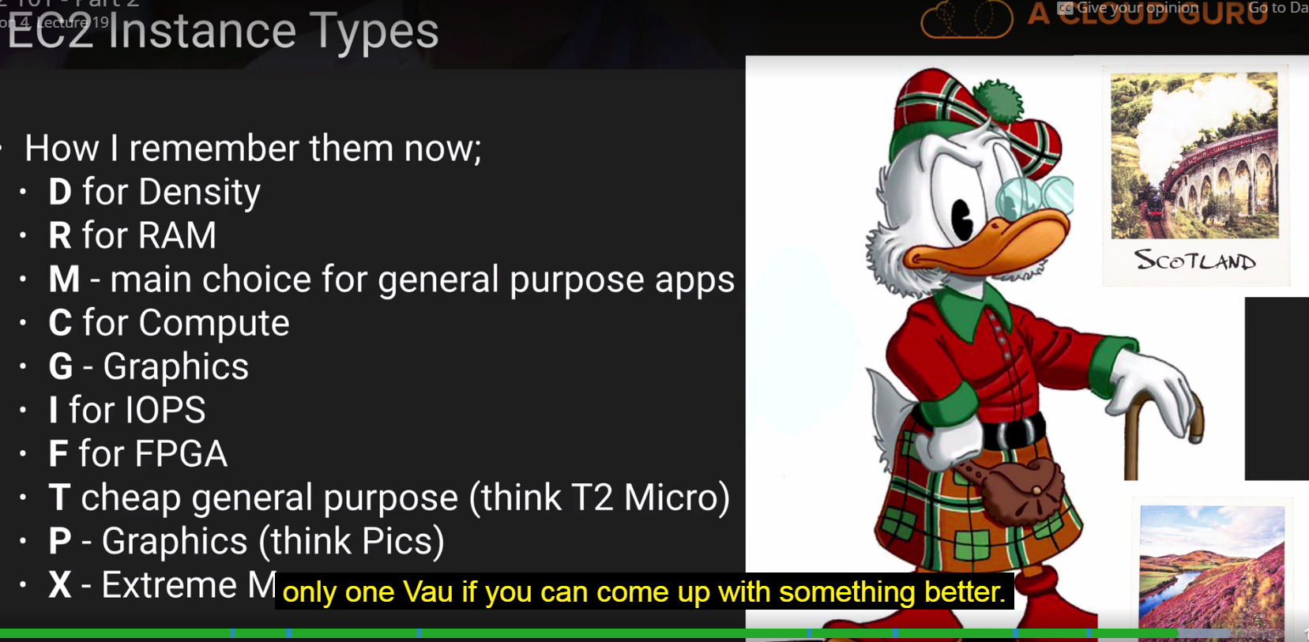

Exam-TIPS for the EC-2 Point of view.

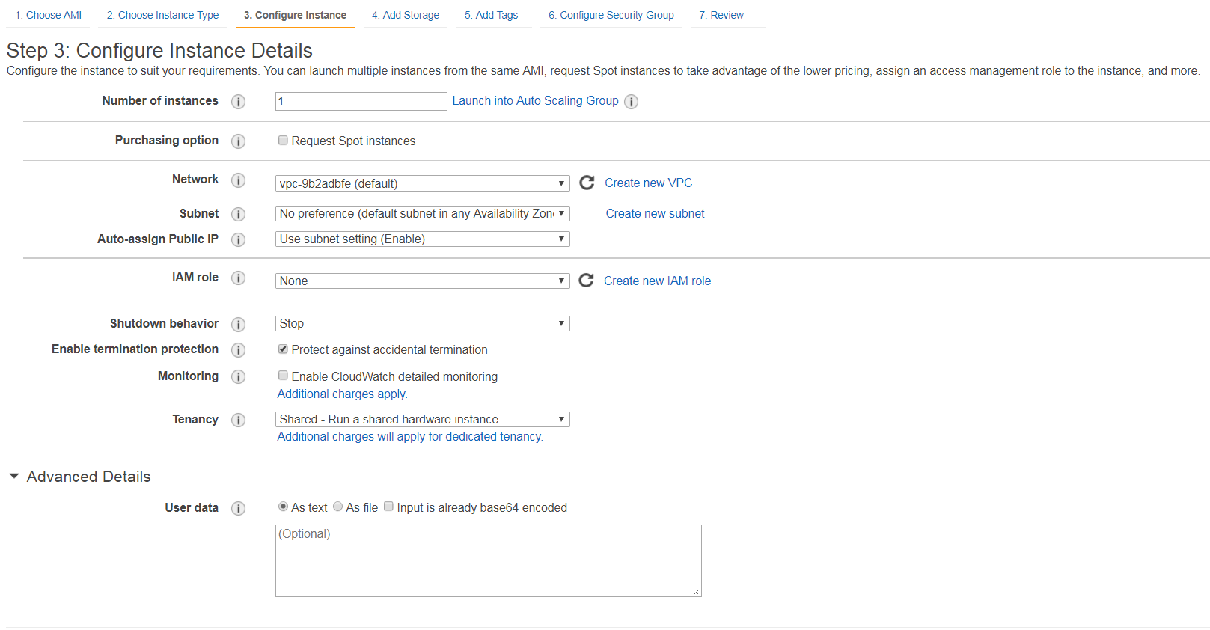

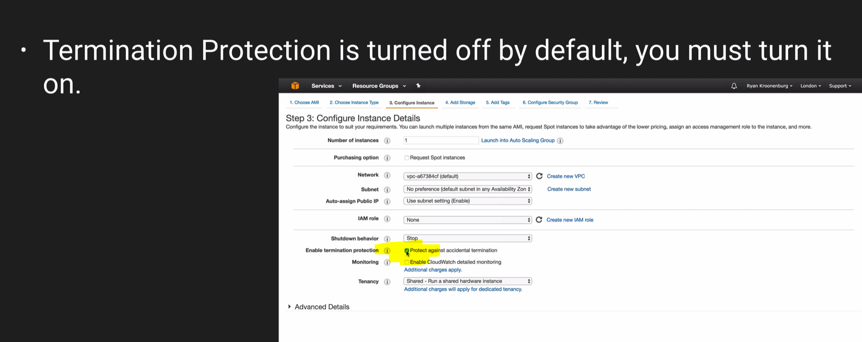

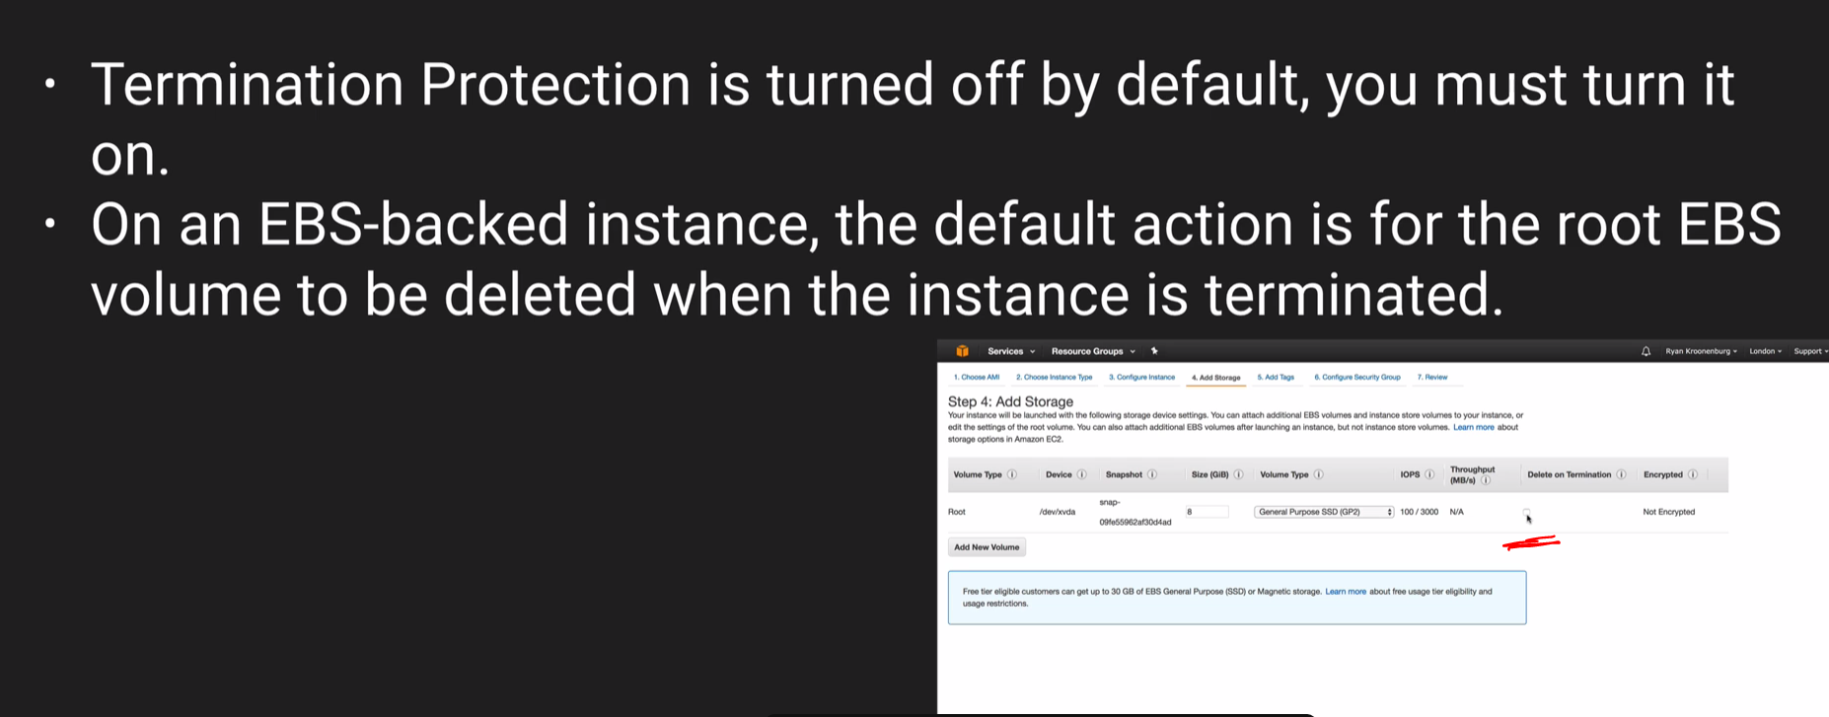

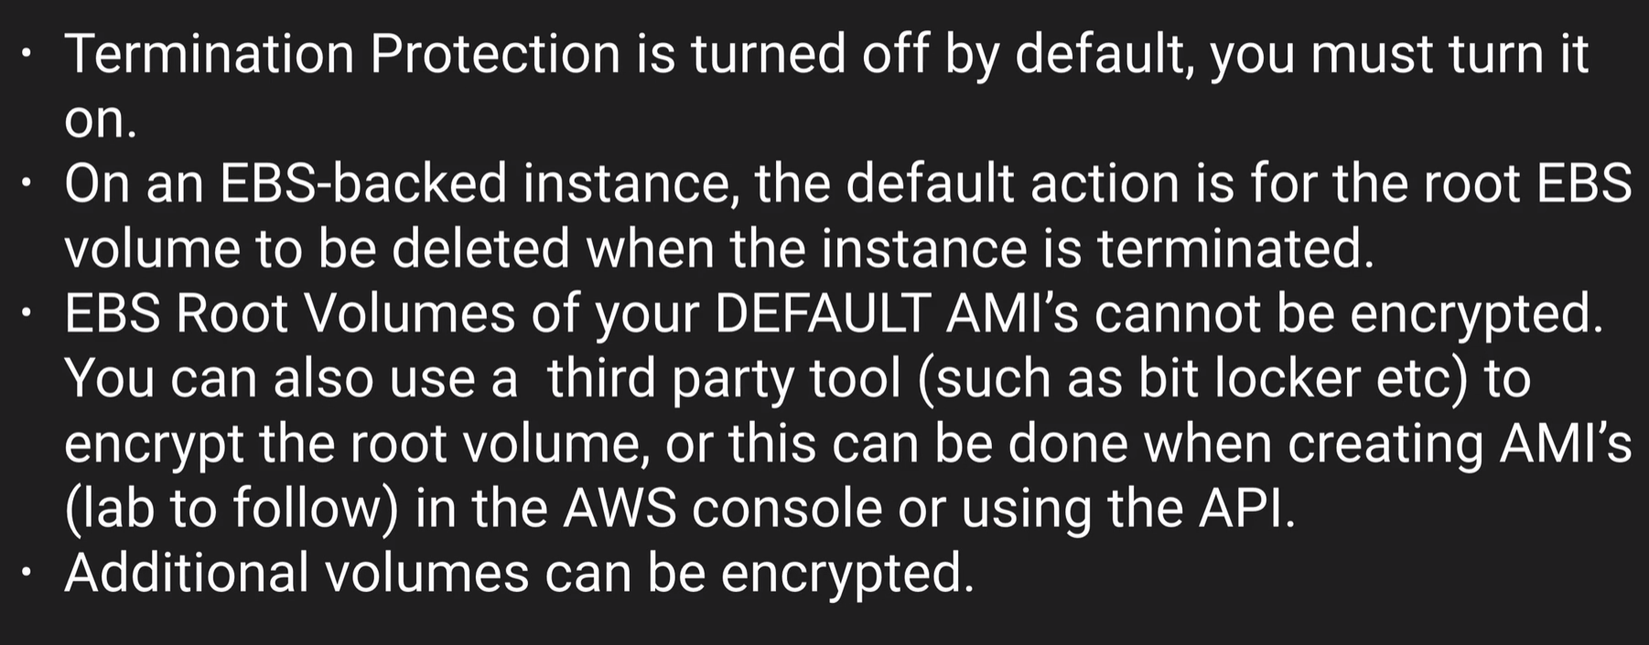

Security Group Lab.

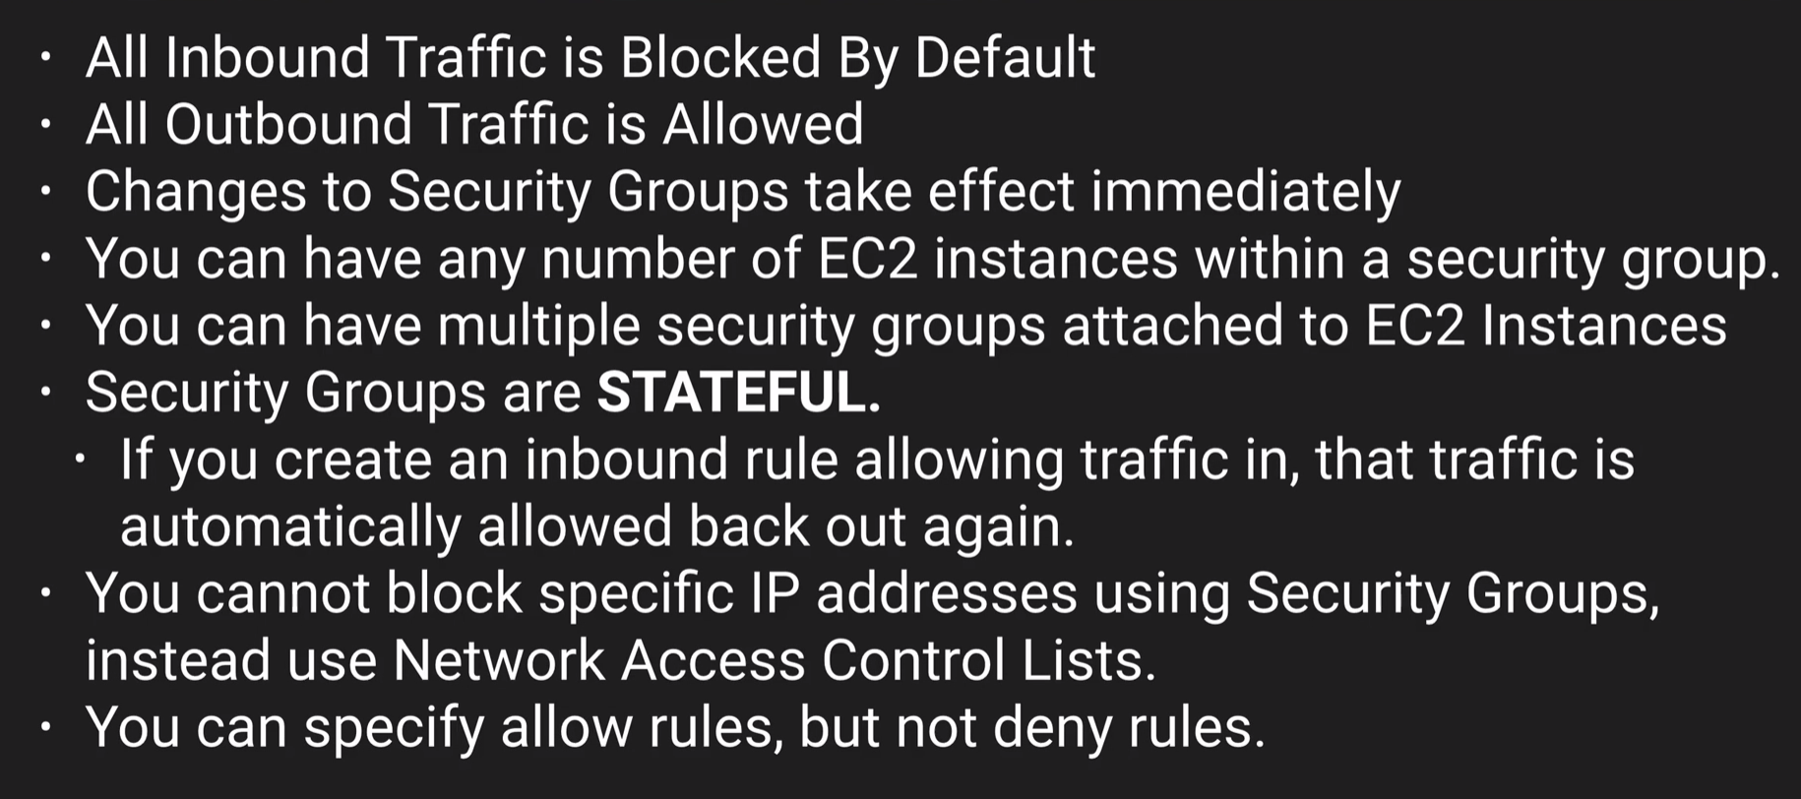

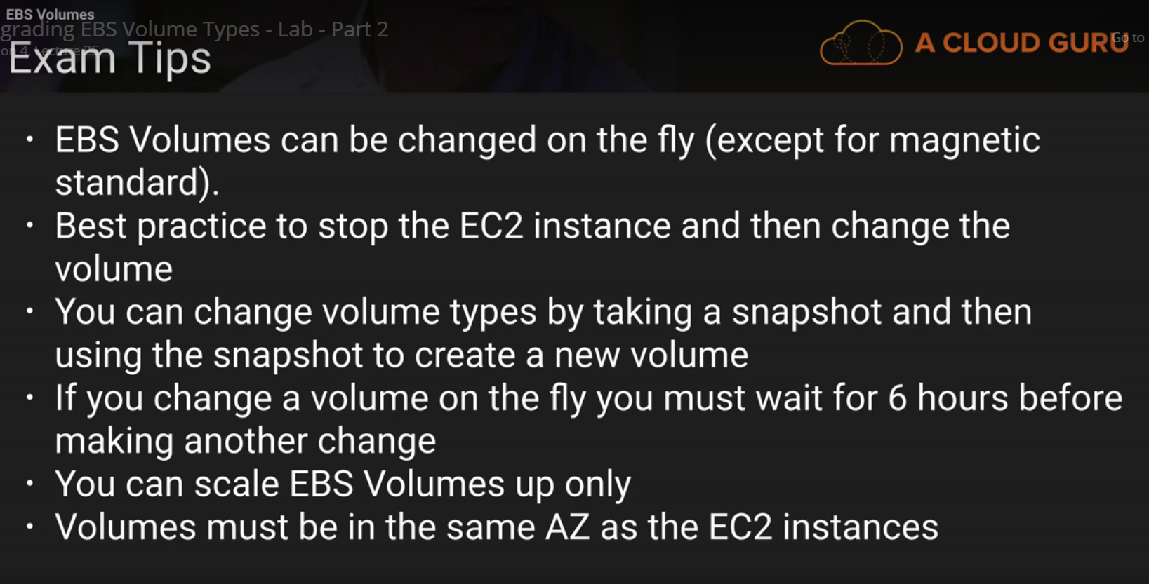

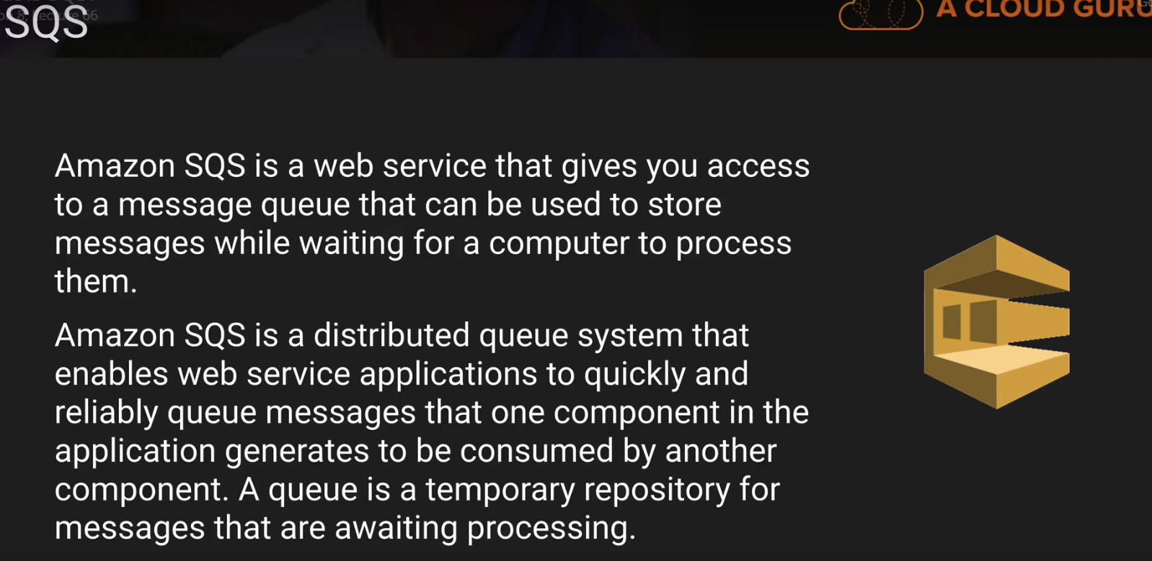

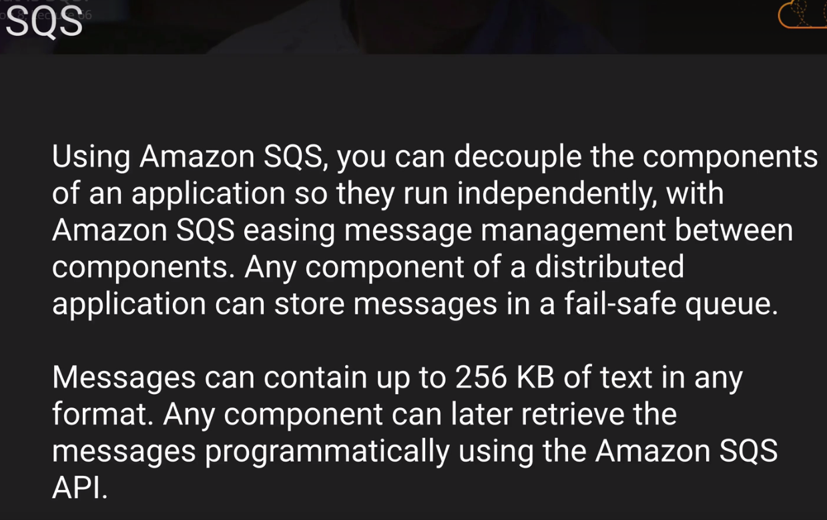

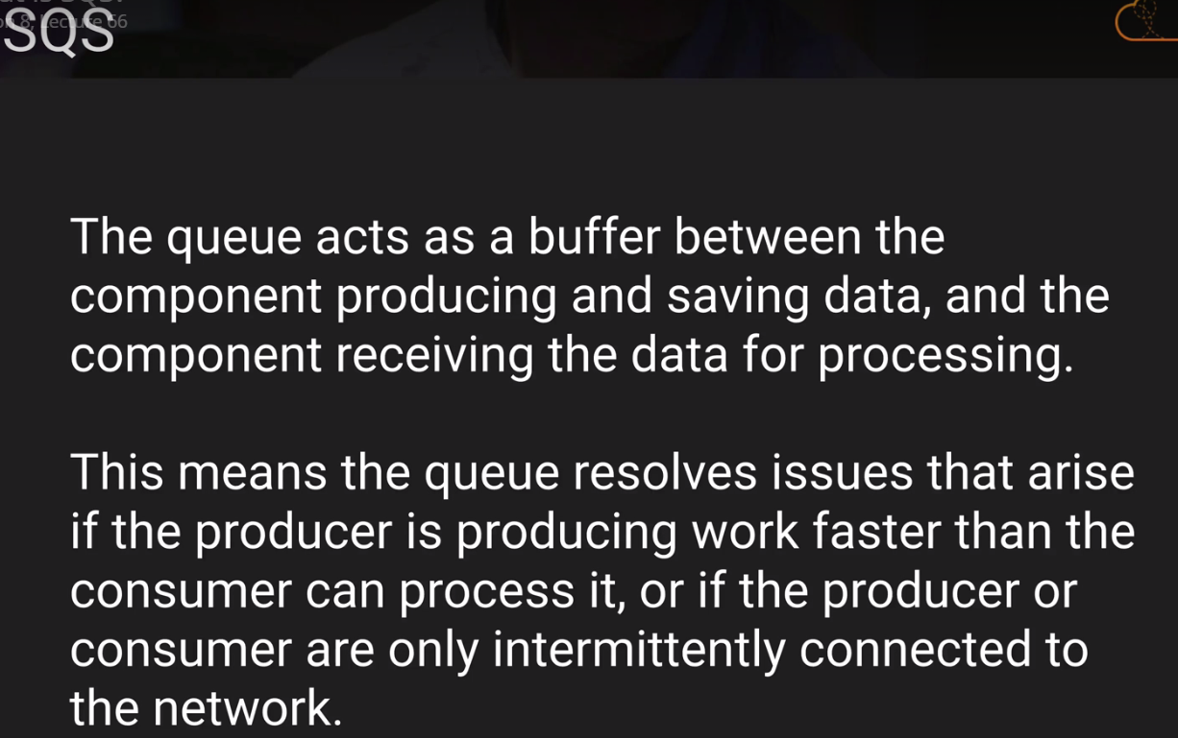

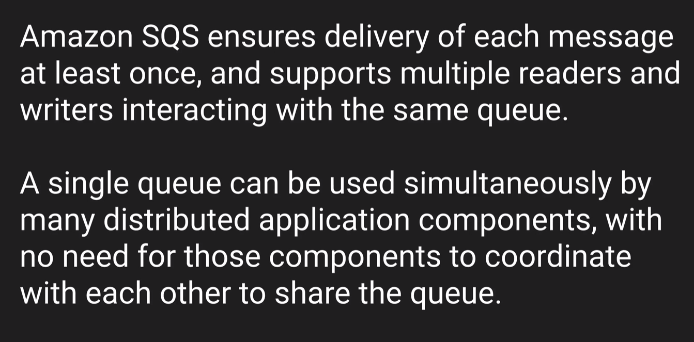

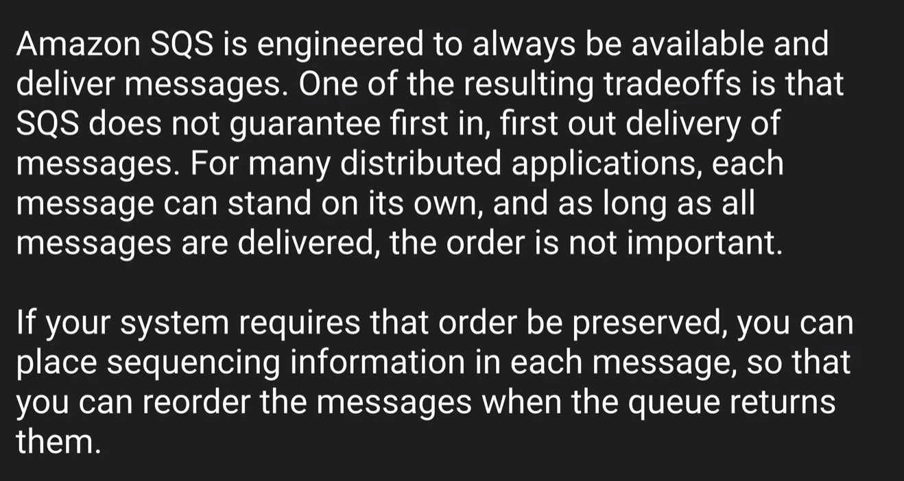

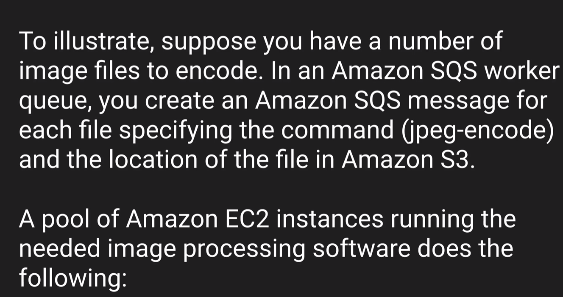

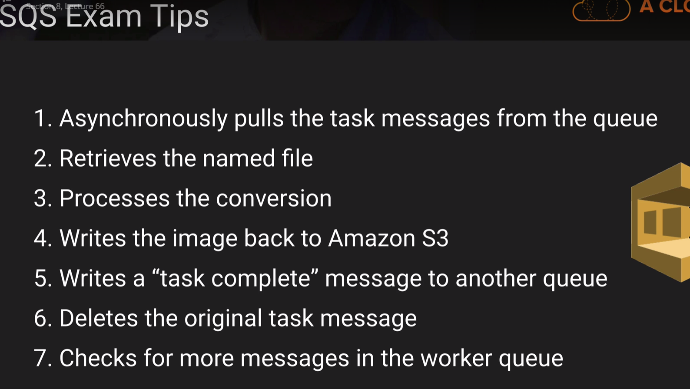

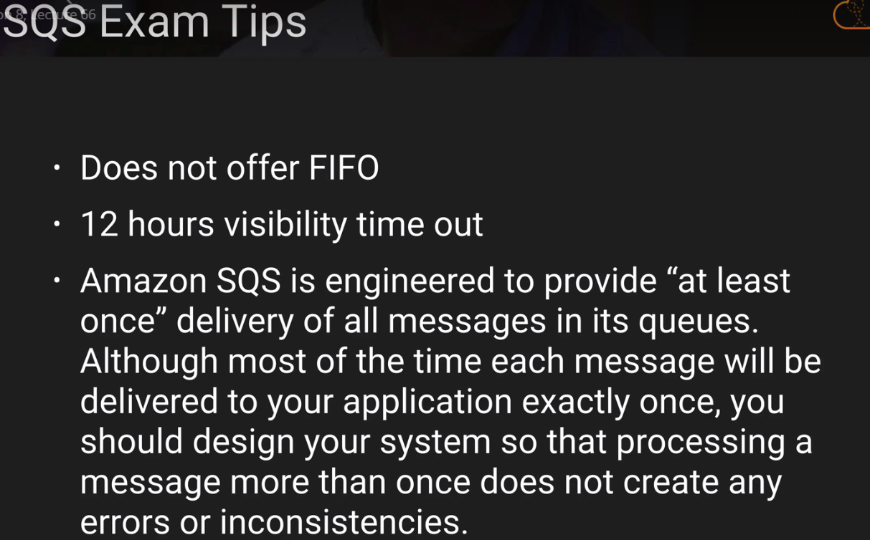

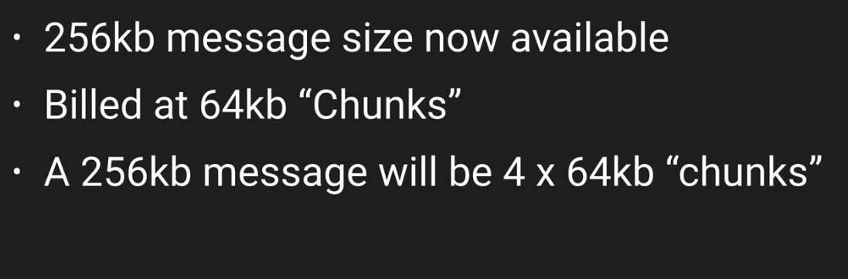

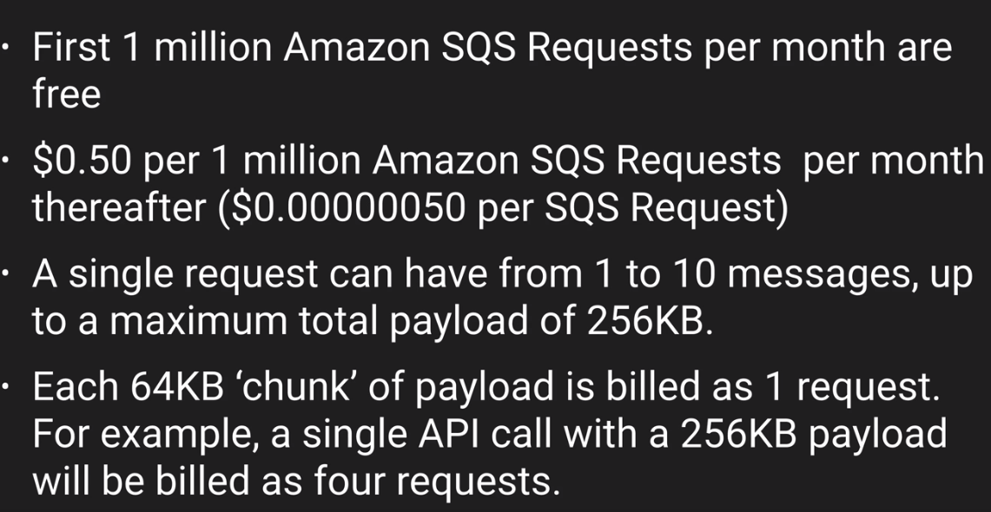

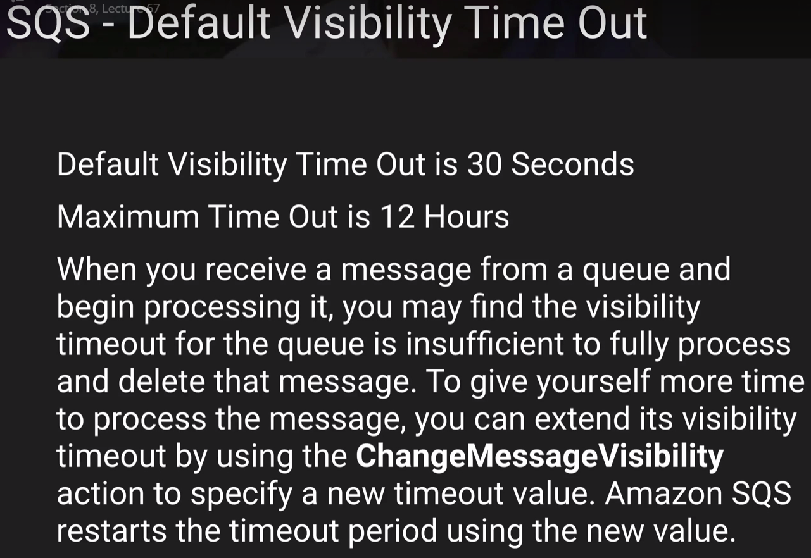

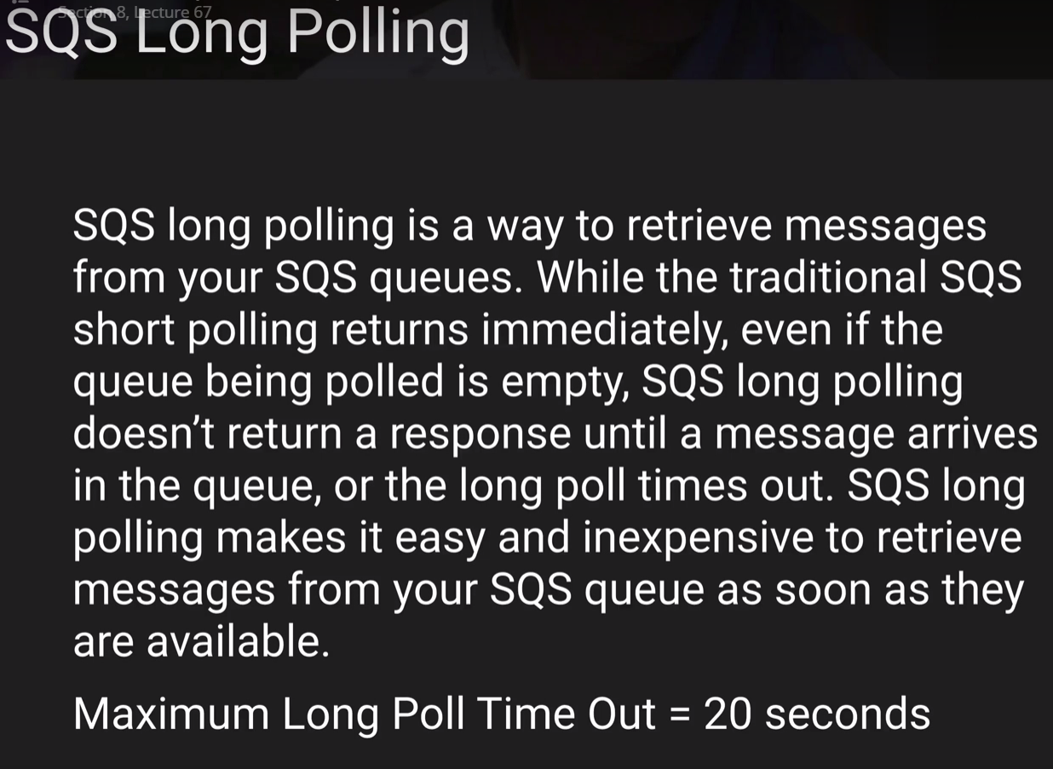

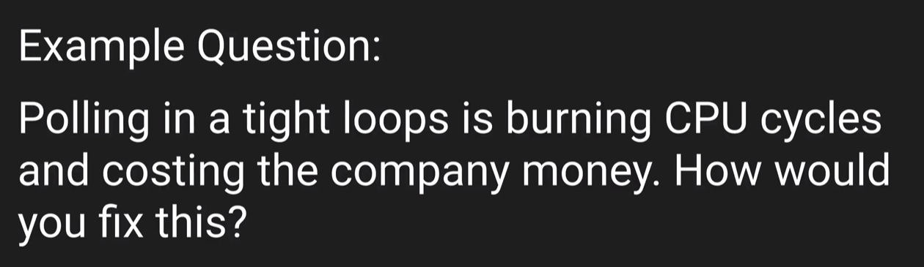

This is can be done using the LONG Polling.

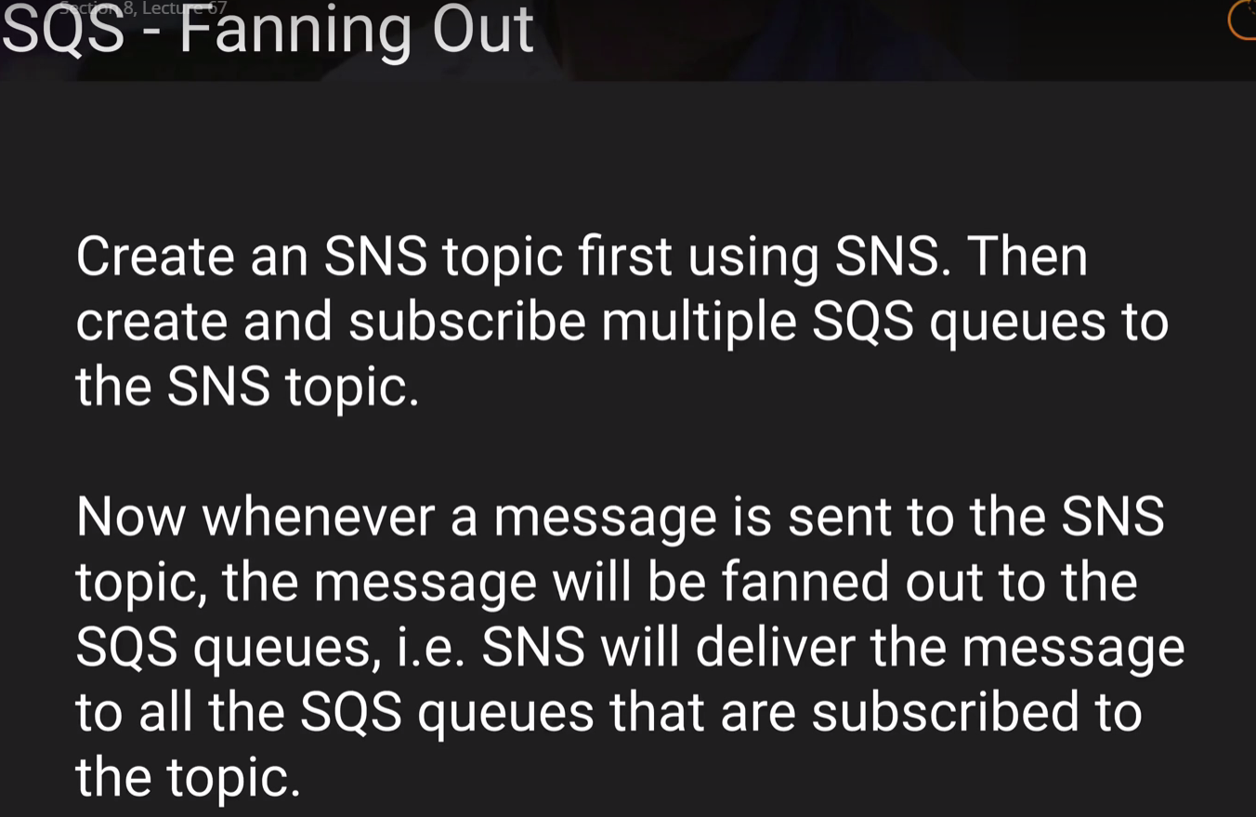

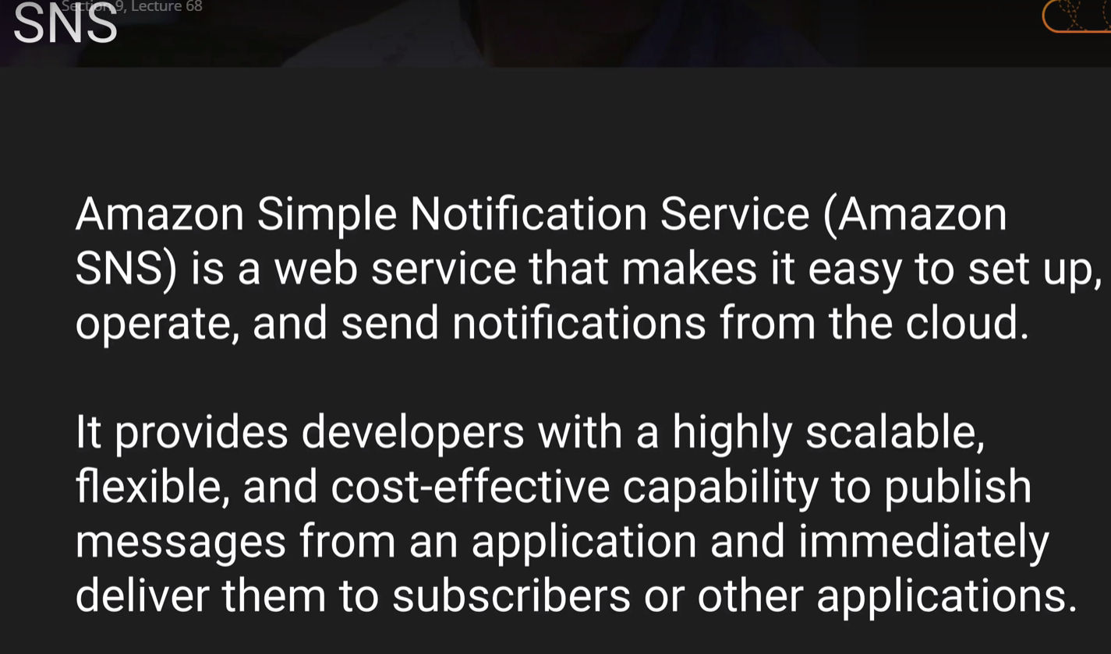

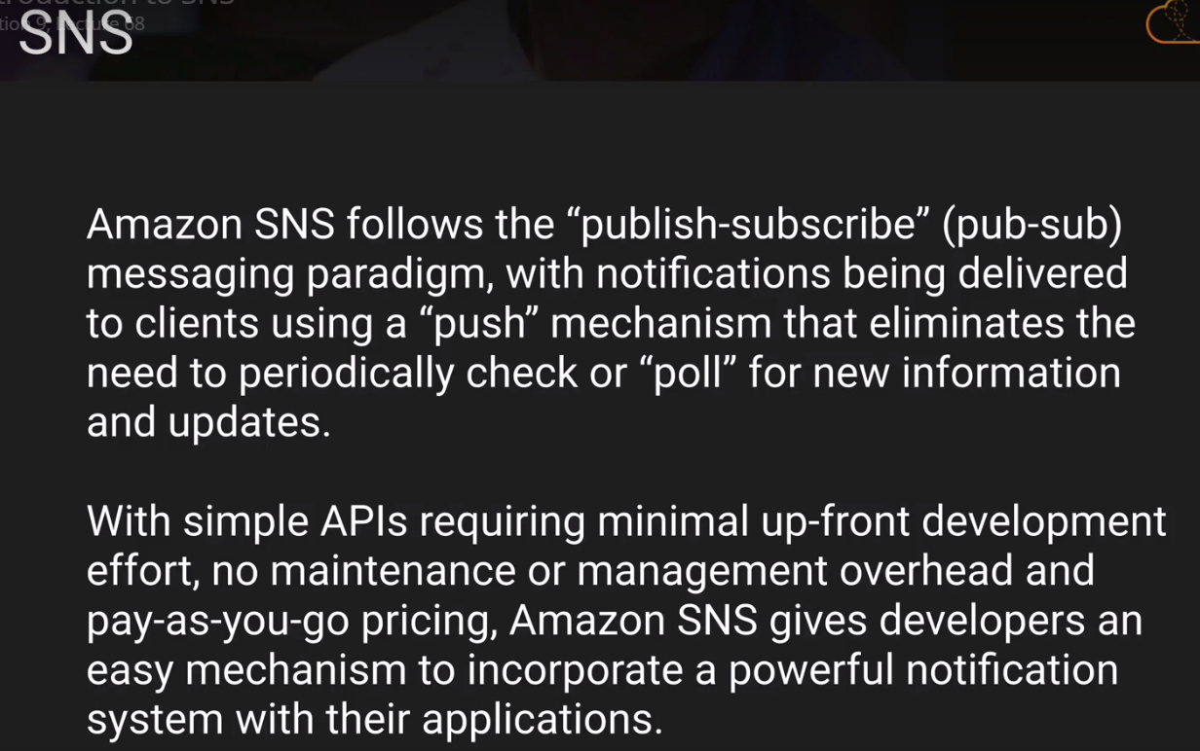

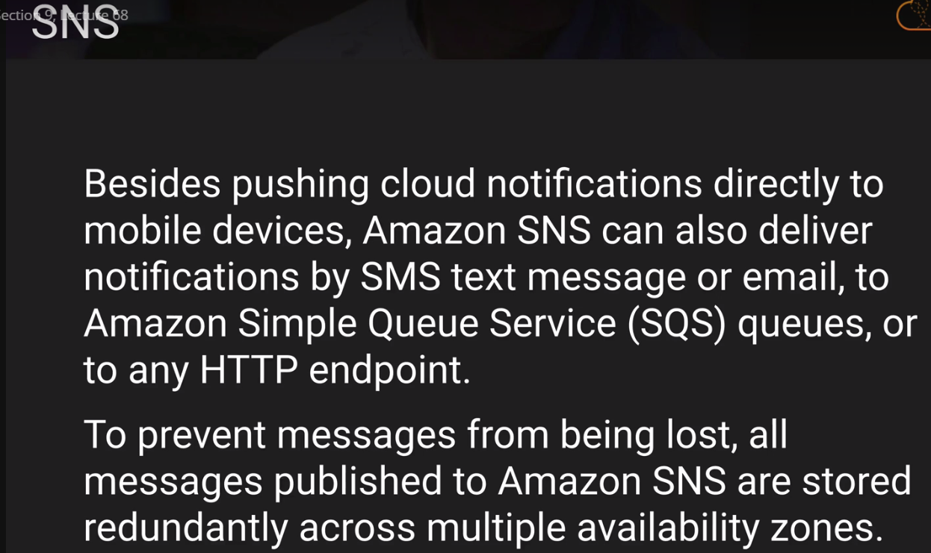

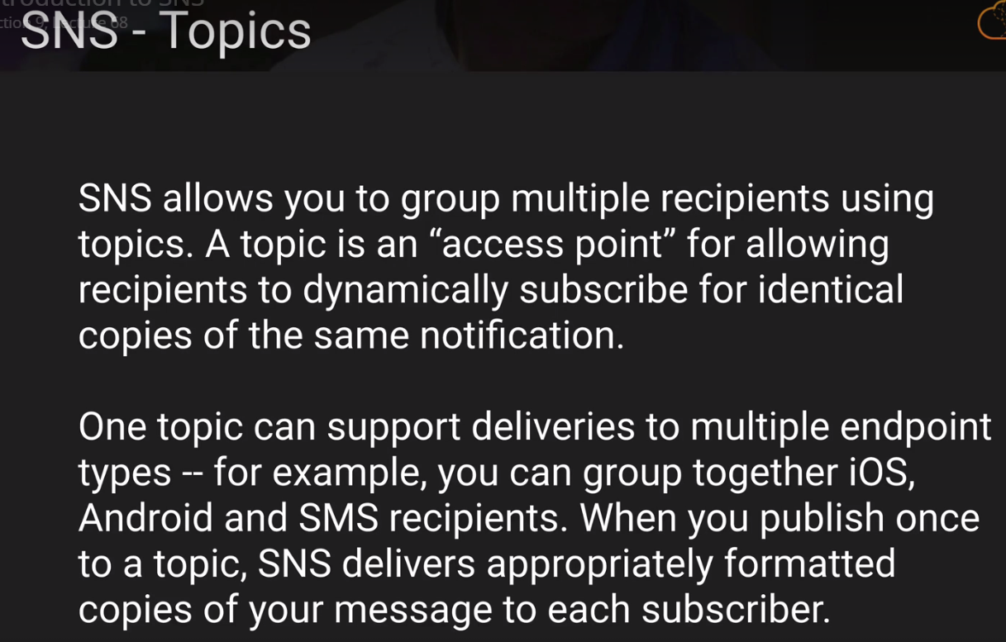

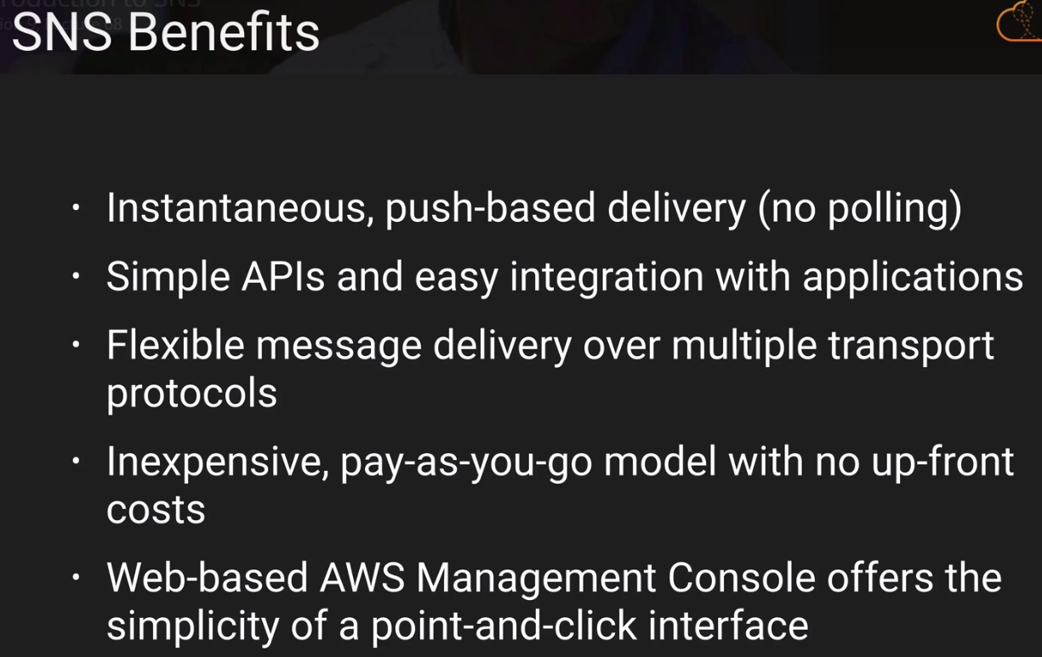

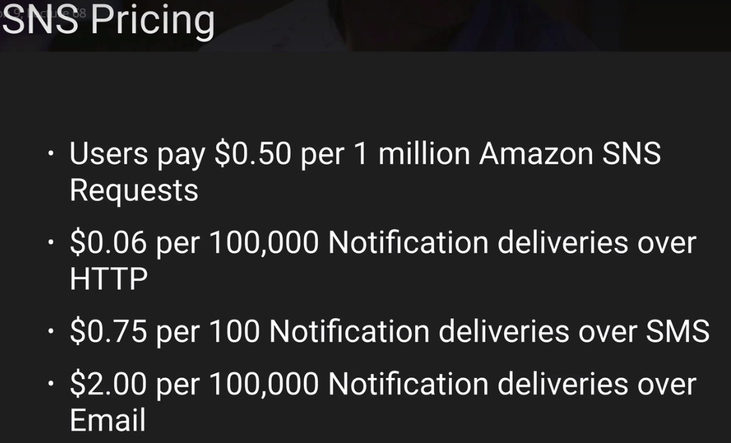

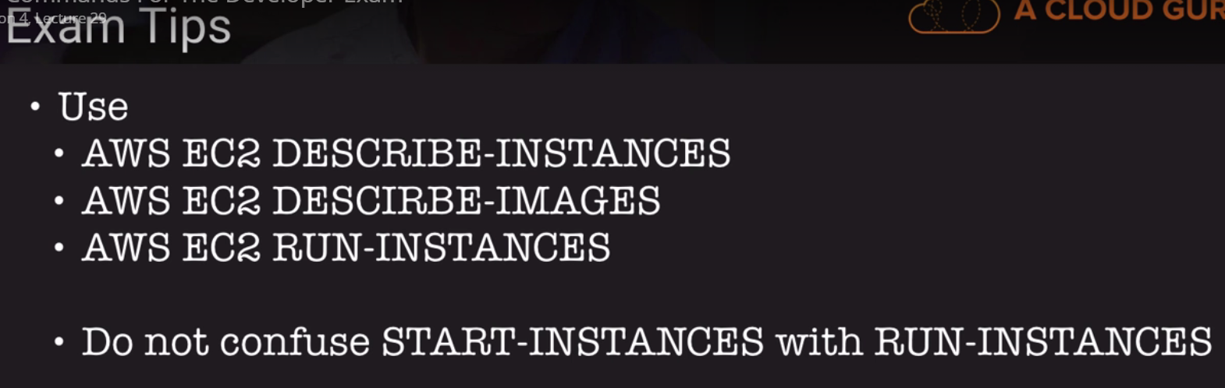

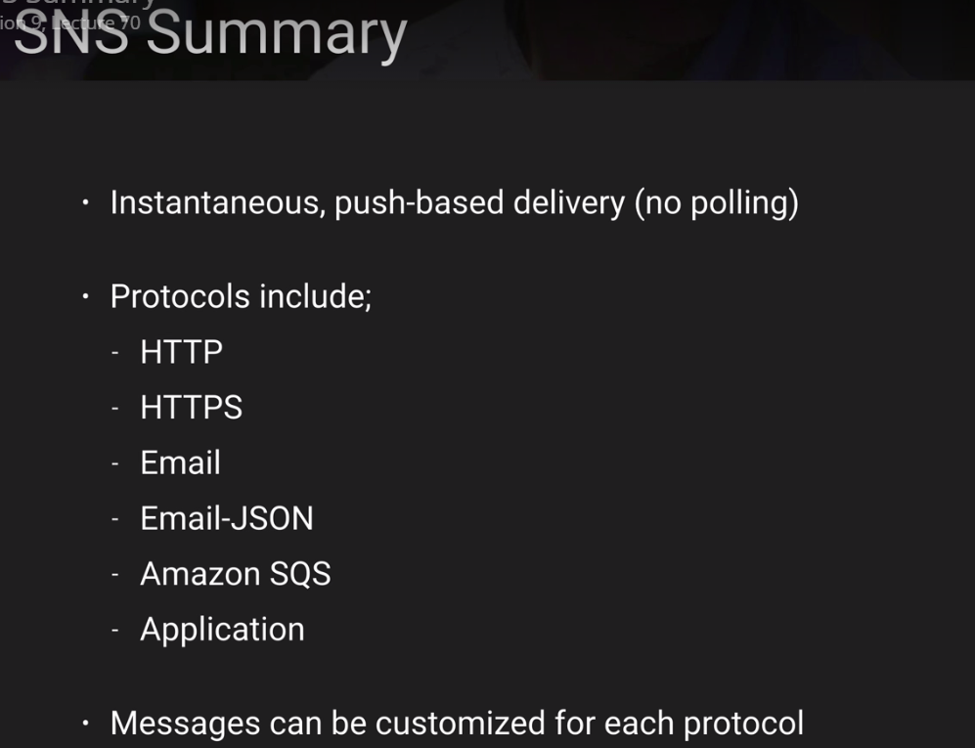

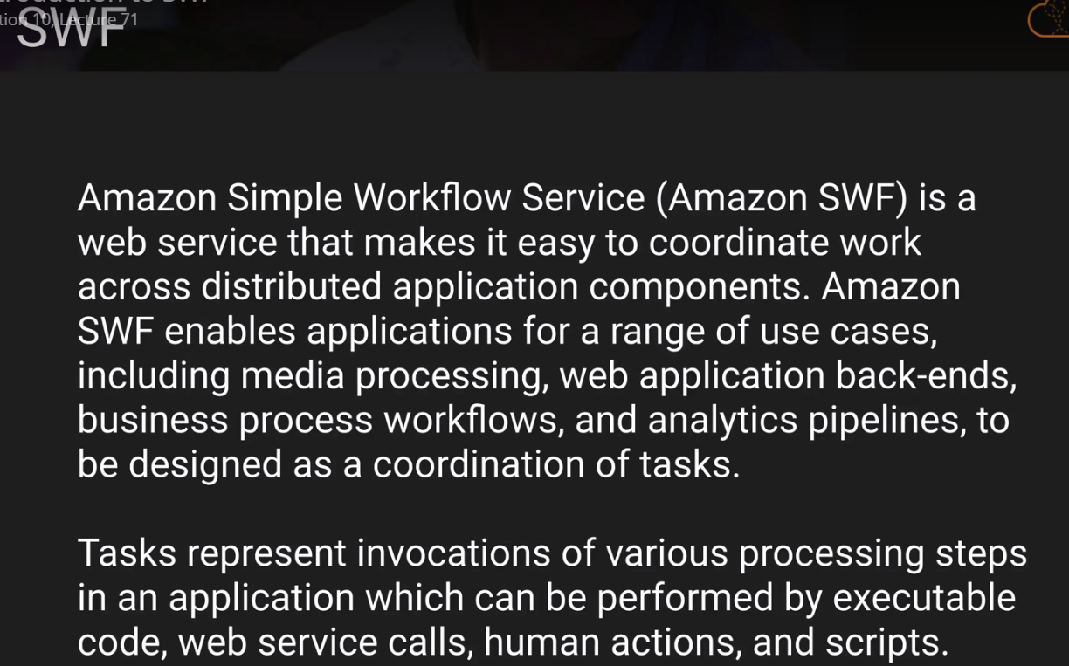

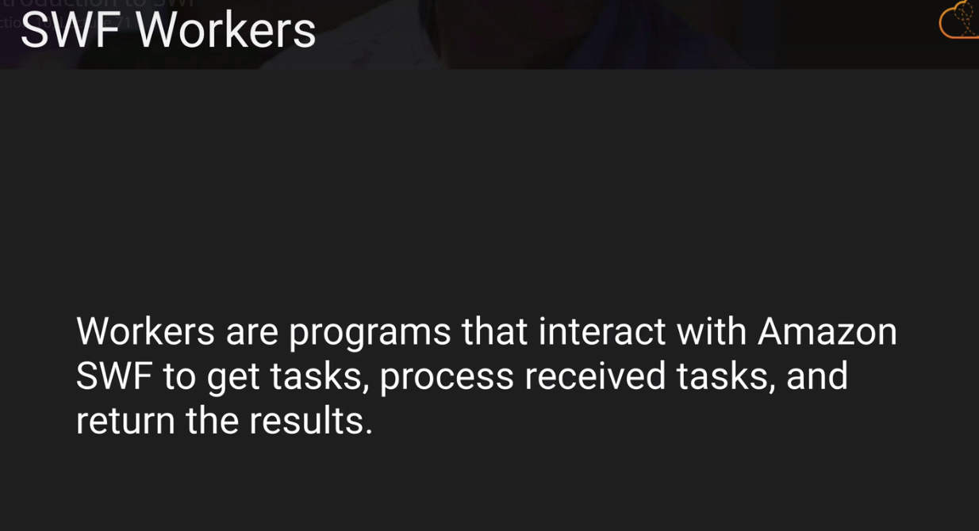

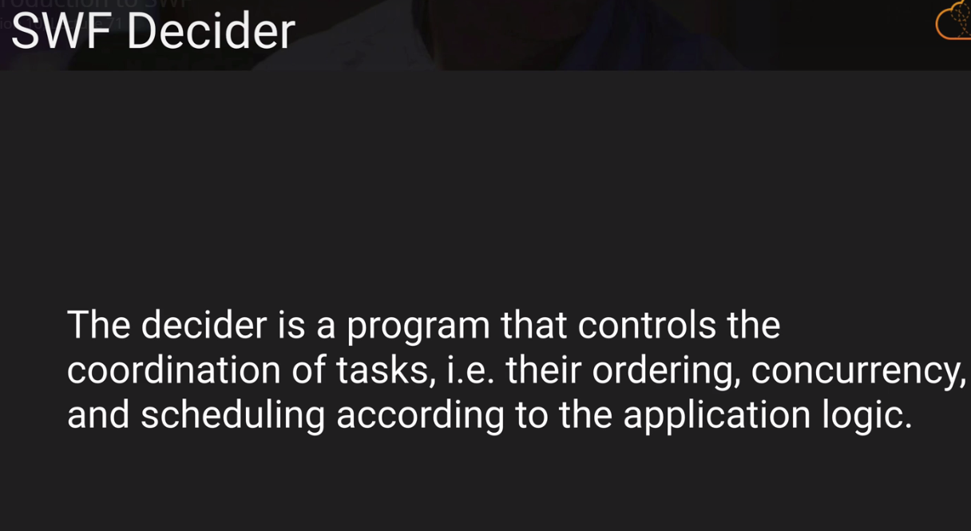

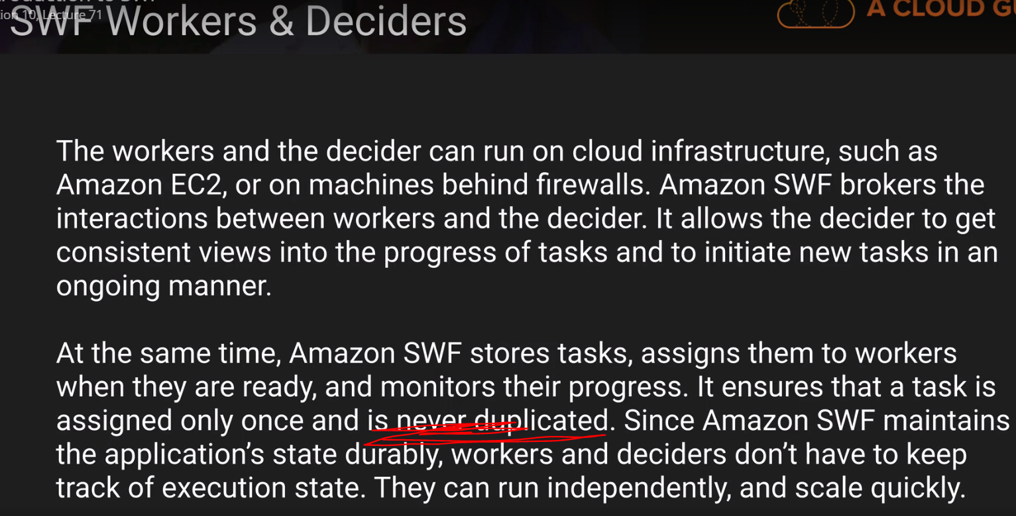

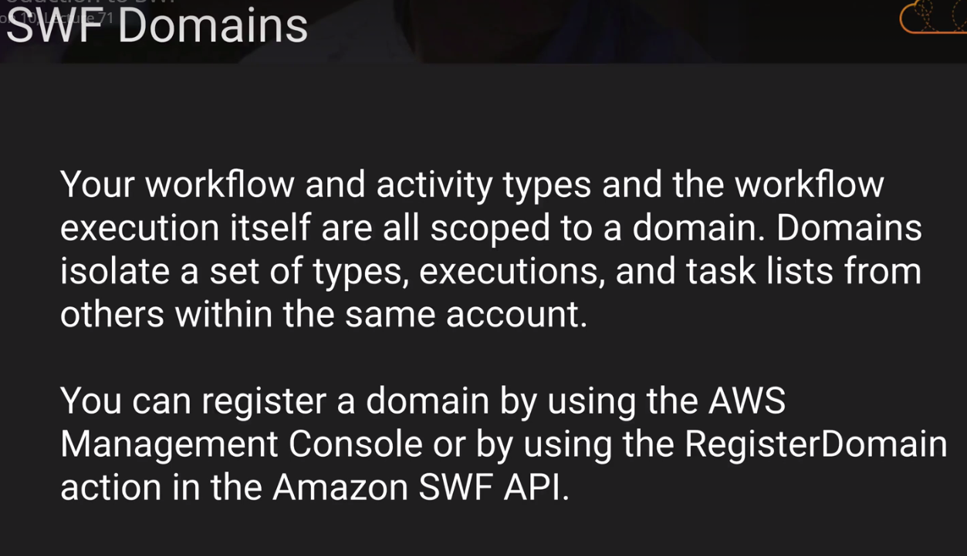

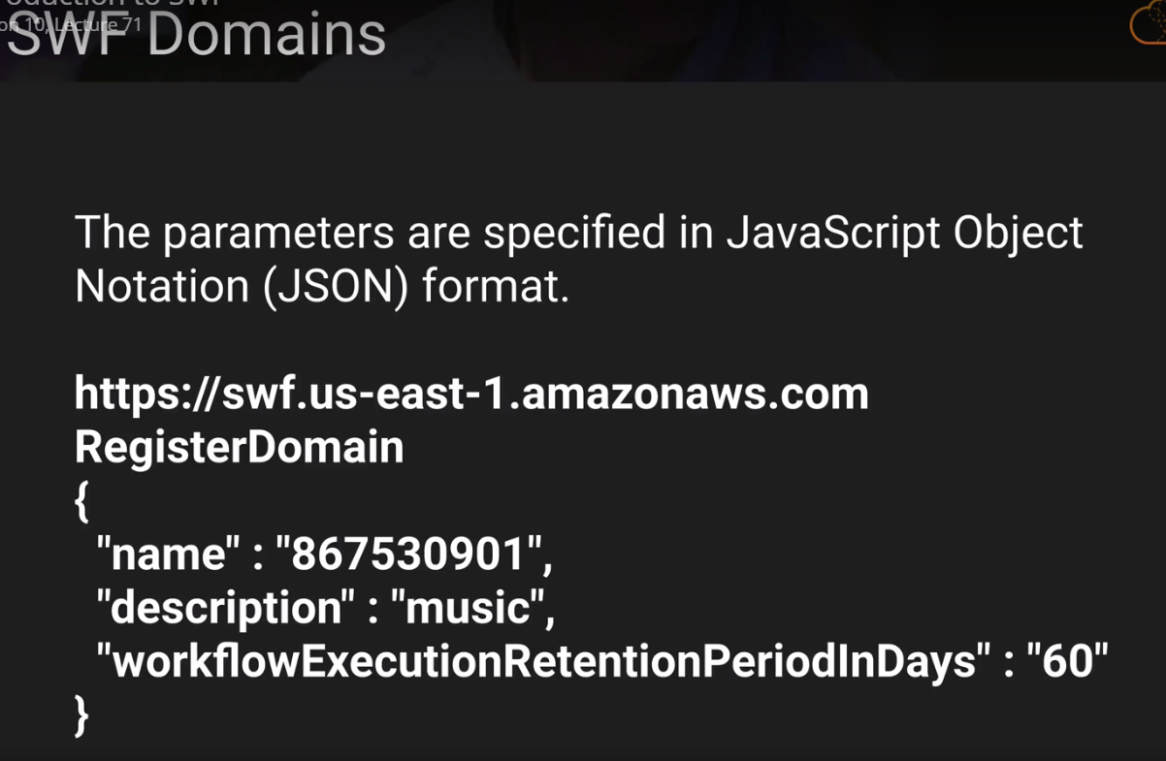

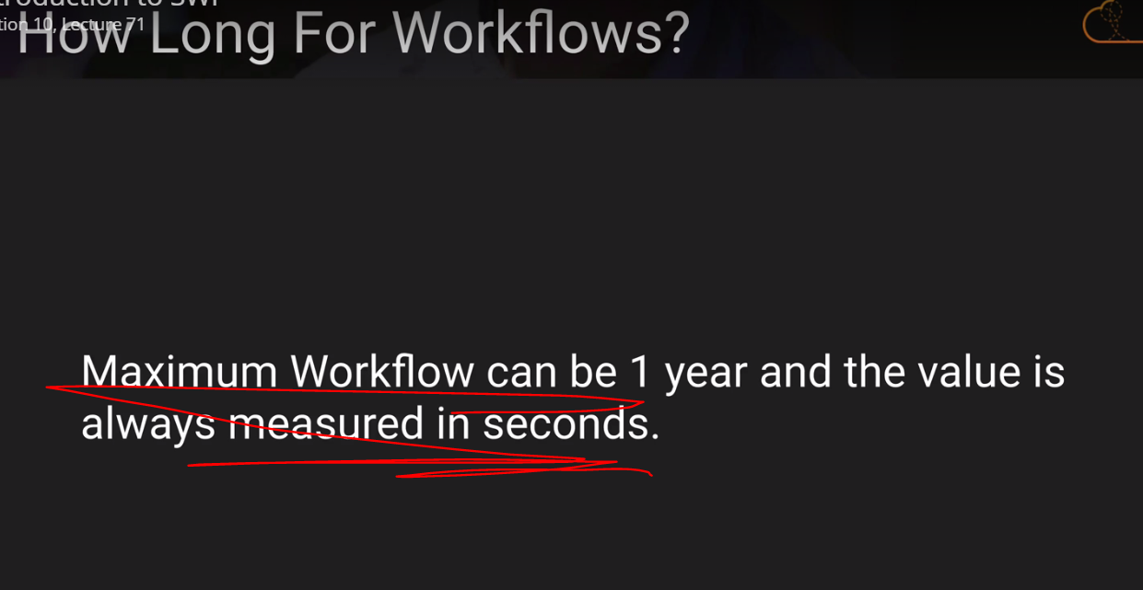

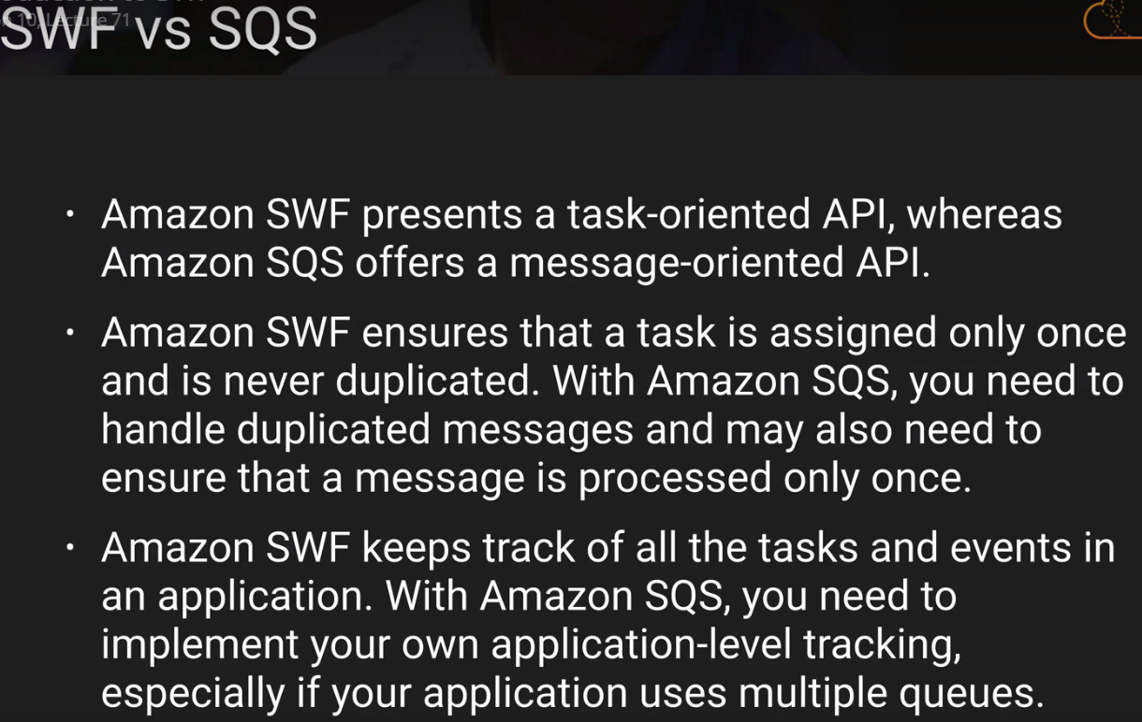

12 Hours 🡪 SQS Message HOLDING

1 Year 🡪 SWF.

DNS:

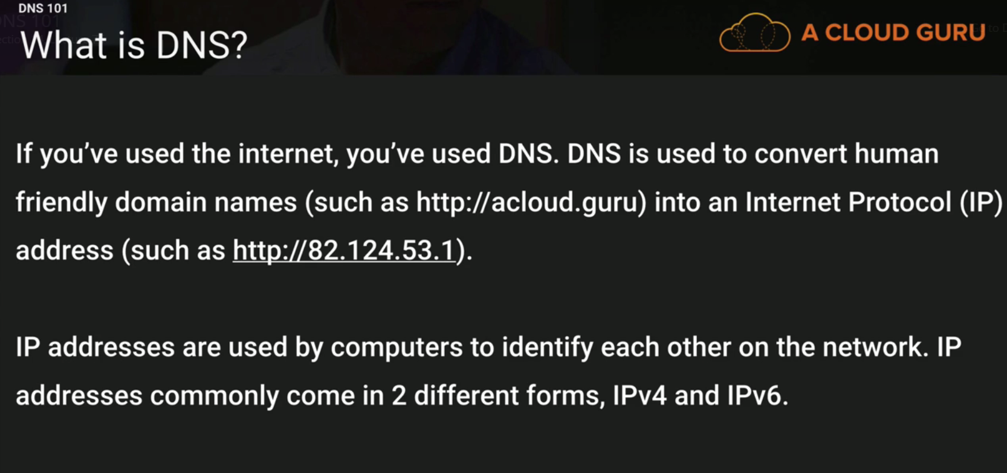

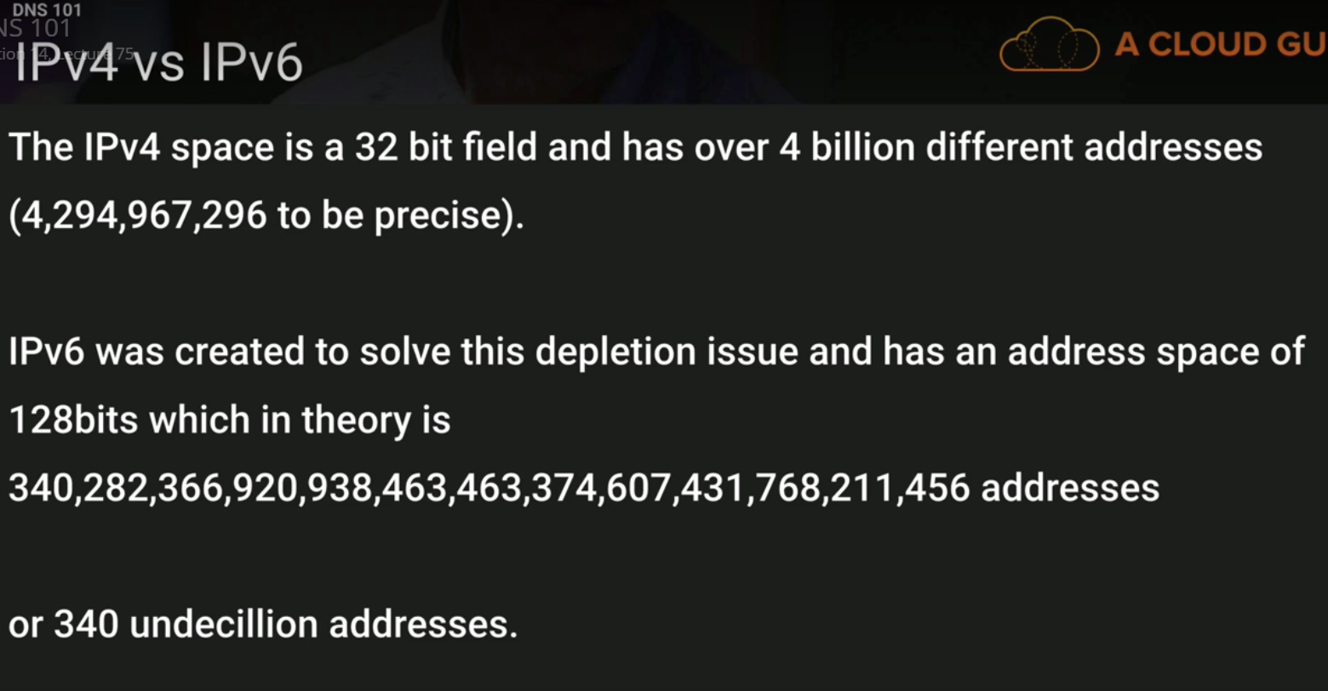

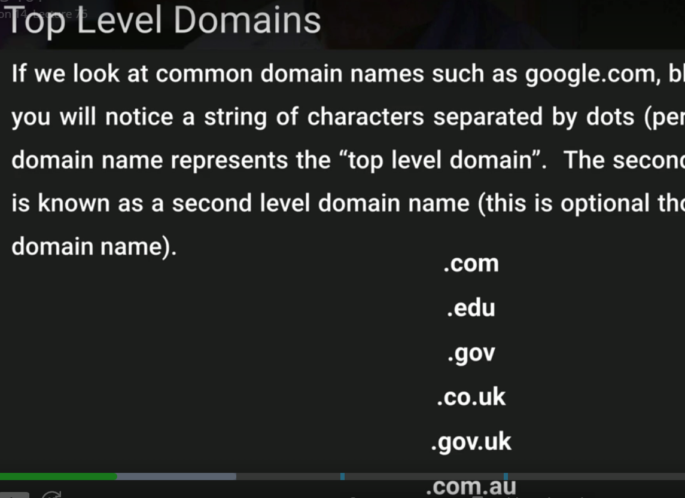

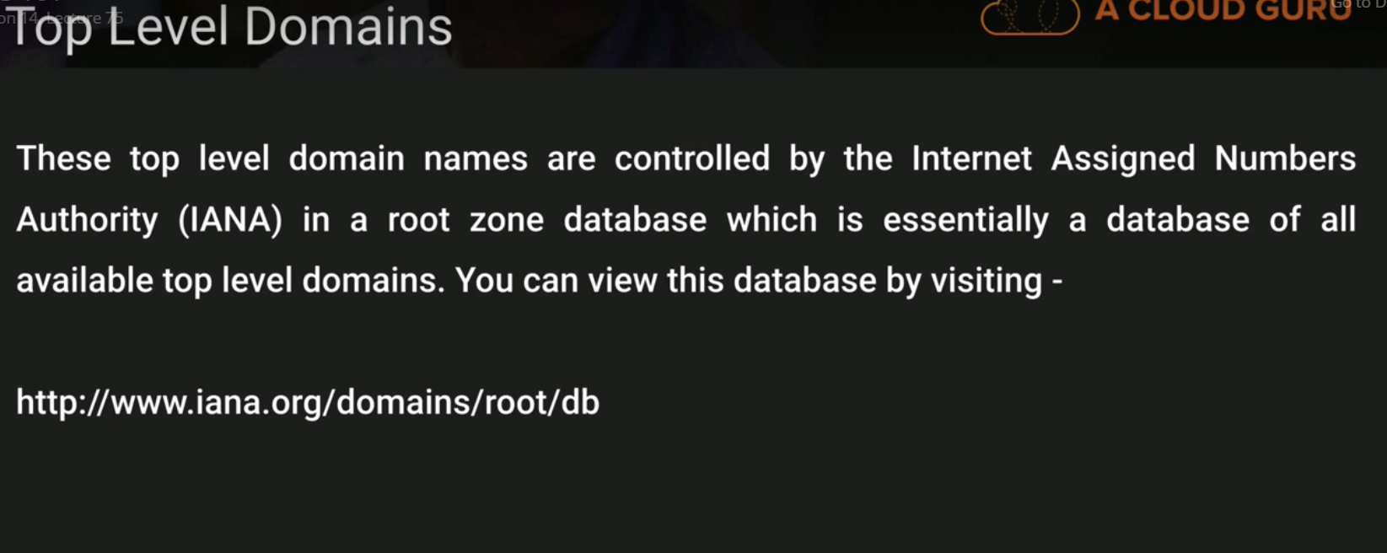

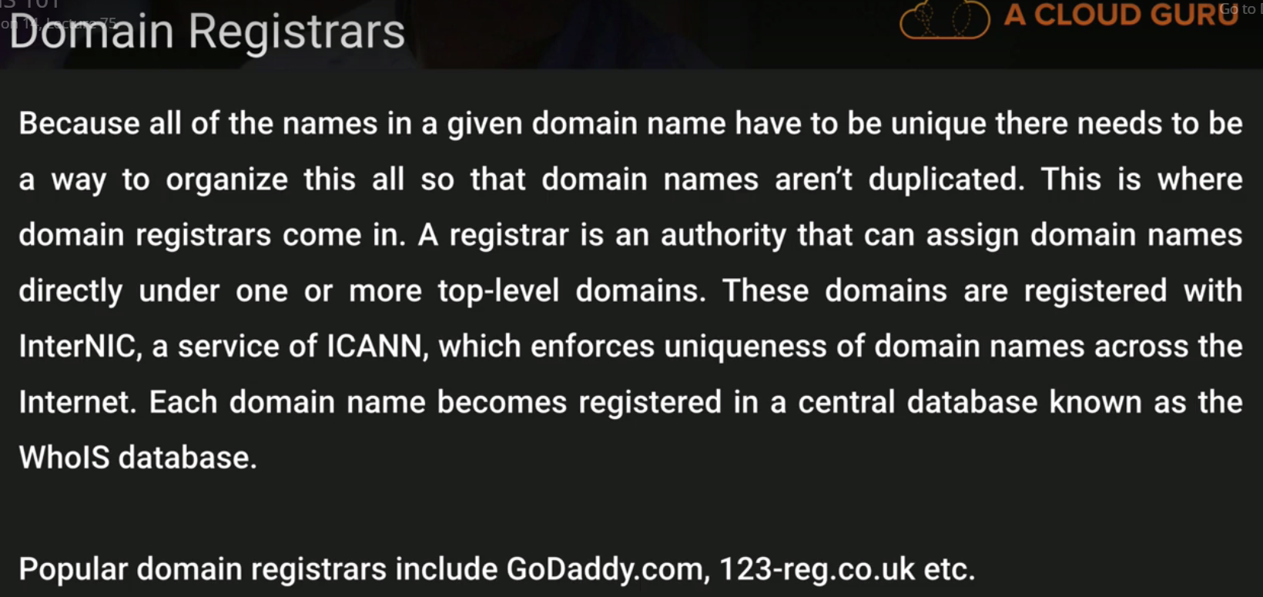

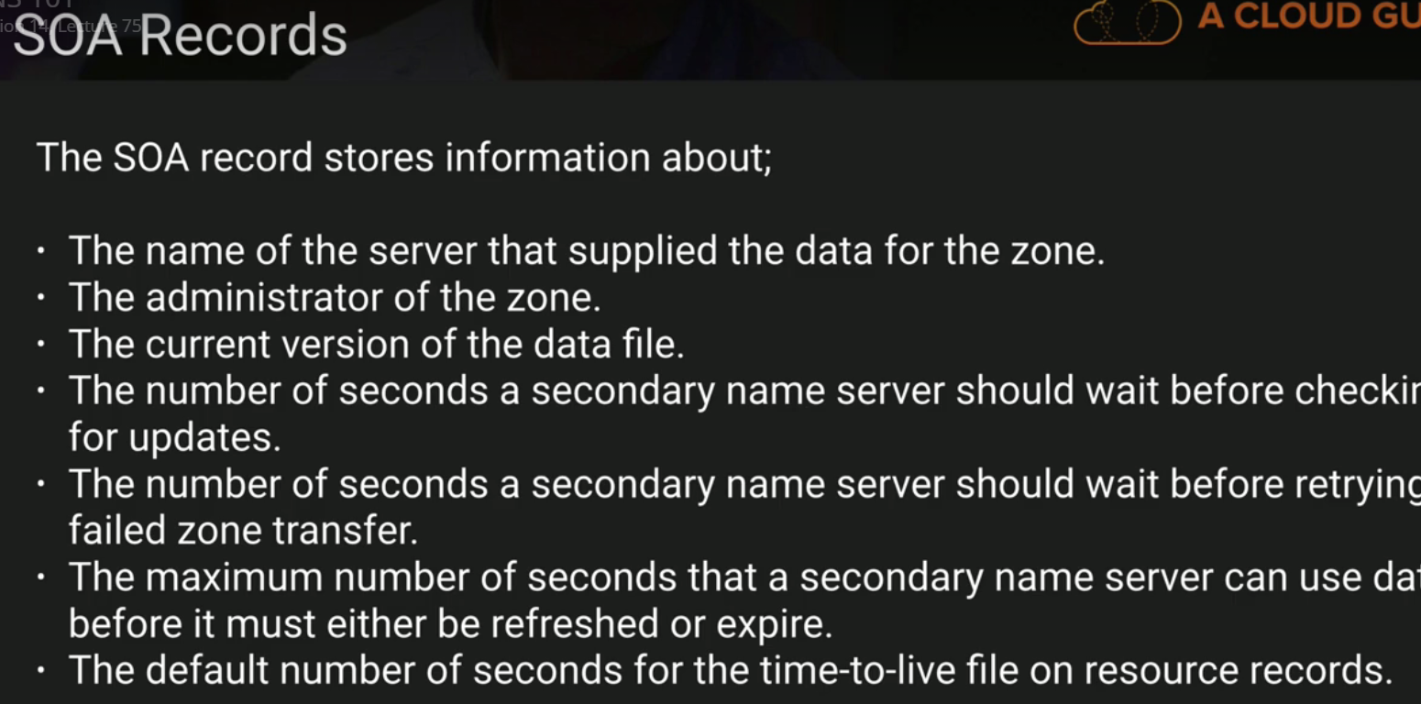

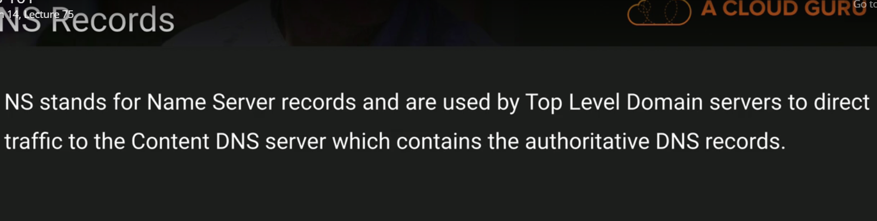

ELB just the DNS Name:

ELB will not have the IPV4 or IPv6.

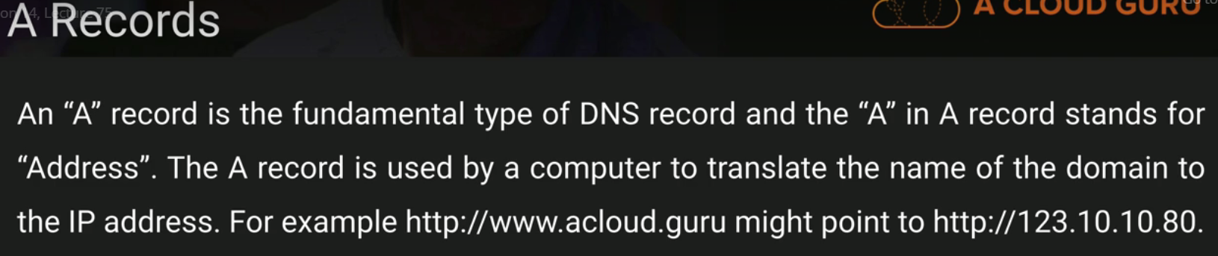

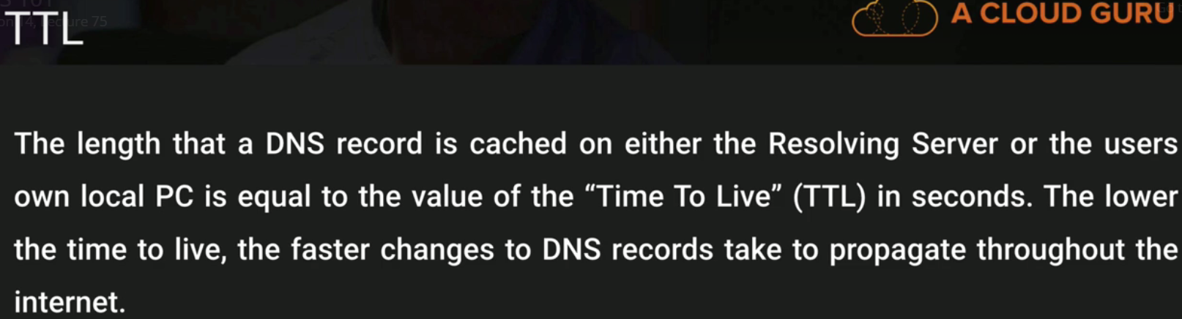

Caching time = TTL how long it will

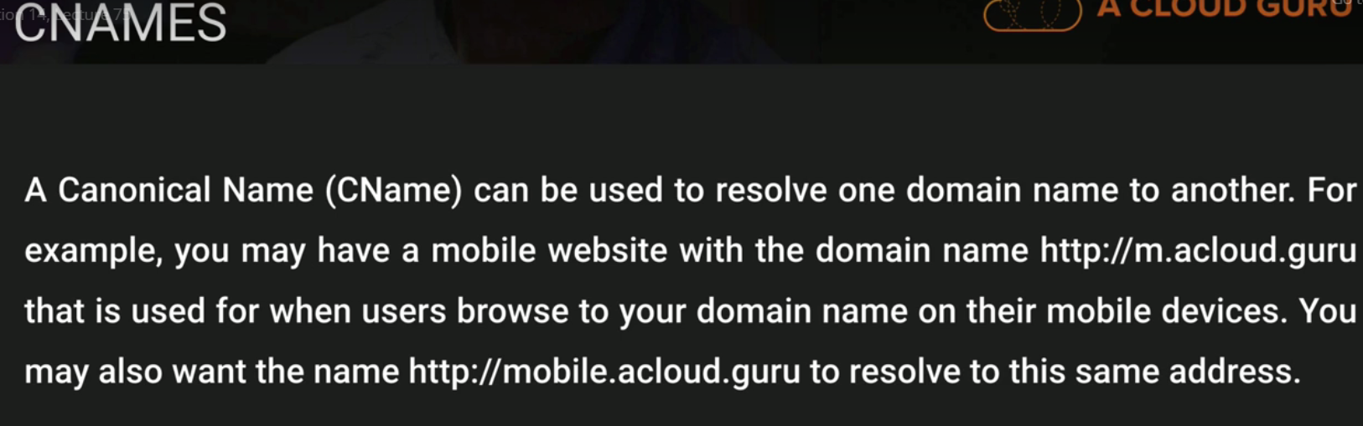

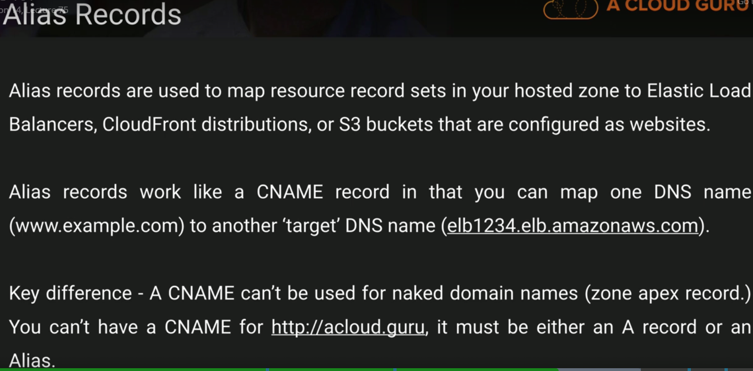

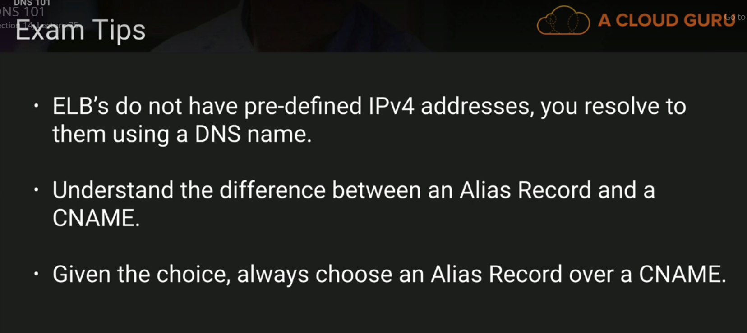

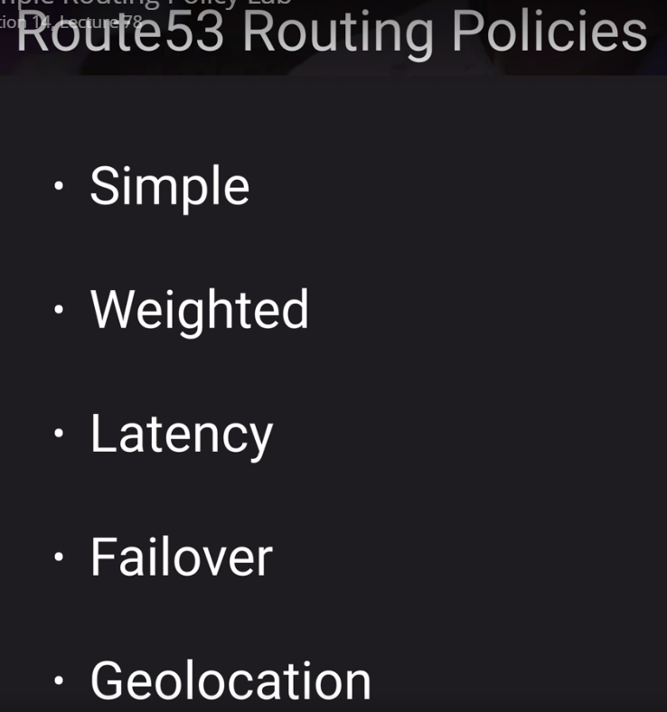

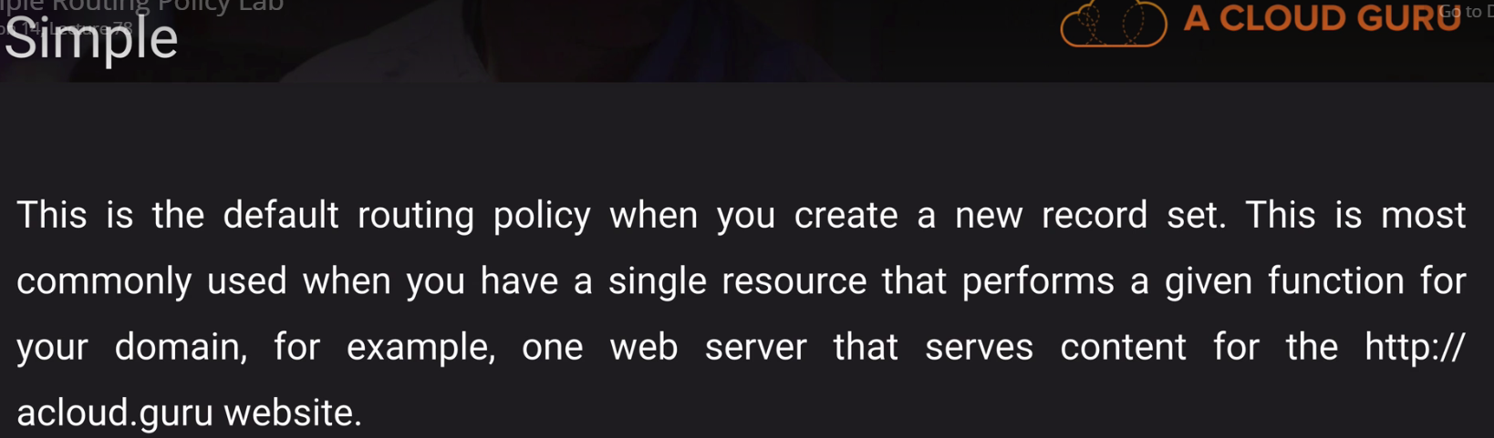

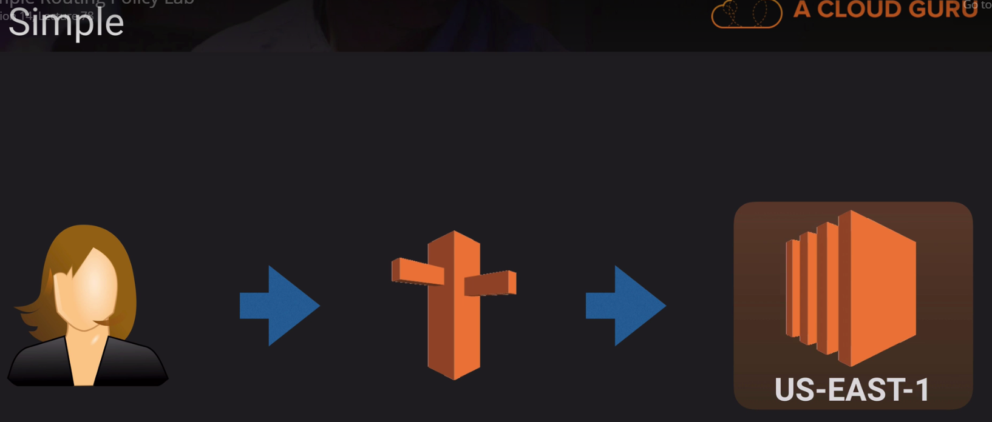

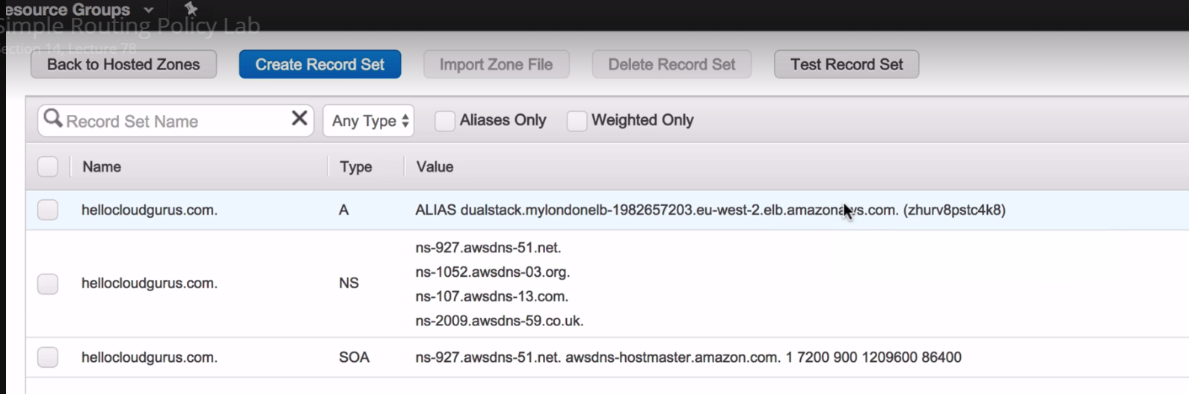

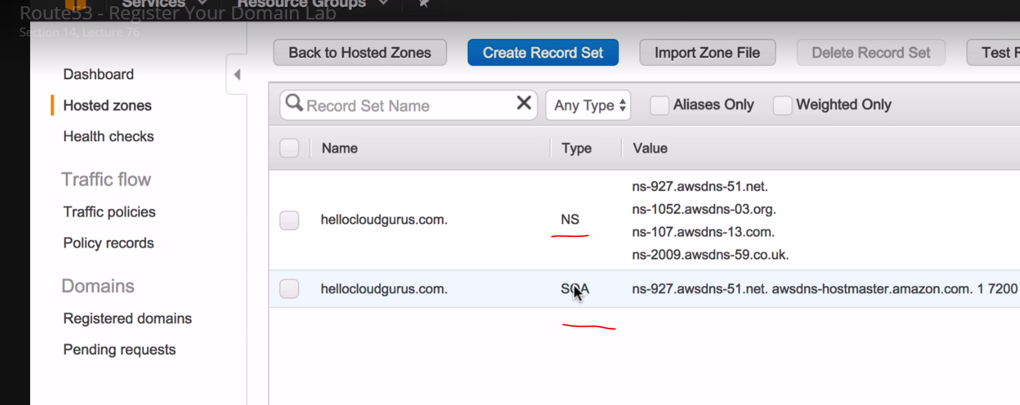

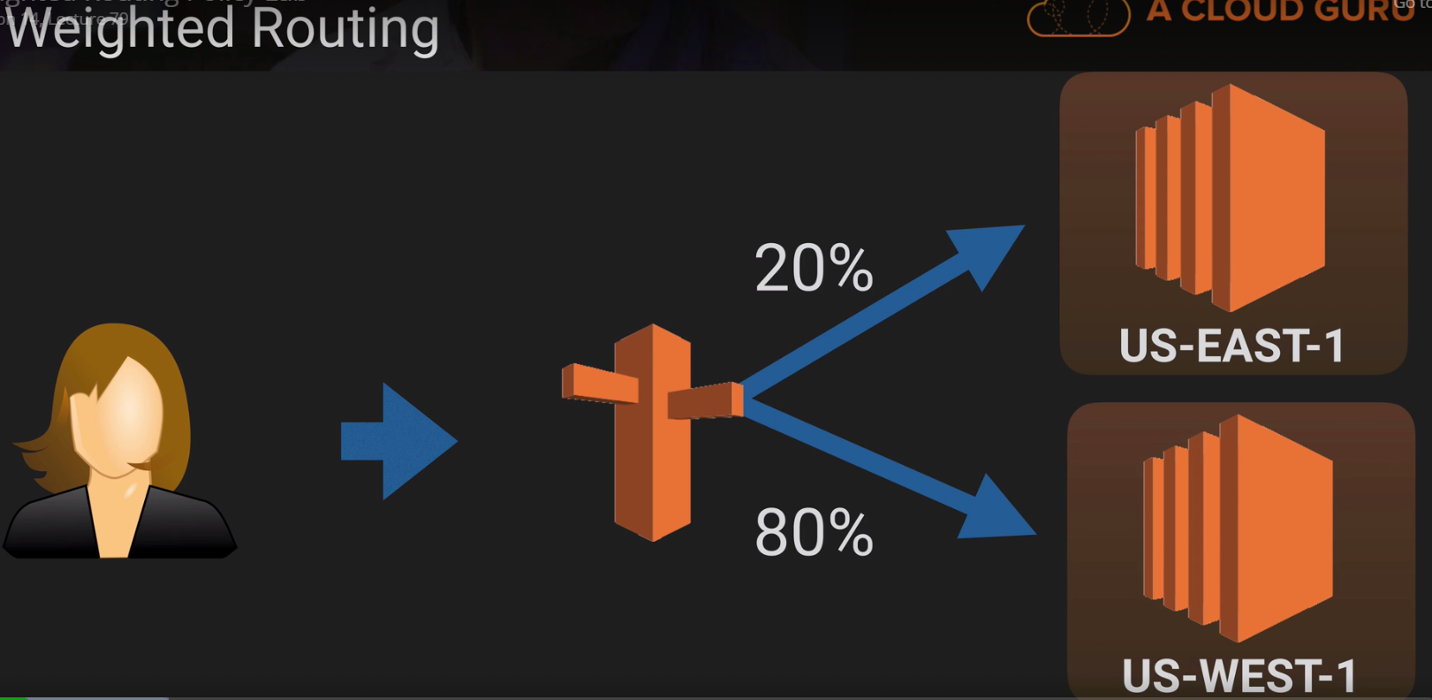

Route-53 is Golbal. Similar to IAM.

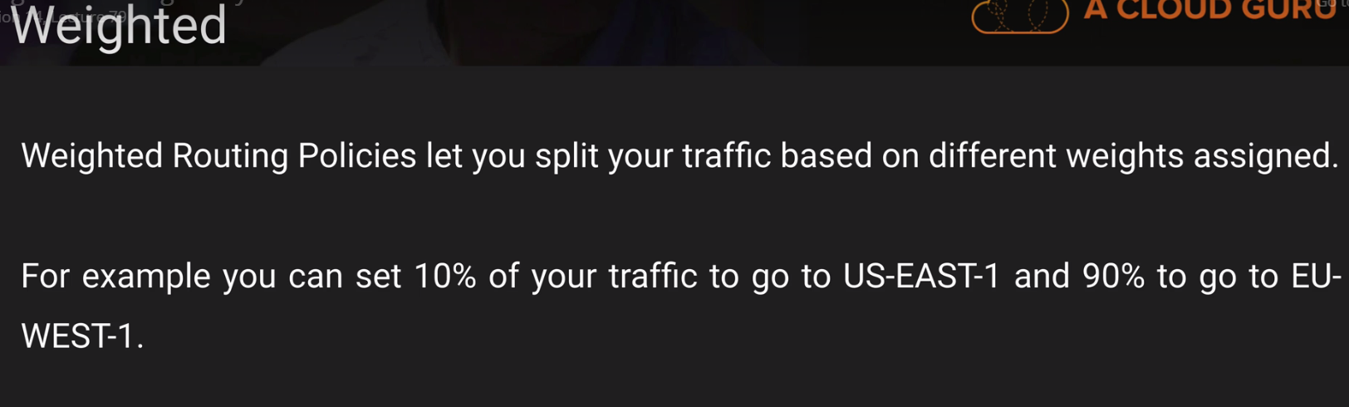

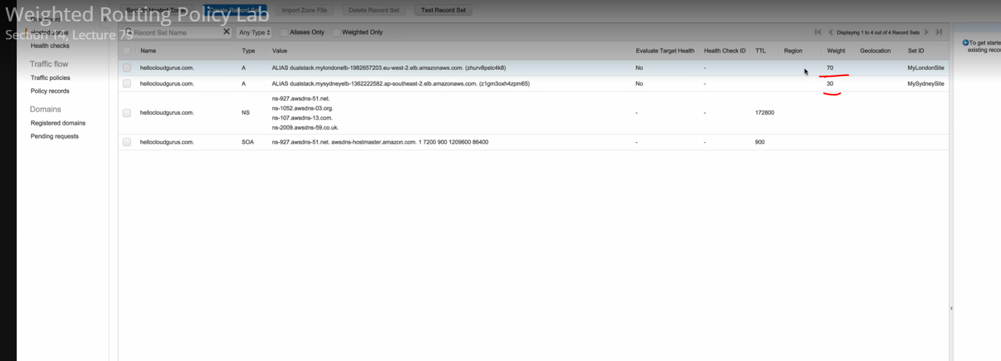

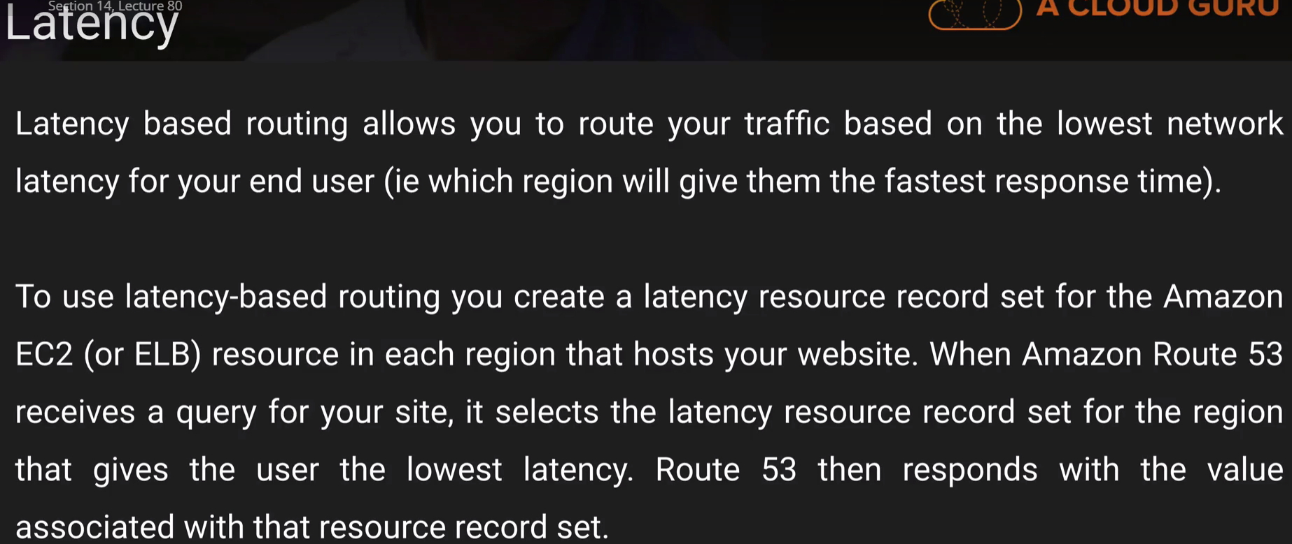

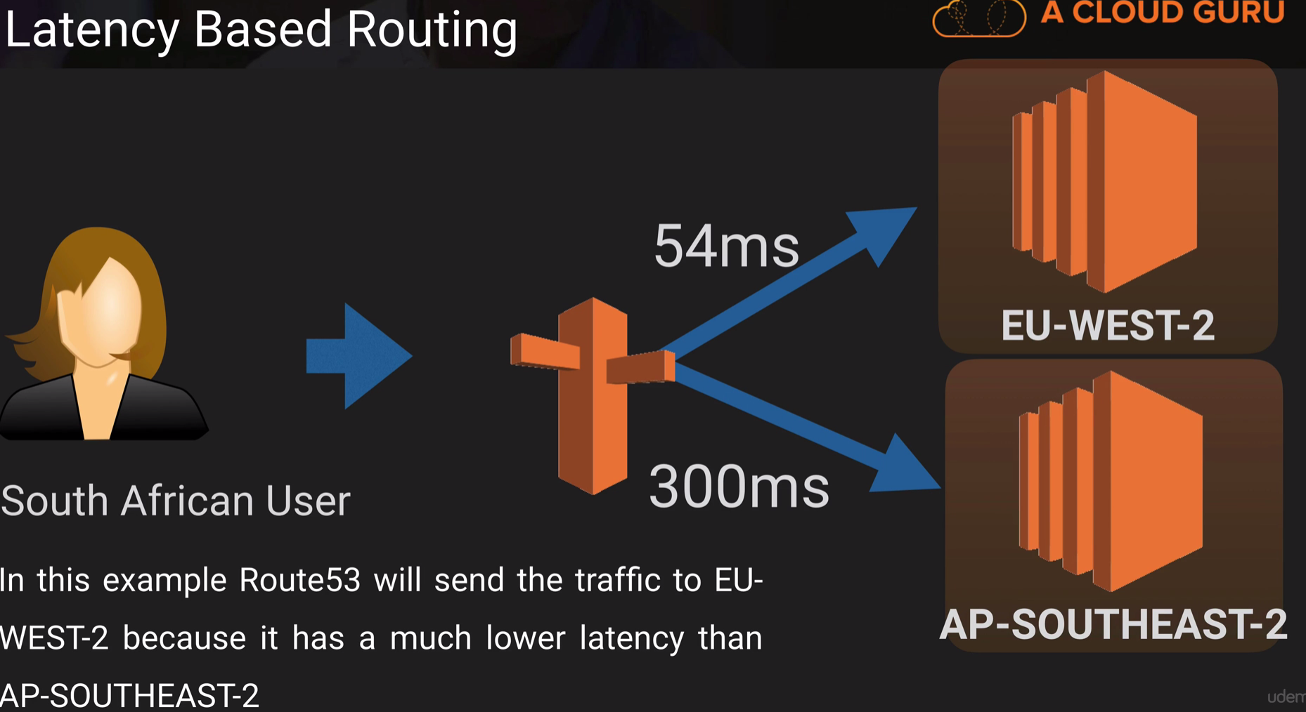

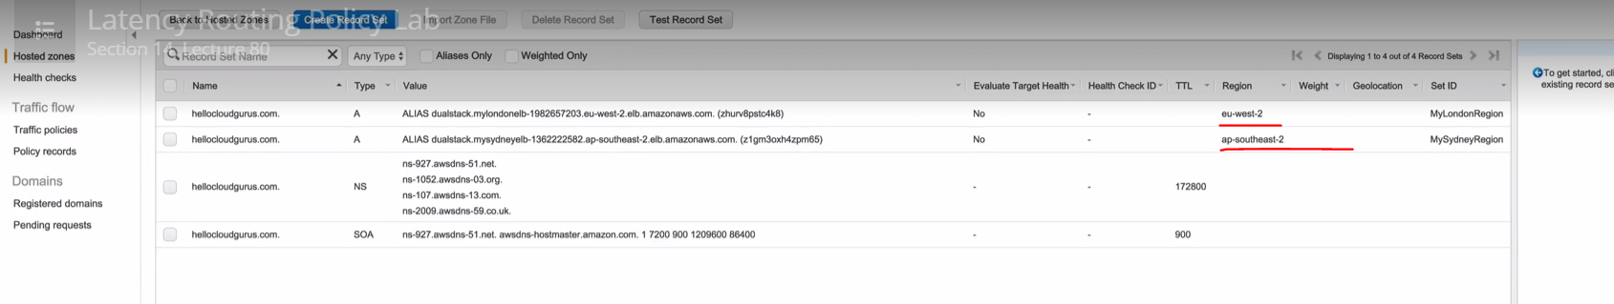

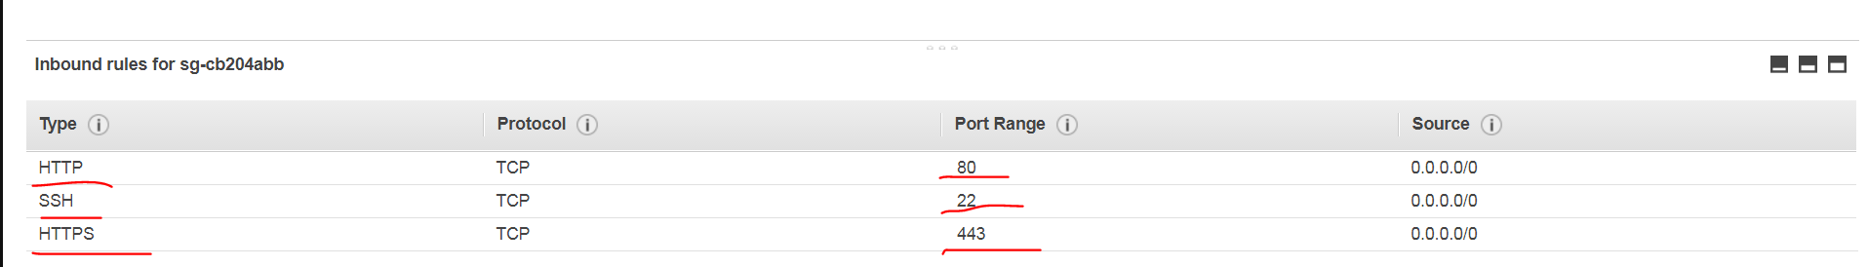

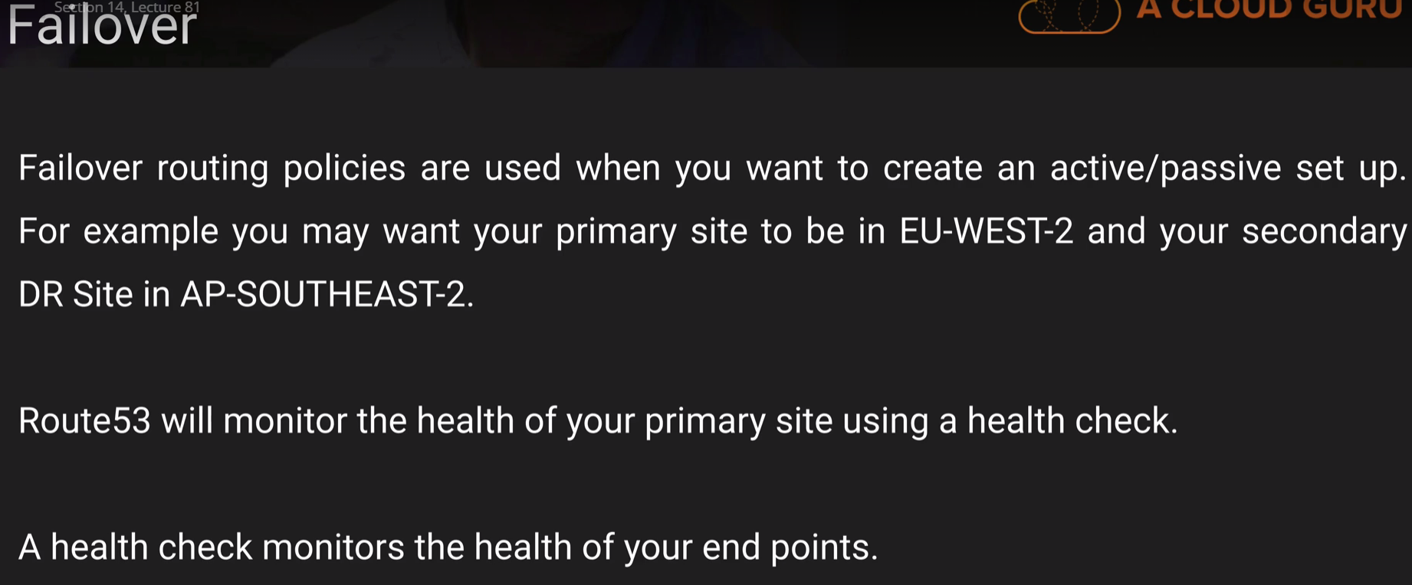

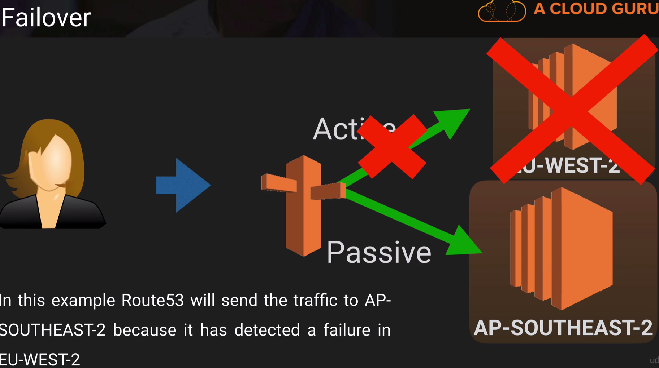

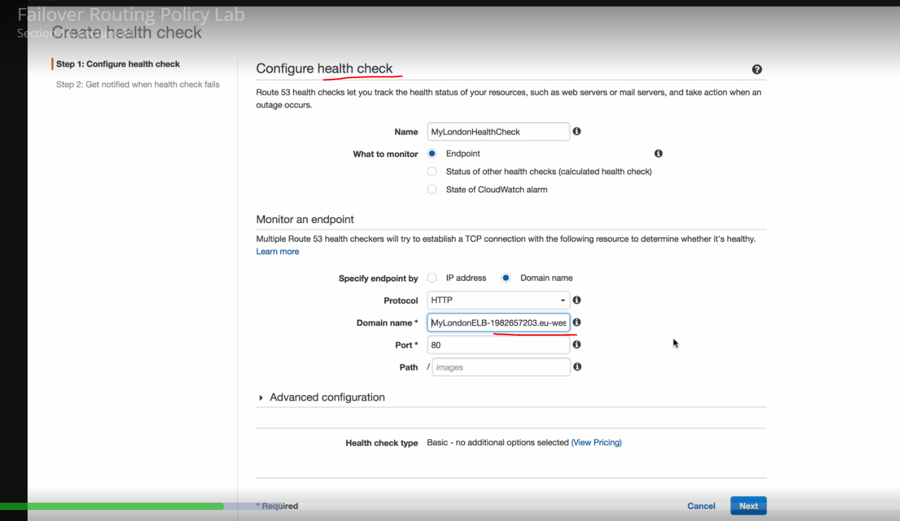

We get the DOMAIN name from the Elastic load balancer

Creating the health check for an EC2 instances.

If the elastic load balances for the EC2 instances go down, our health check is going to fail.

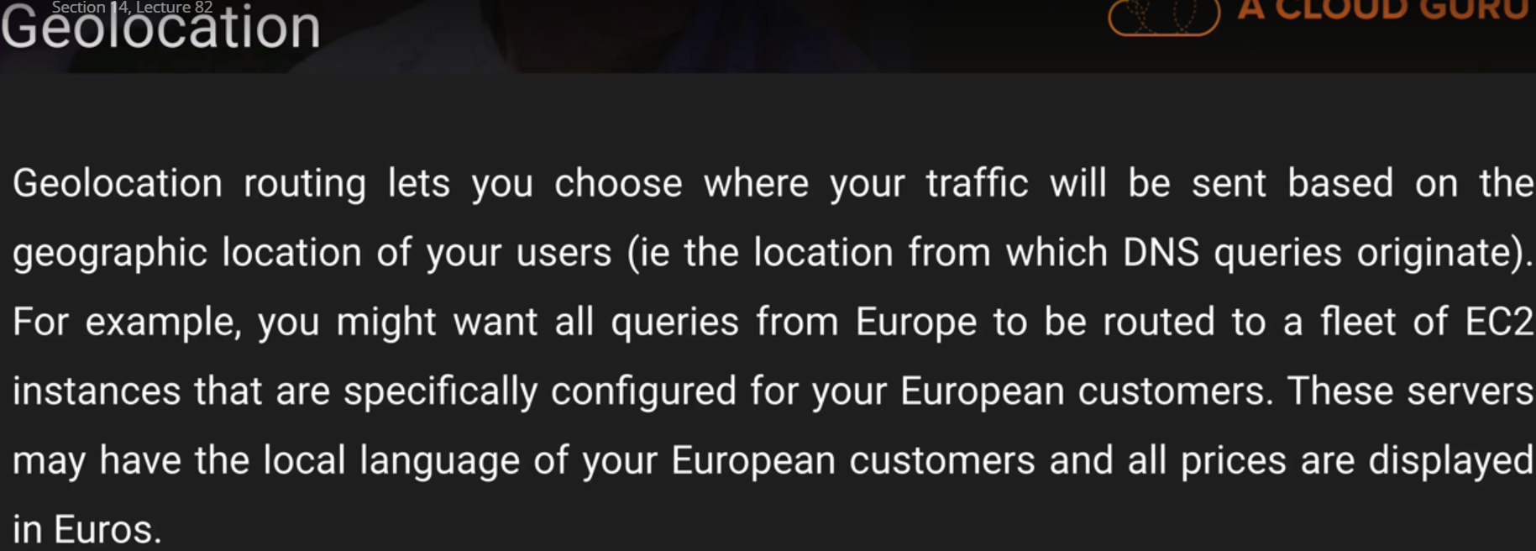

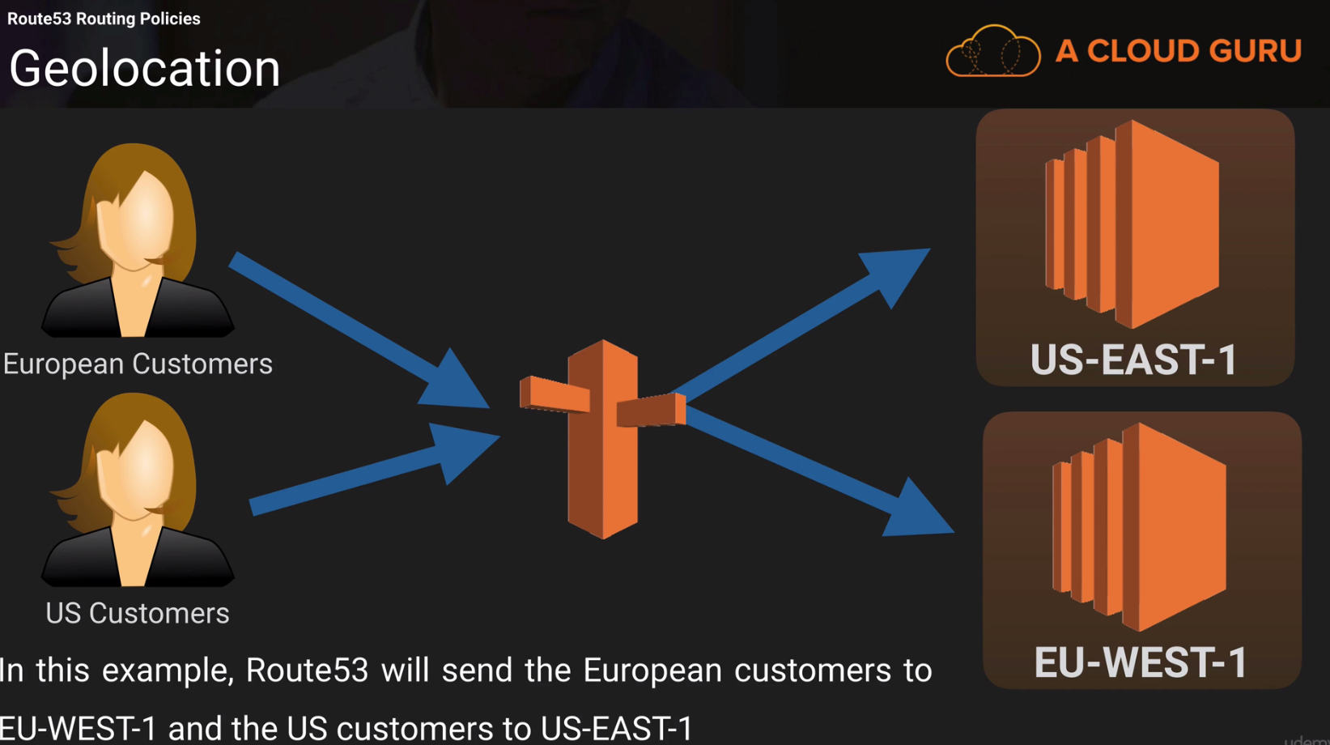

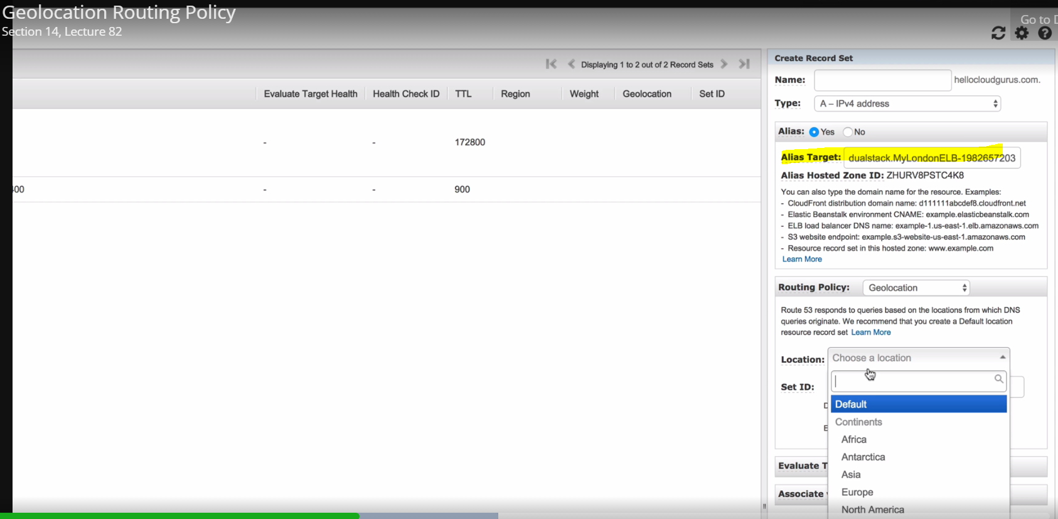

Alias target 🡪 ELB. You need to pass the

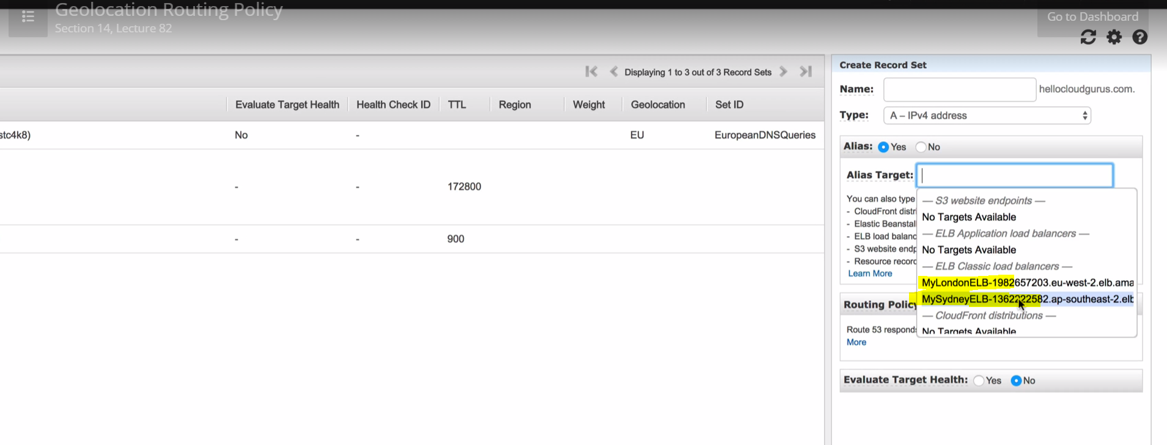

MySydneyELB-144541315.ap-southeast-2.elb.amazonaws.com (A Record) 🡪 This is just the DNS name of the Elastic load balancer.

Definite Exam topic: ELB’s never have IPV4 addresses, it just have the DNS names.

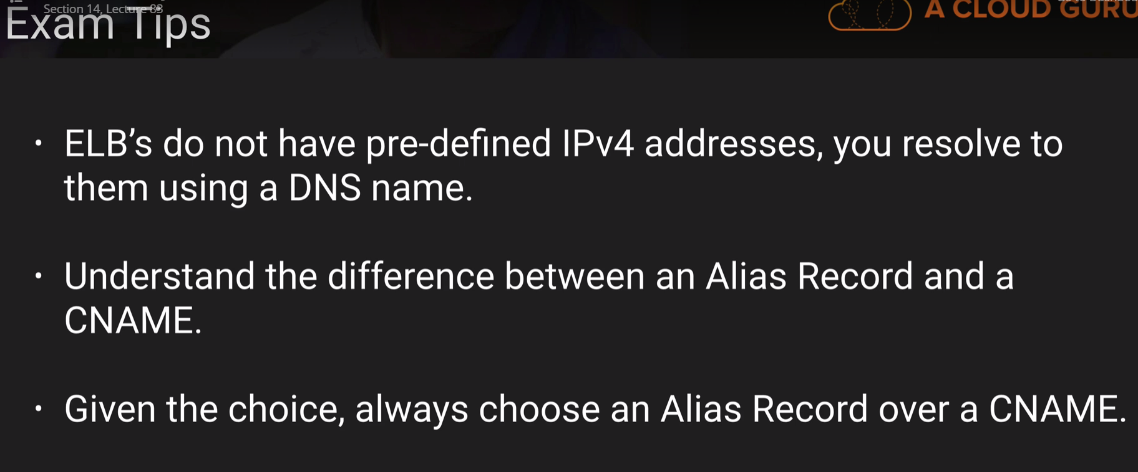

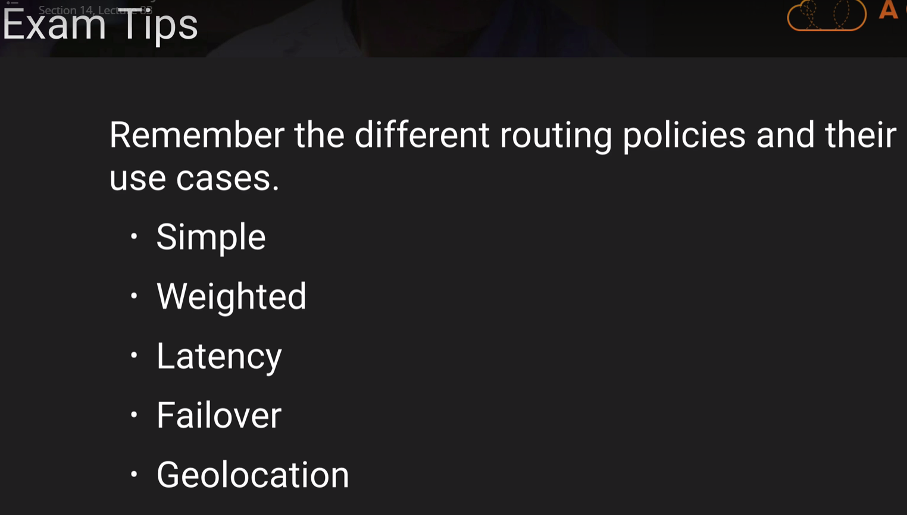

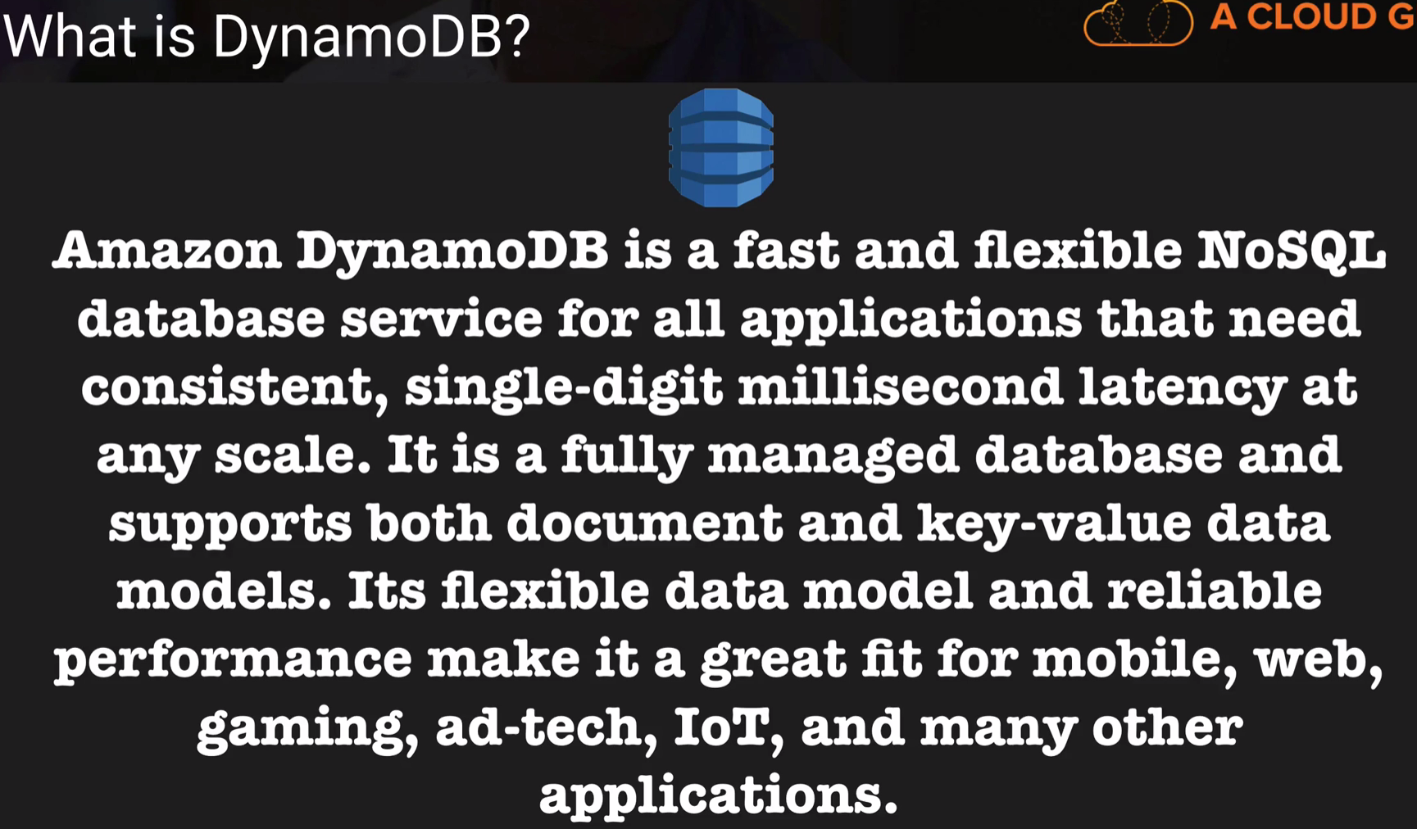

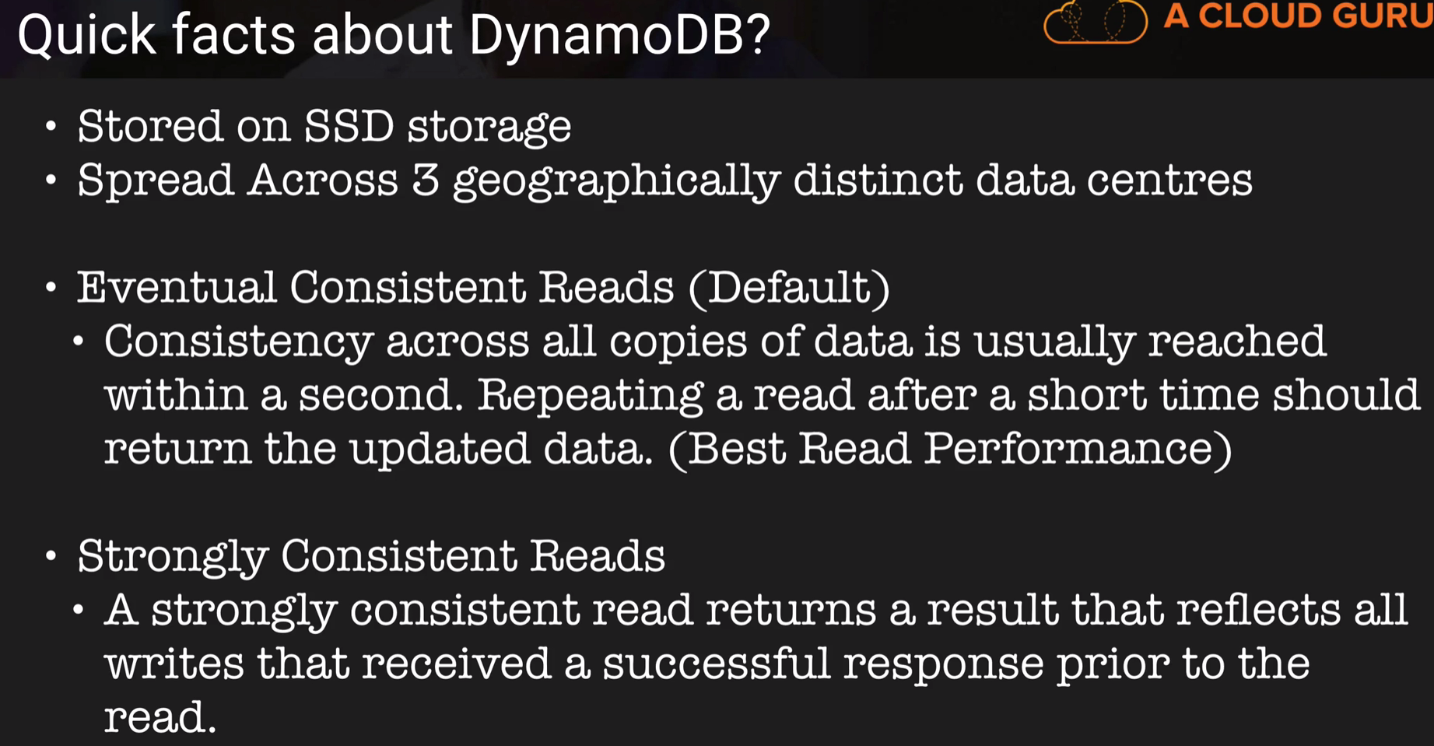

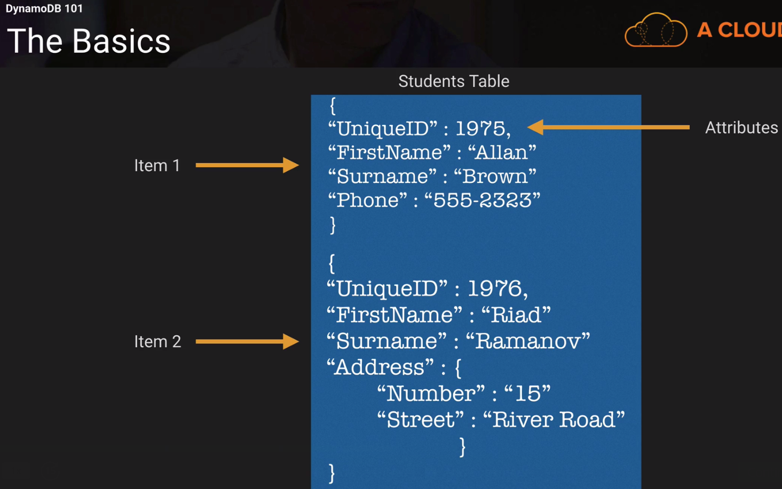

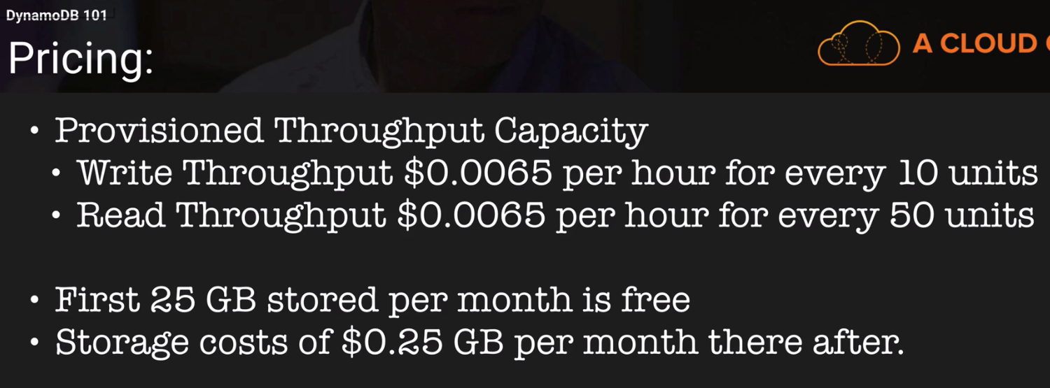

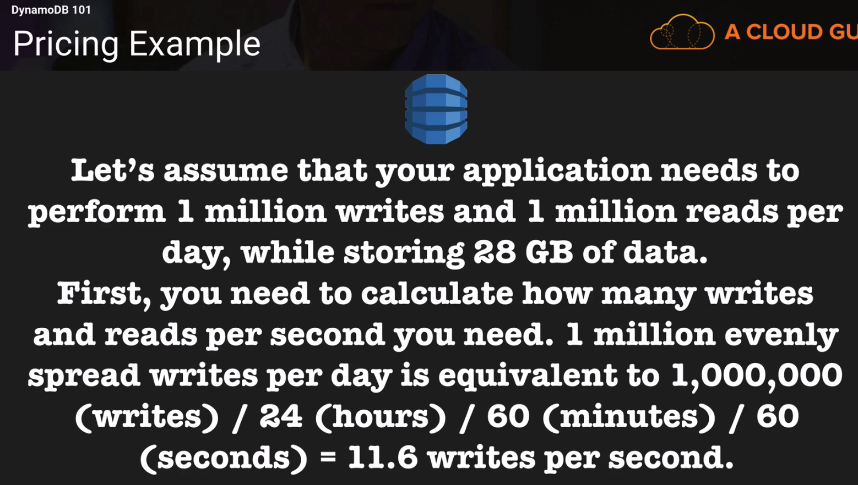

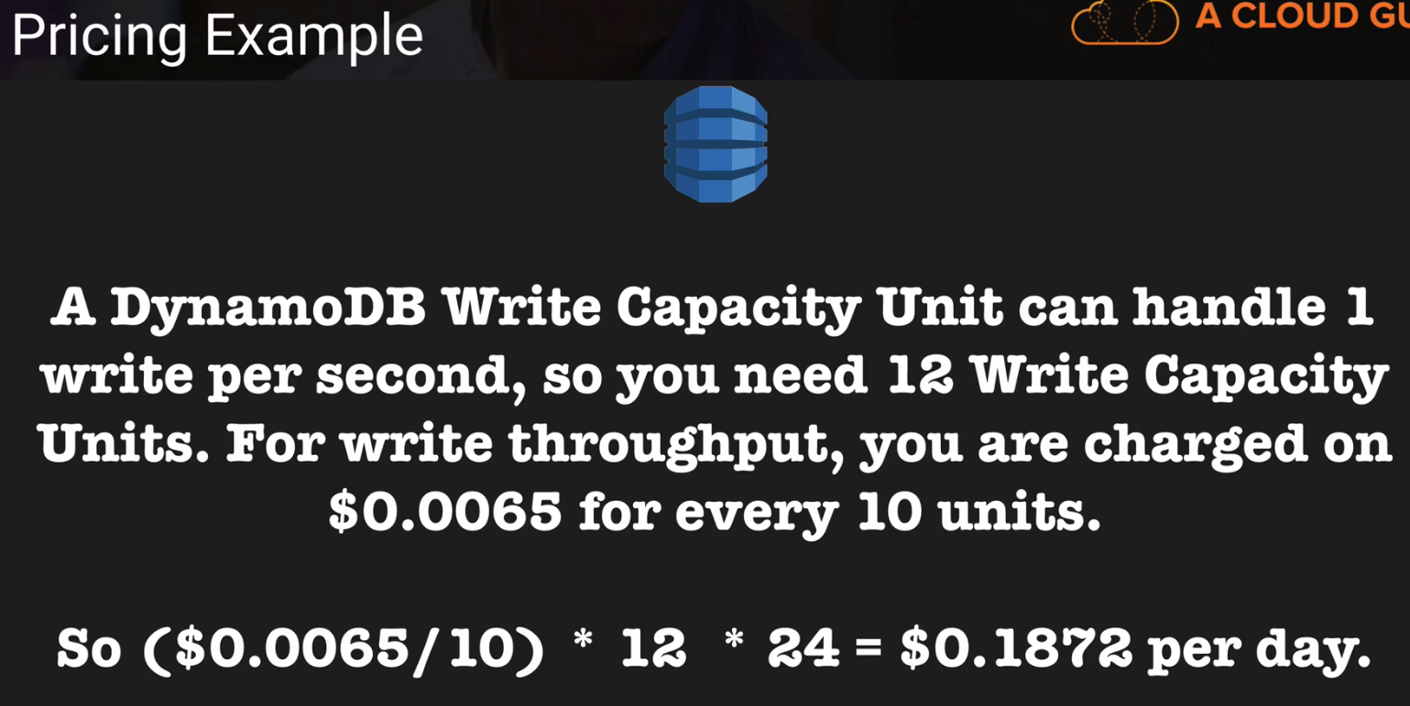

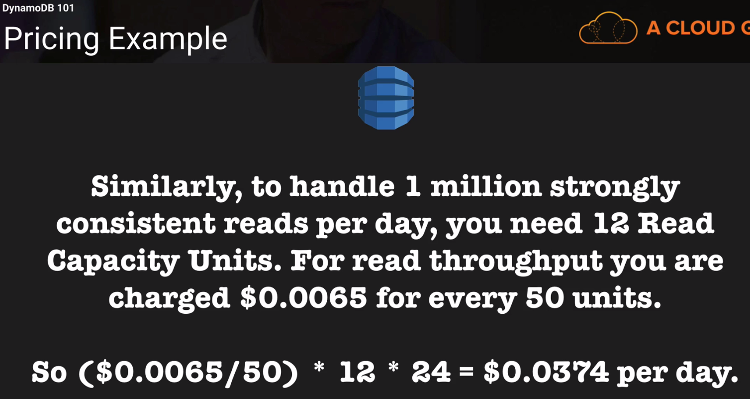

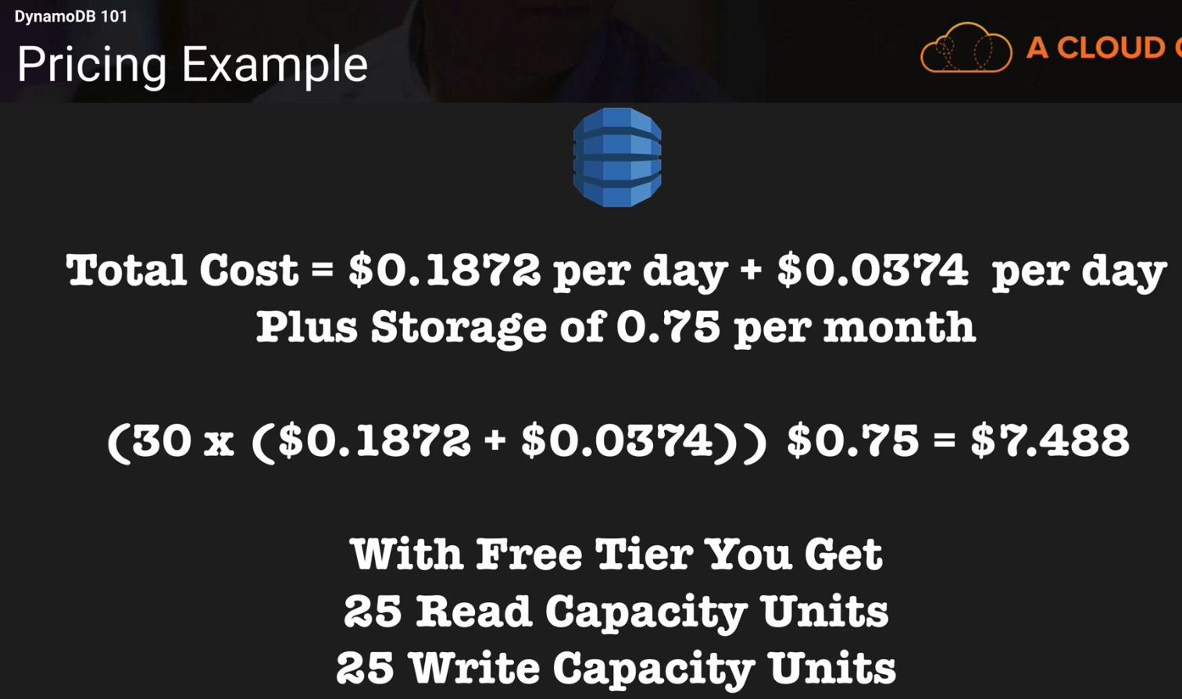

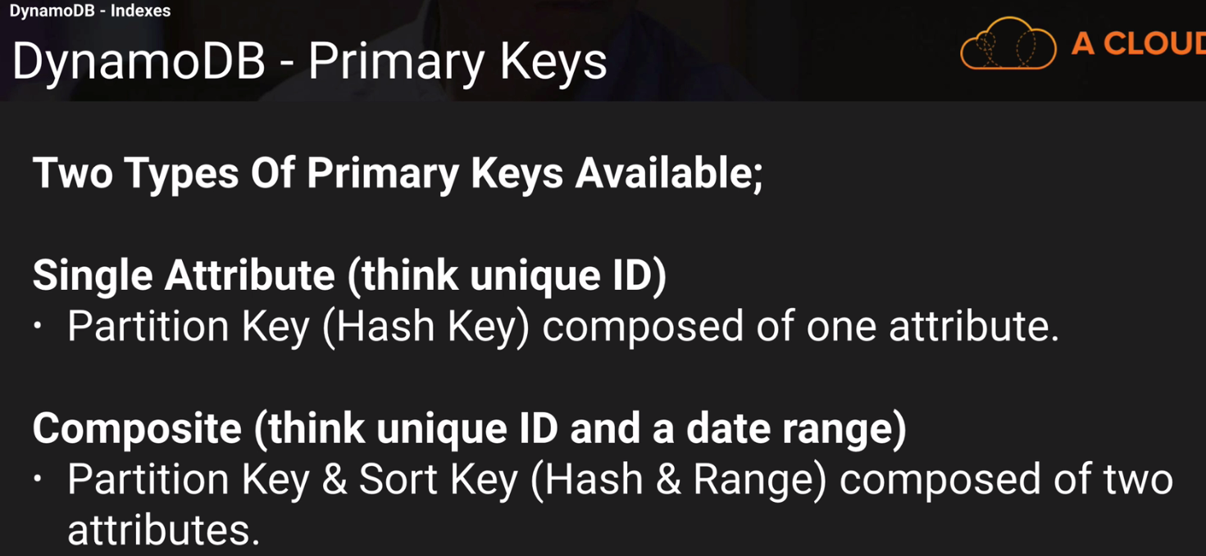

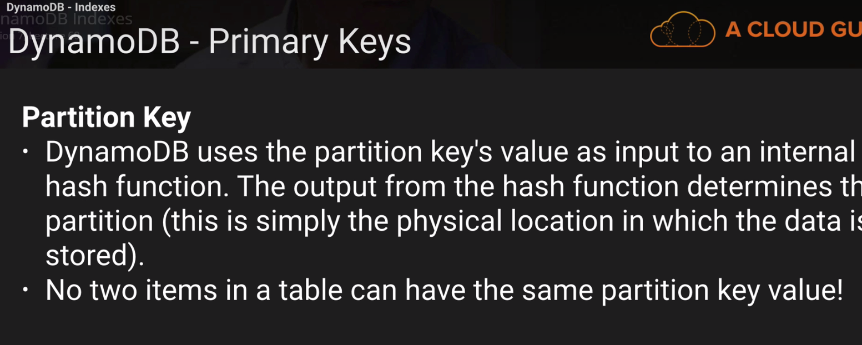

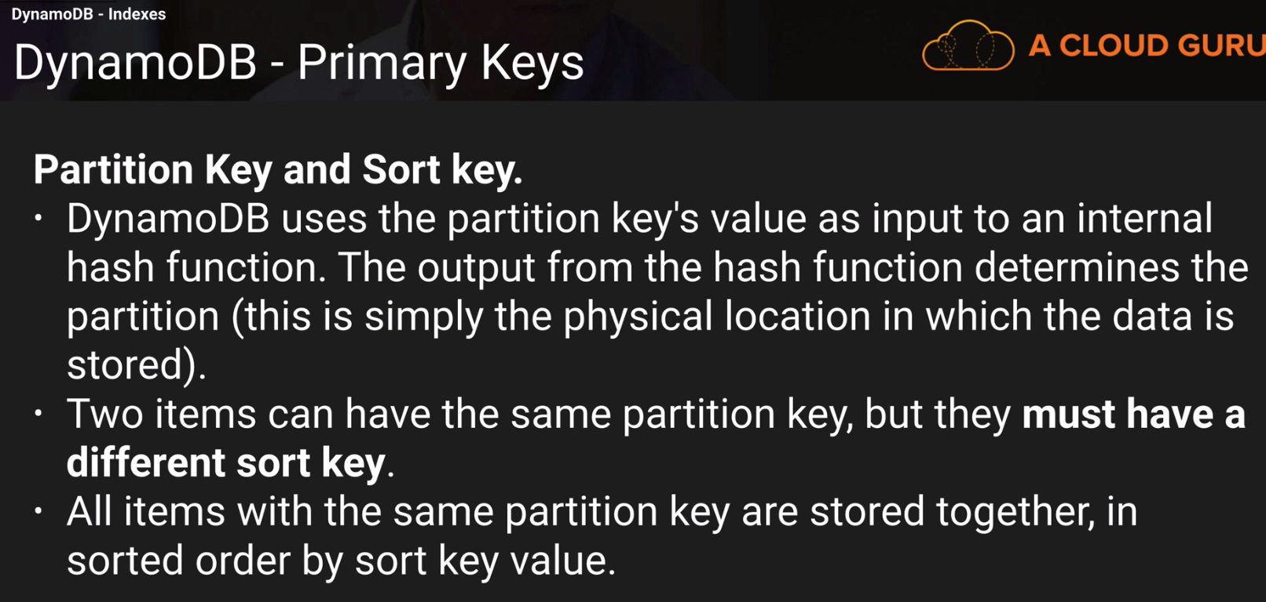

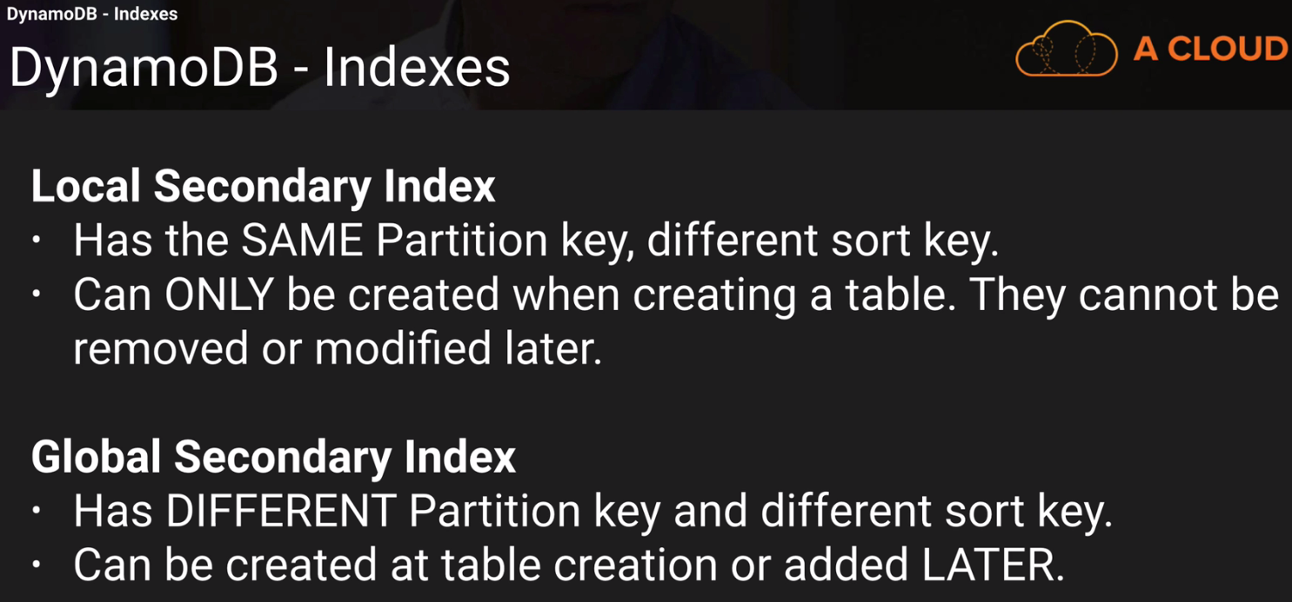

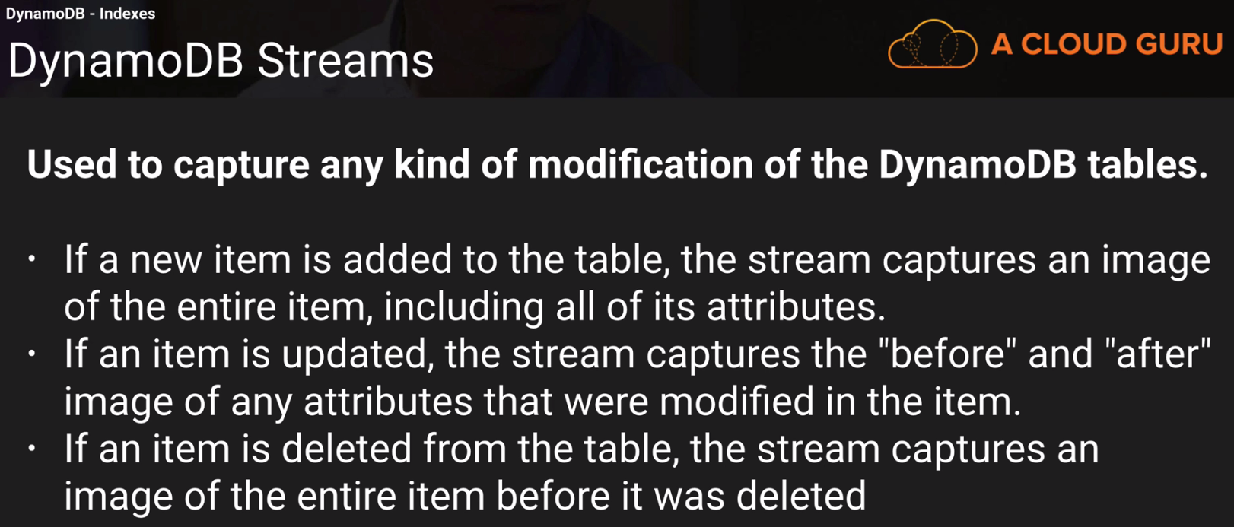

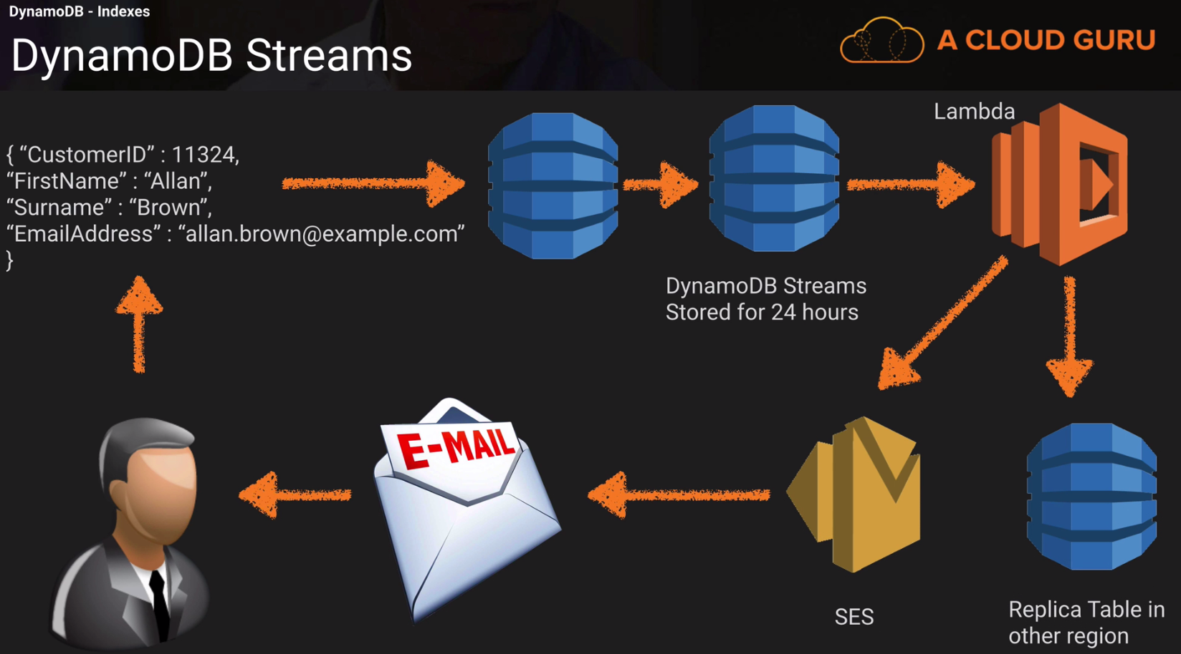

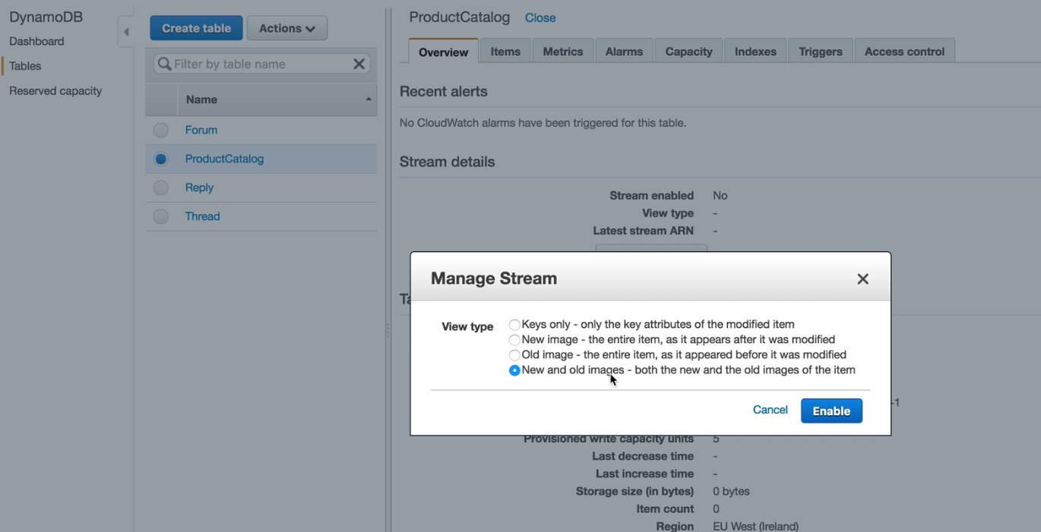

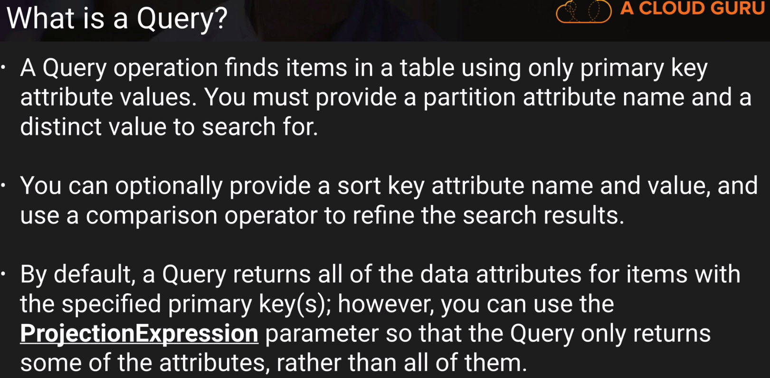

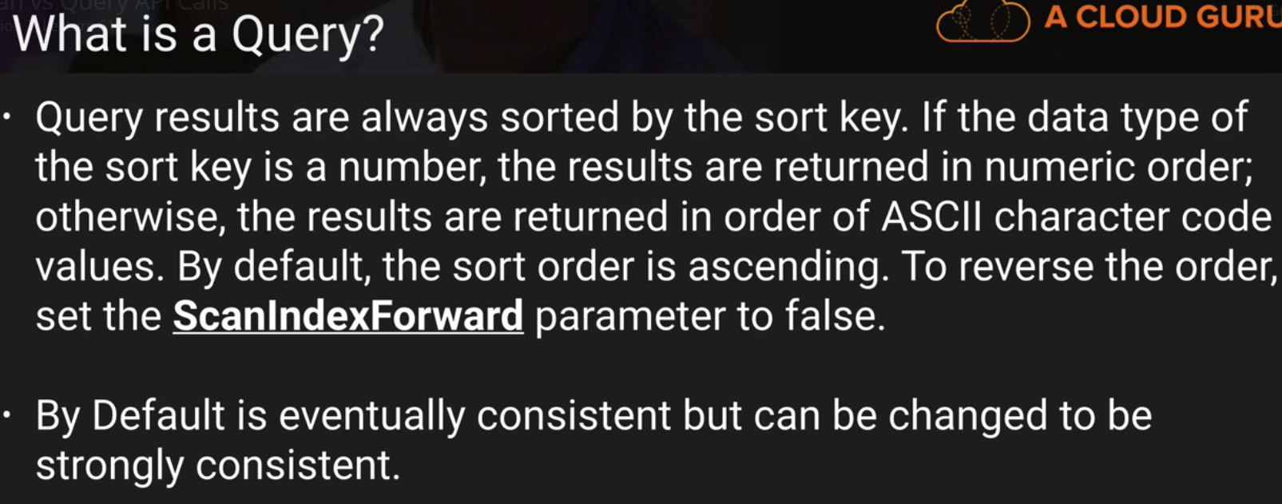

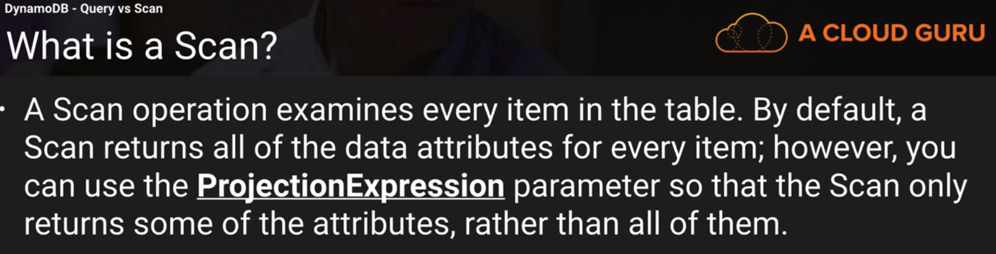

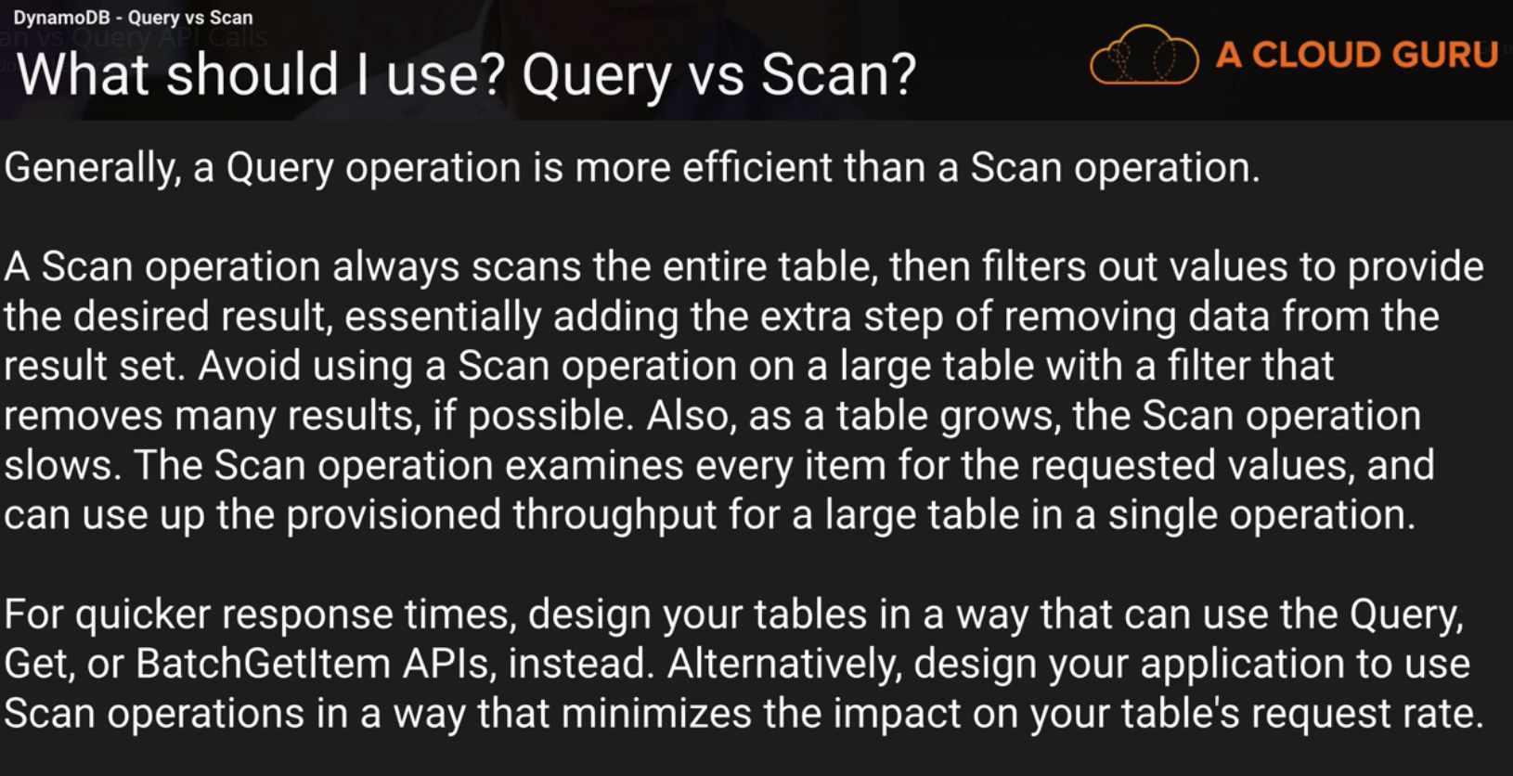

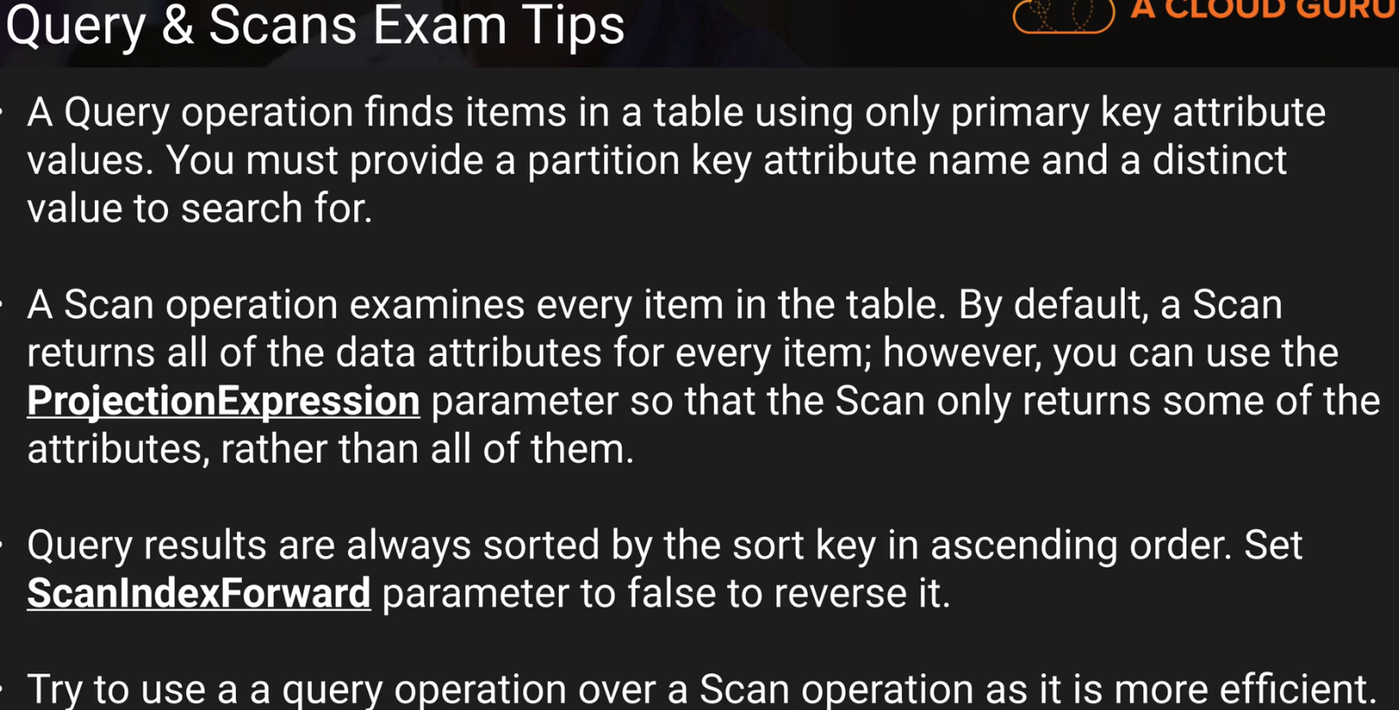

Query vs scan

Projection scan for limiting number of attributes.

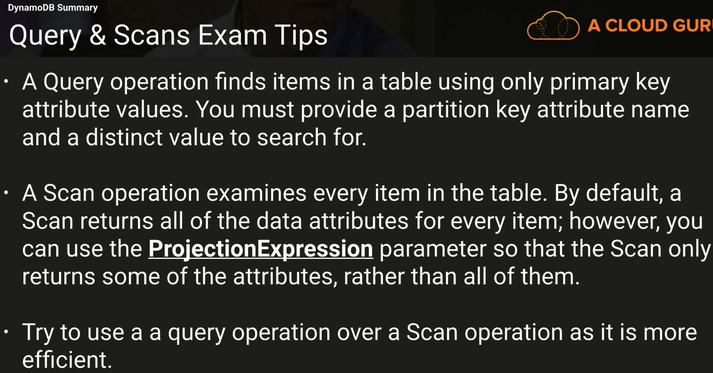

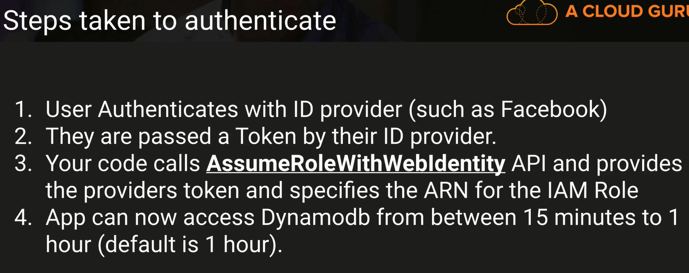

DynamoDB provisioned throughput calculation 🡪 This we can expect in the exam.

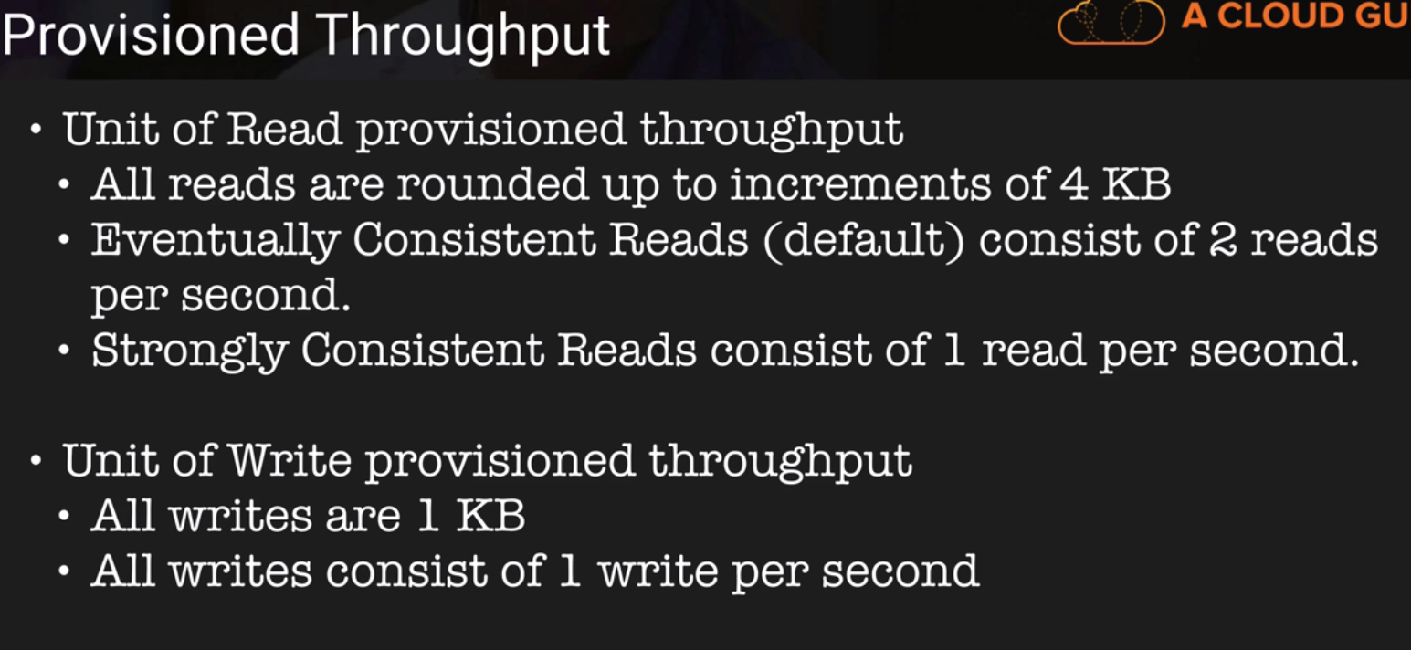

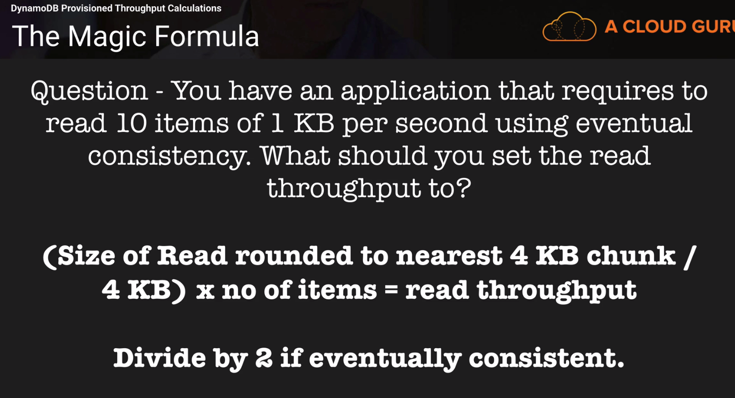

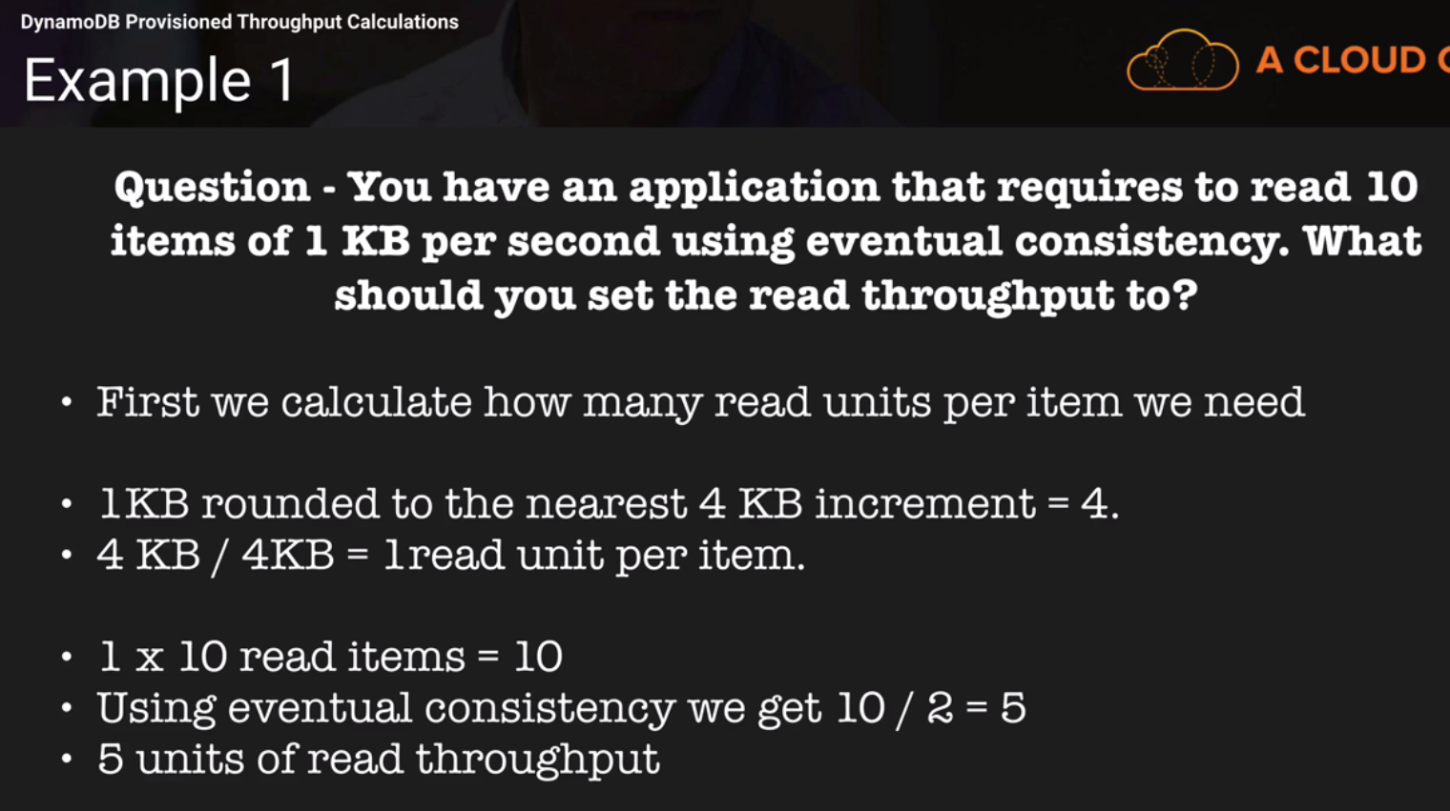

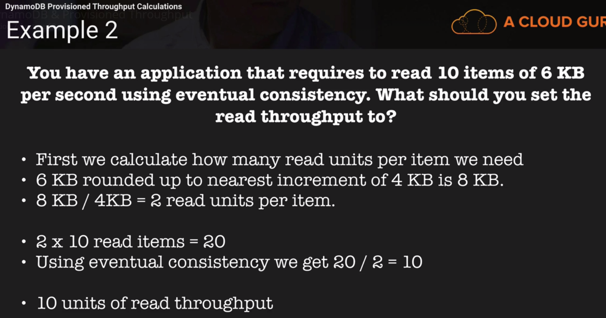

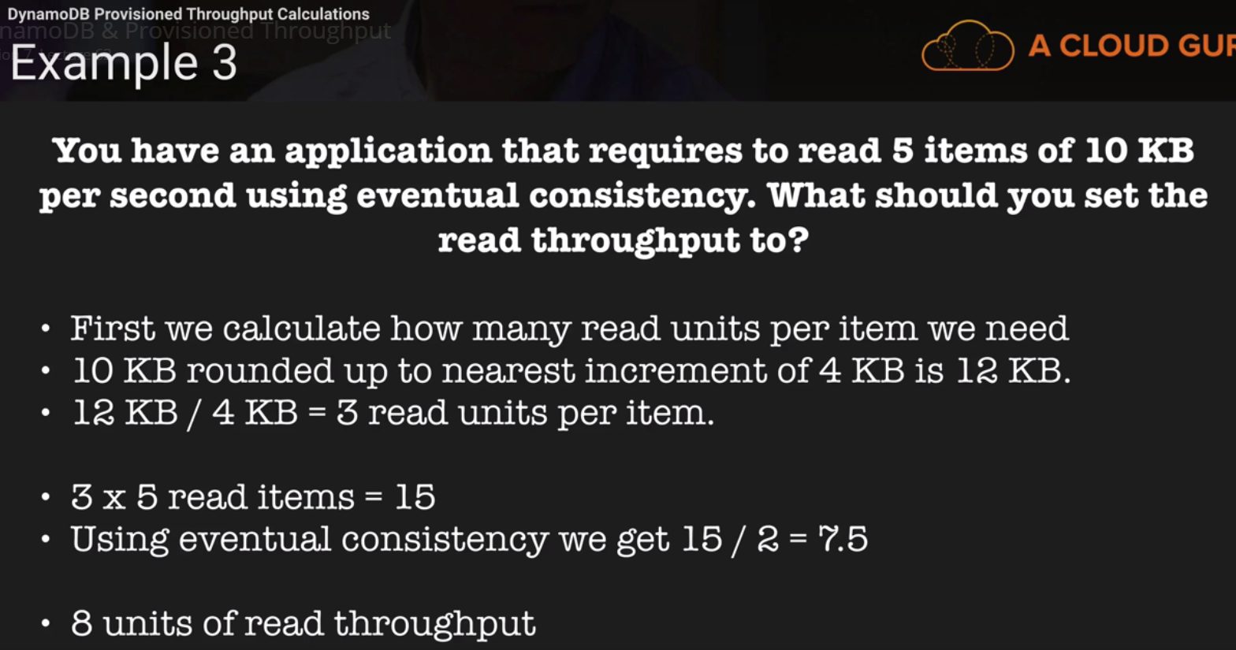

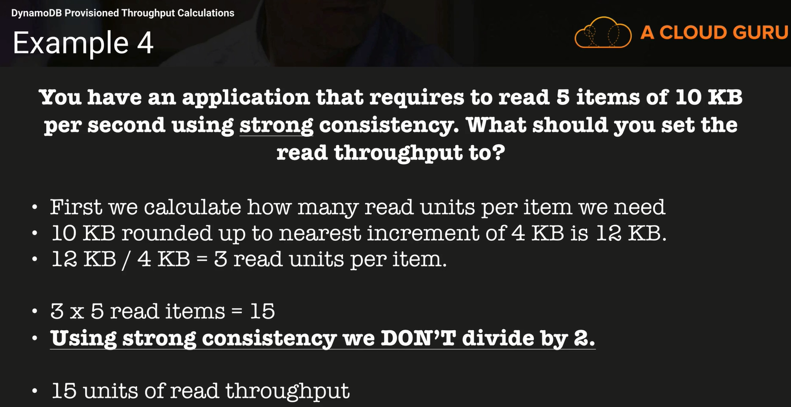

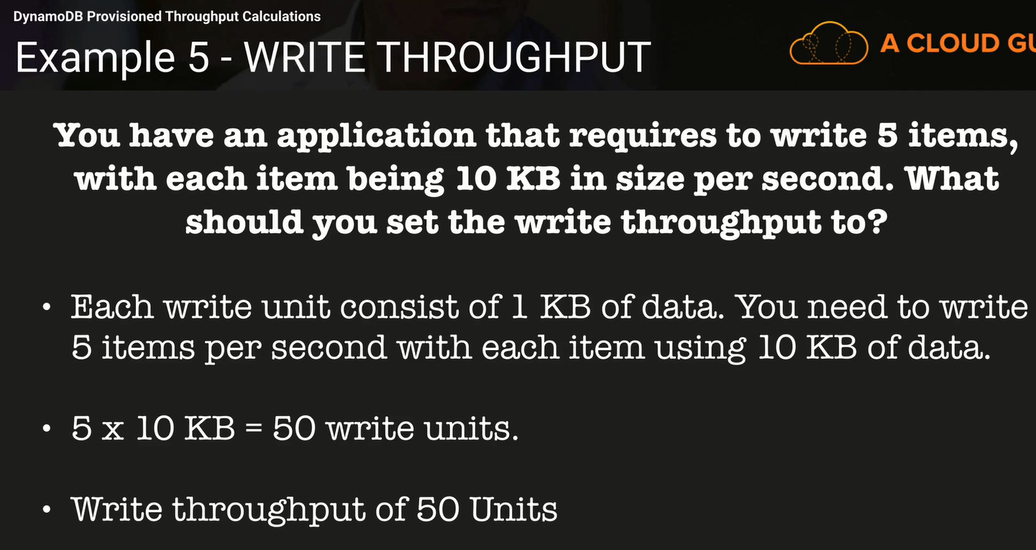

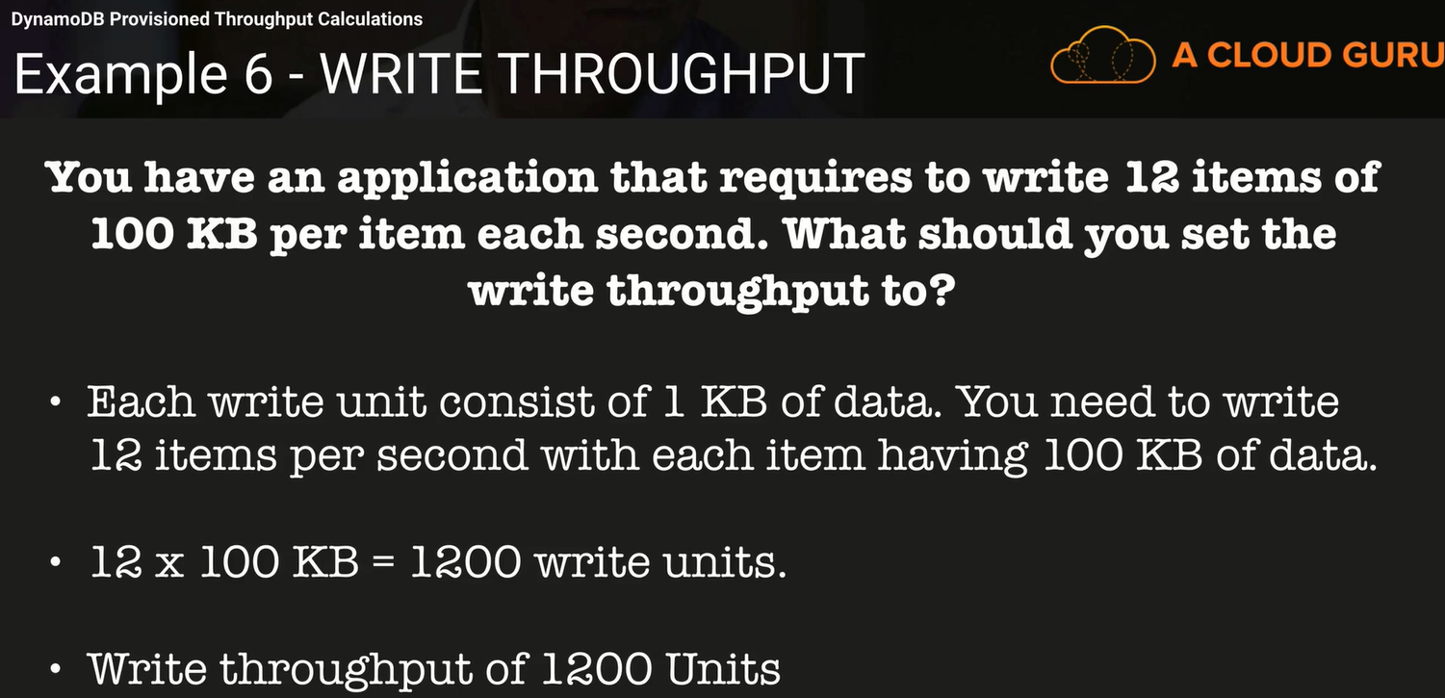

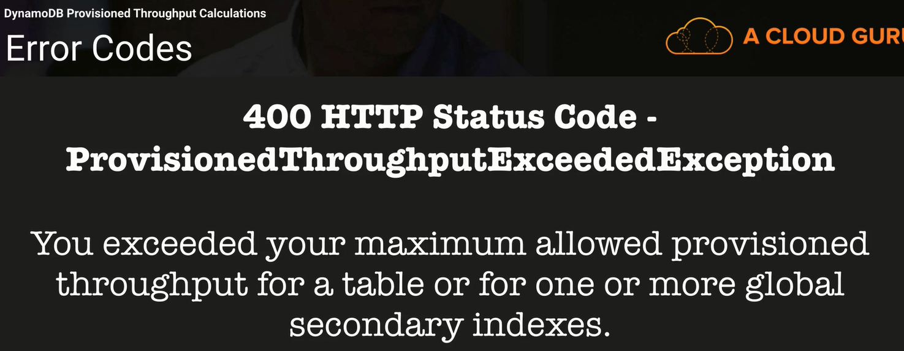

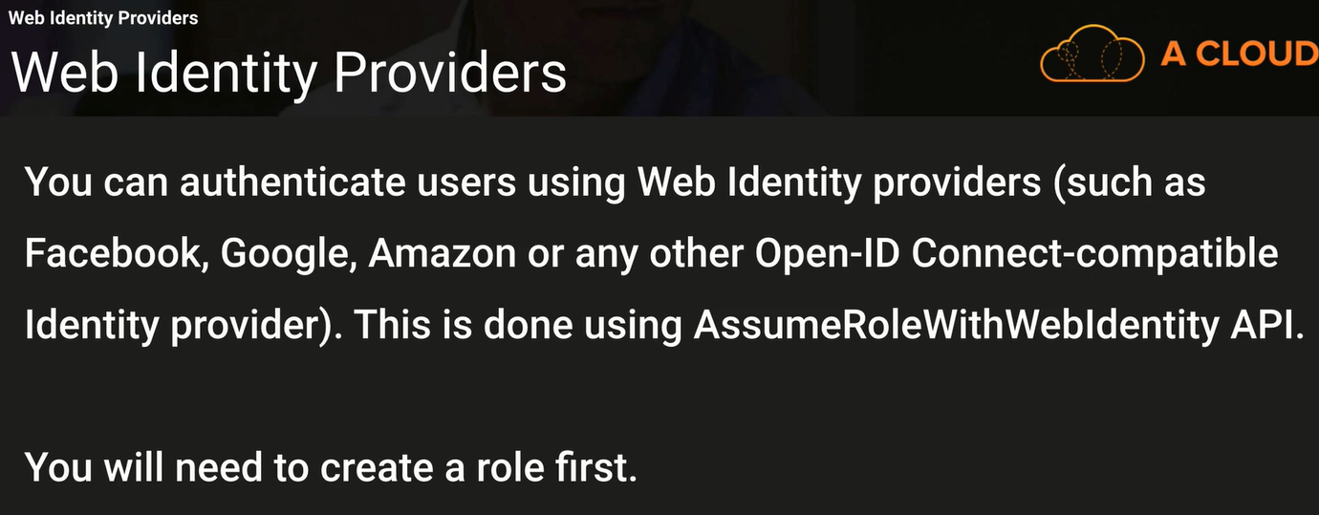

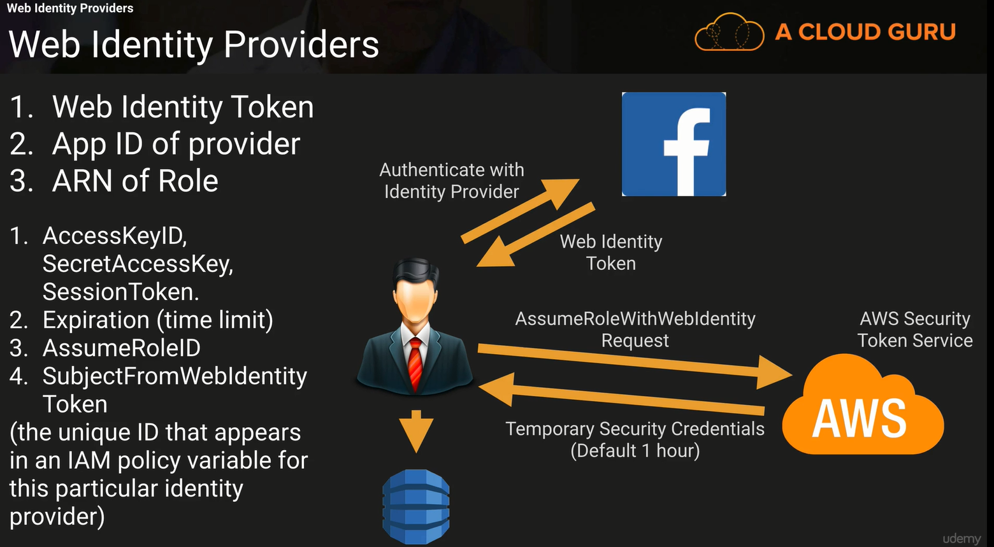

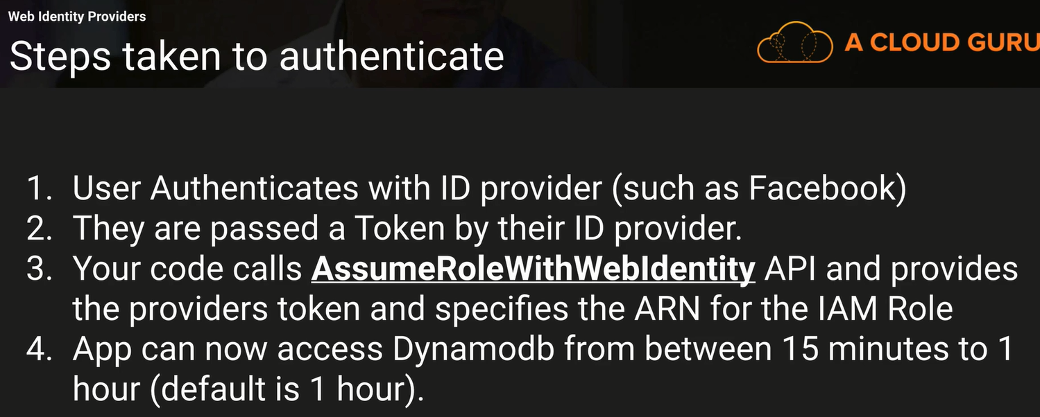

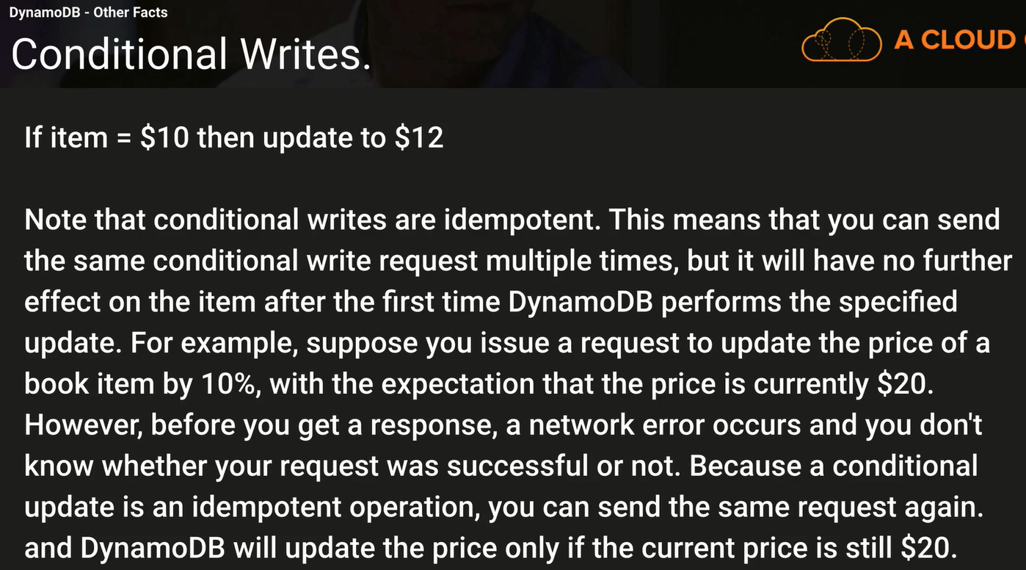

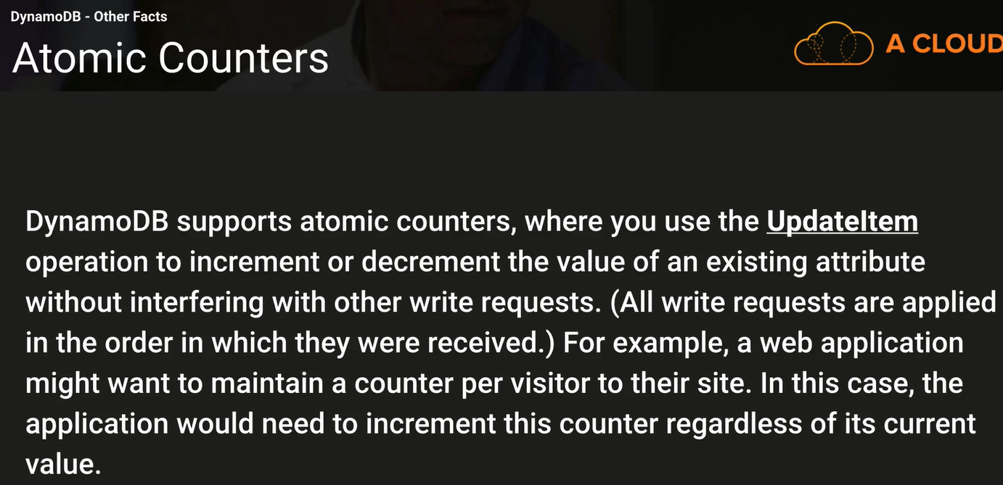

Atomic counters vs conditional parameters.

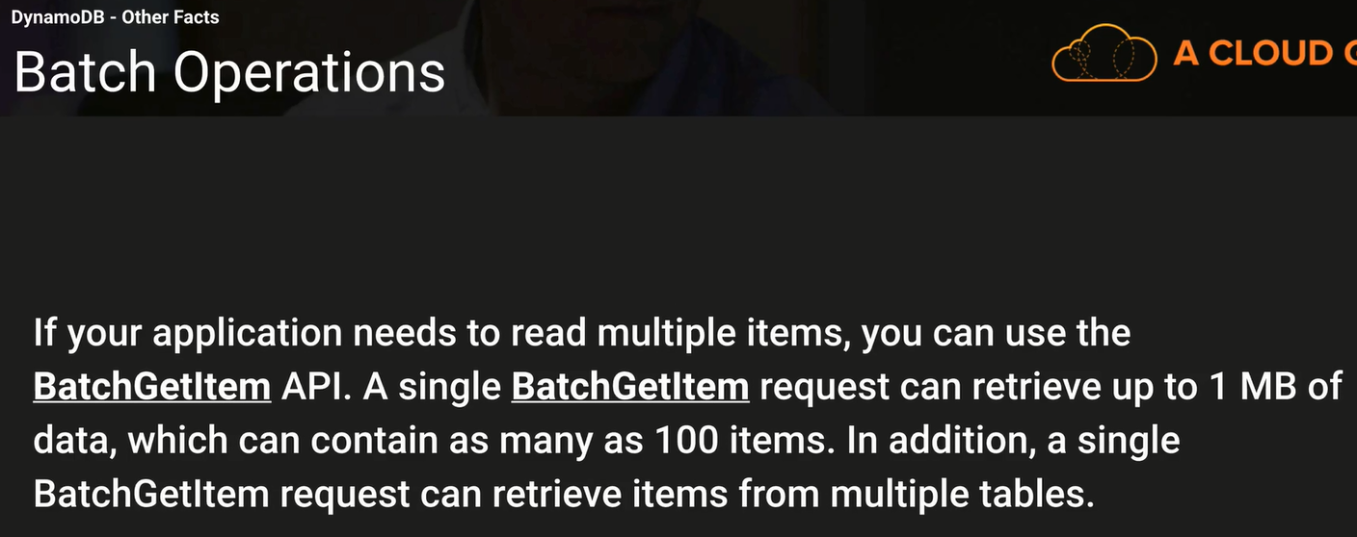

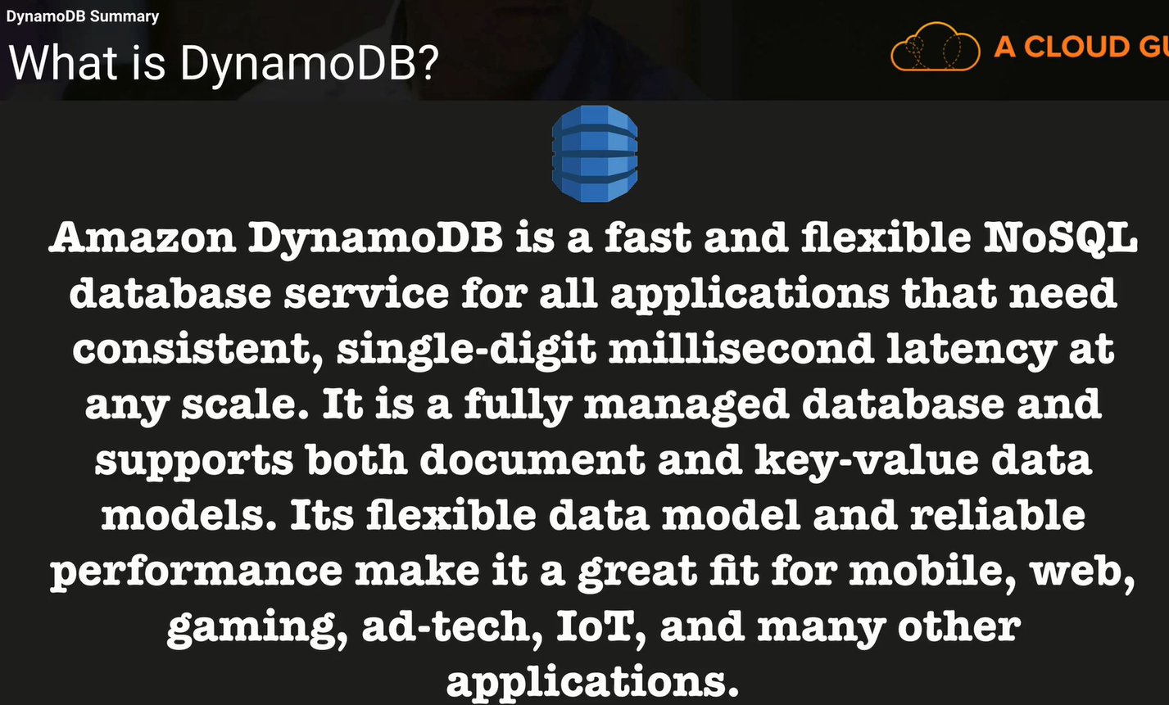

You cannot SSH to DynamoDB. It’s a service provided.

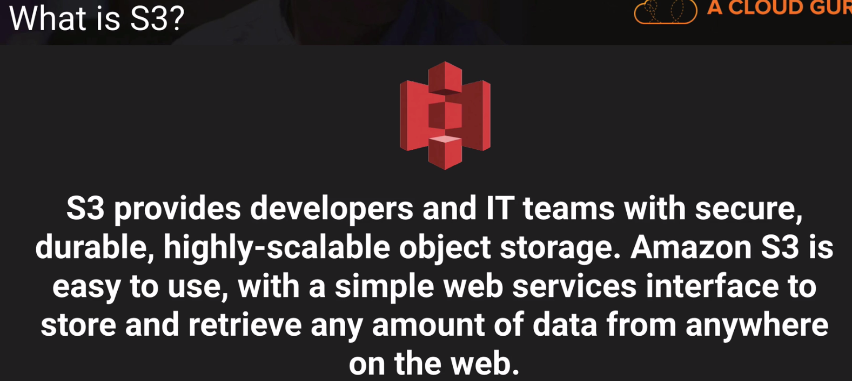

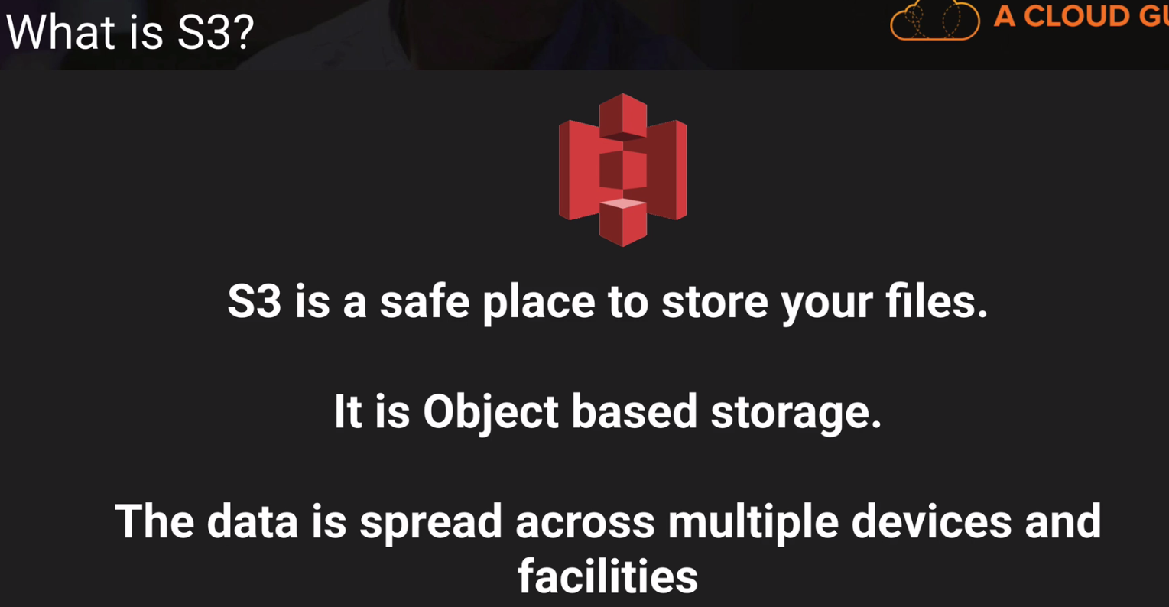

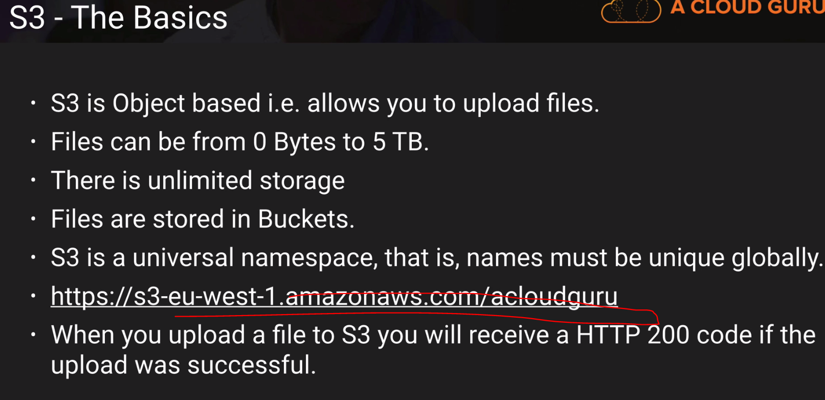

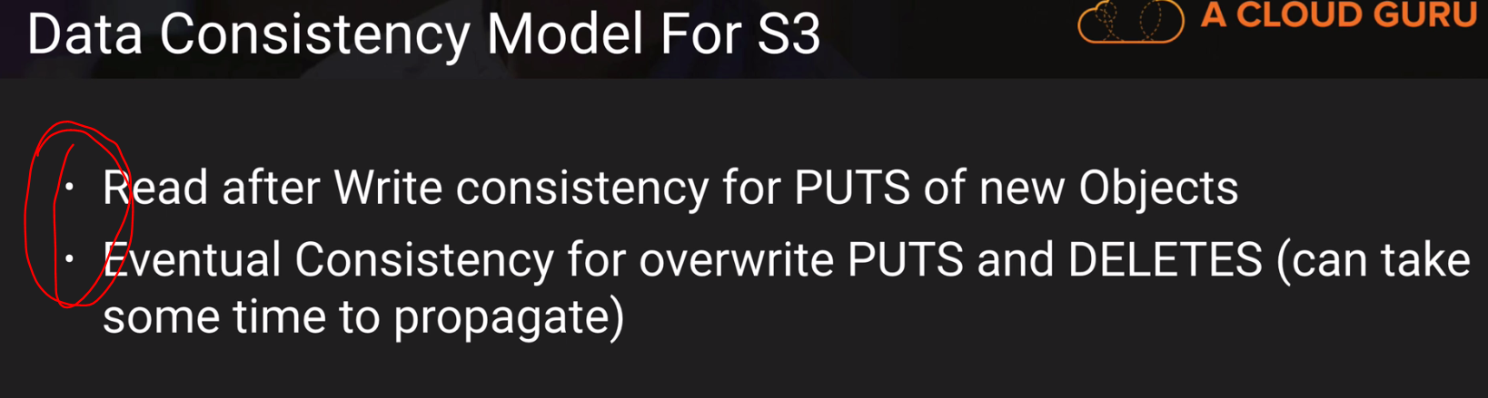

These two are important exam topics.

You need to see the video again to understand better.

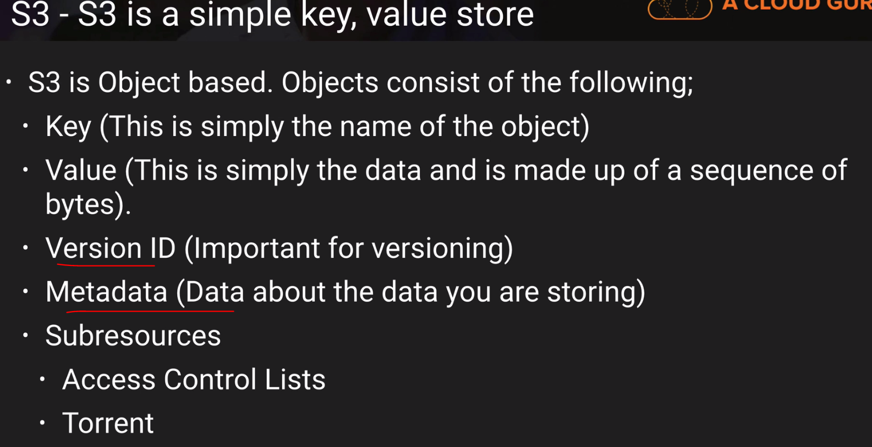

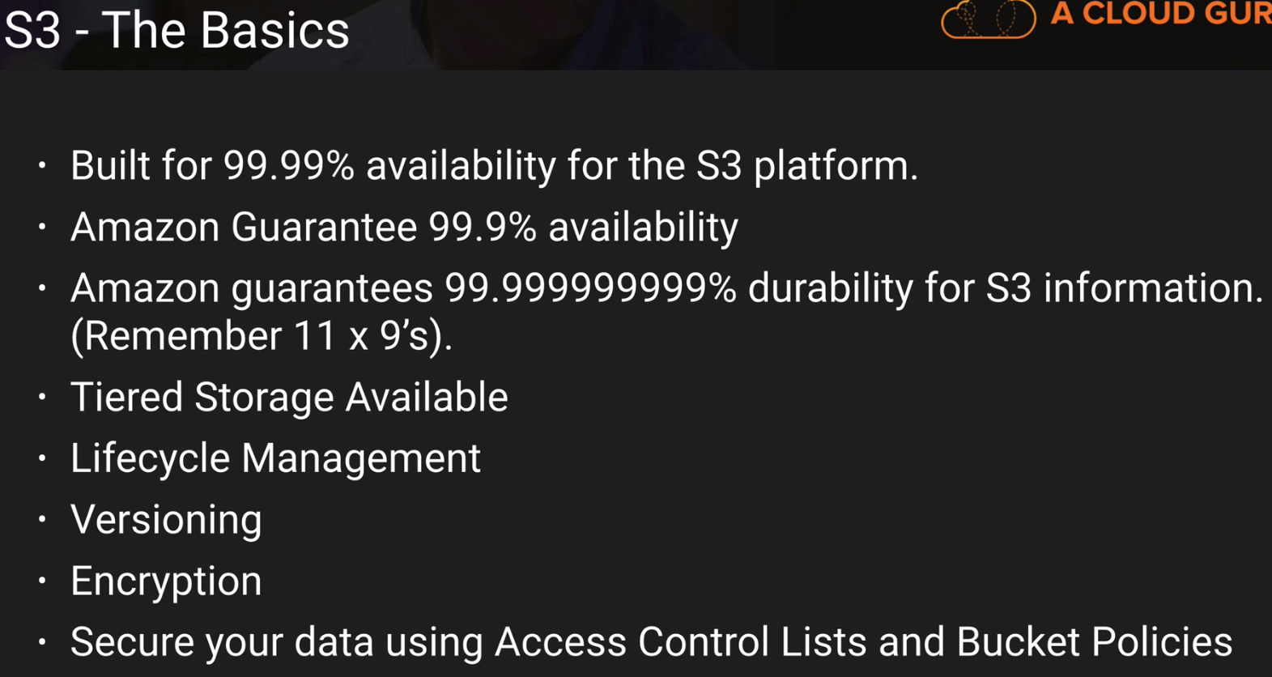

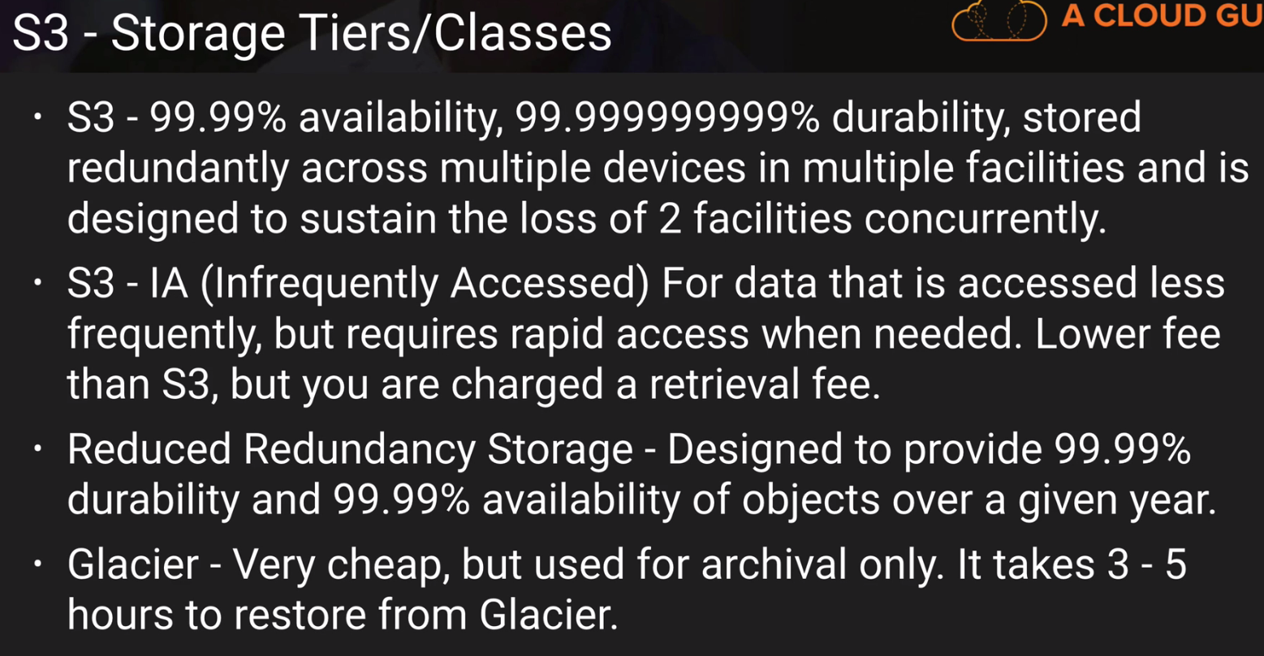

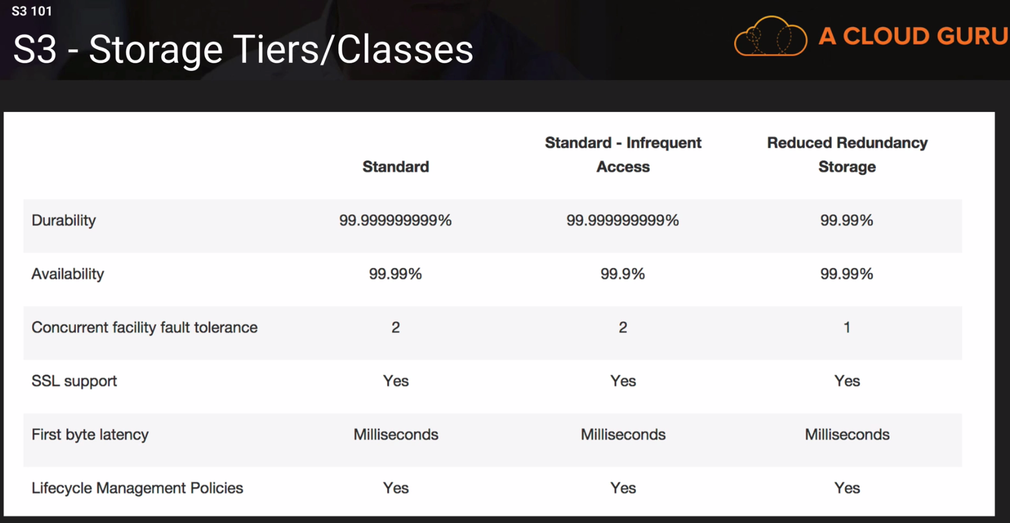

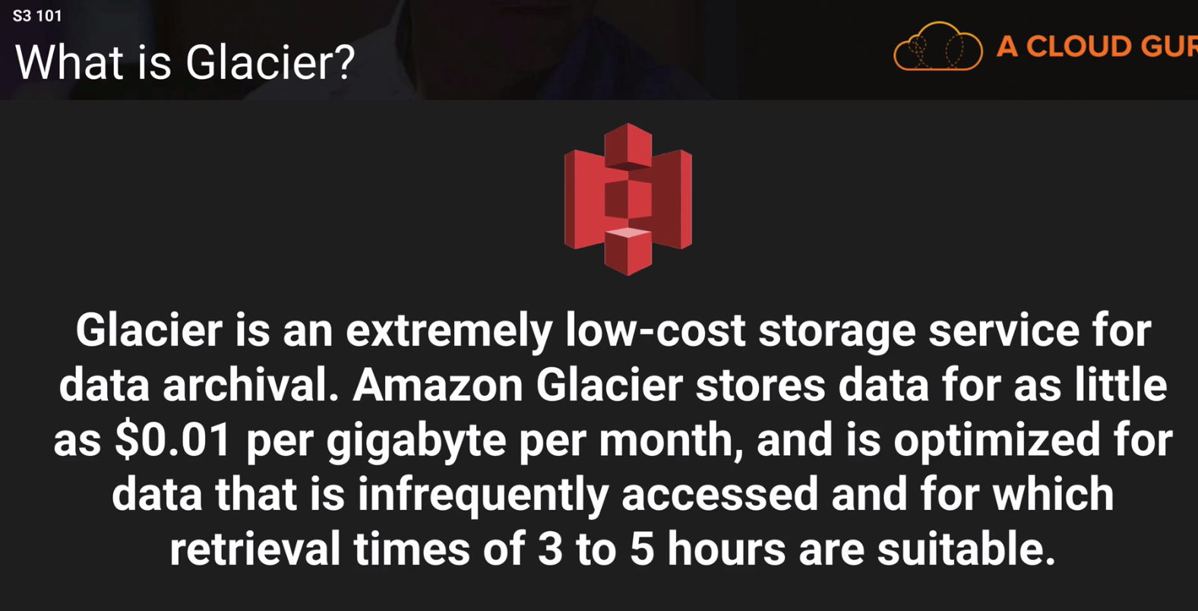

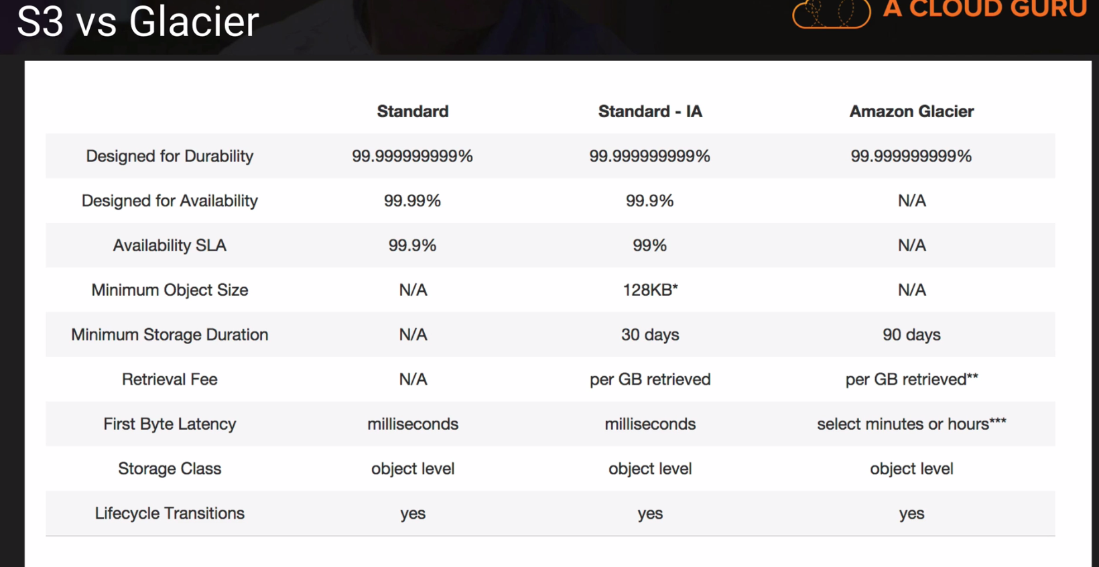

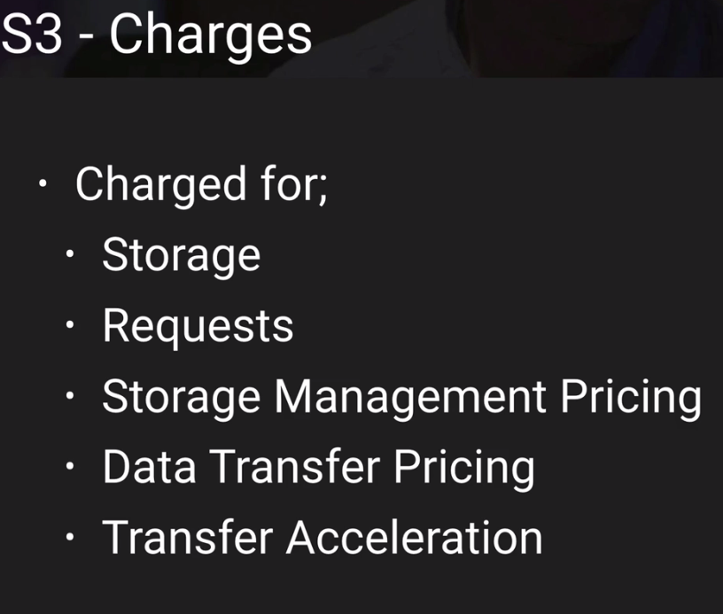

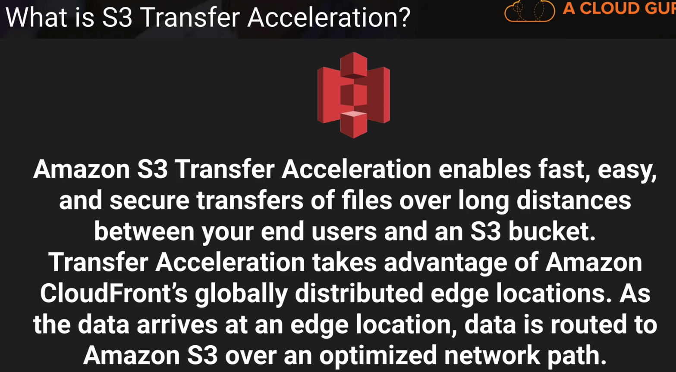

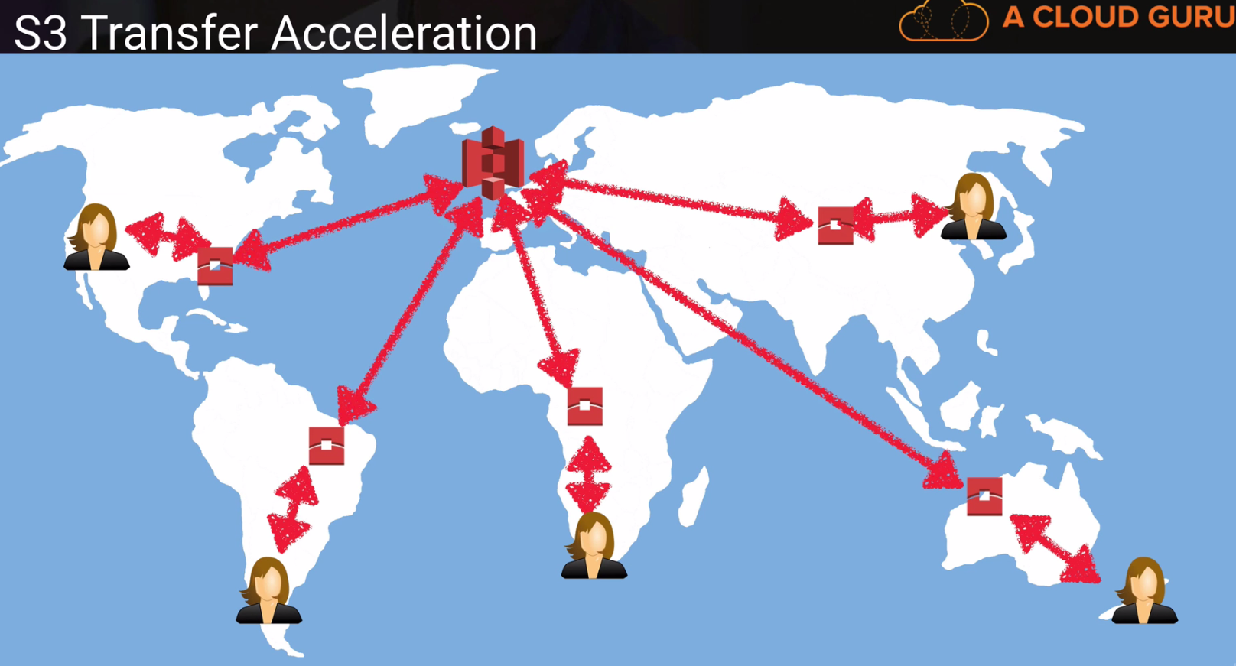

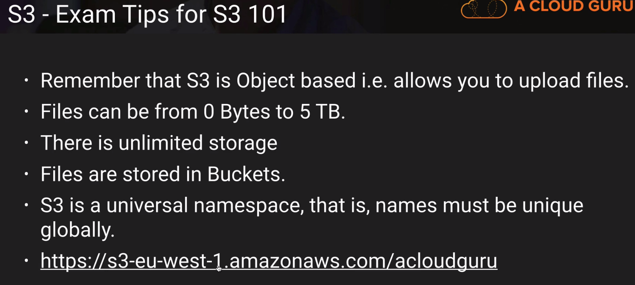

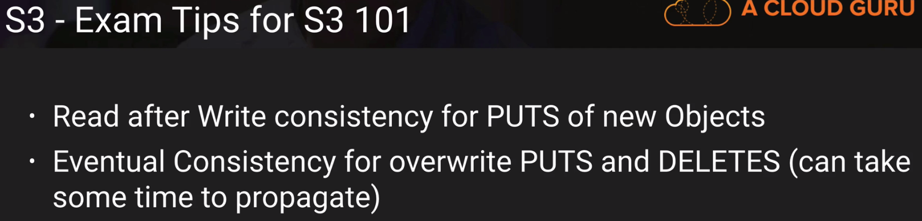

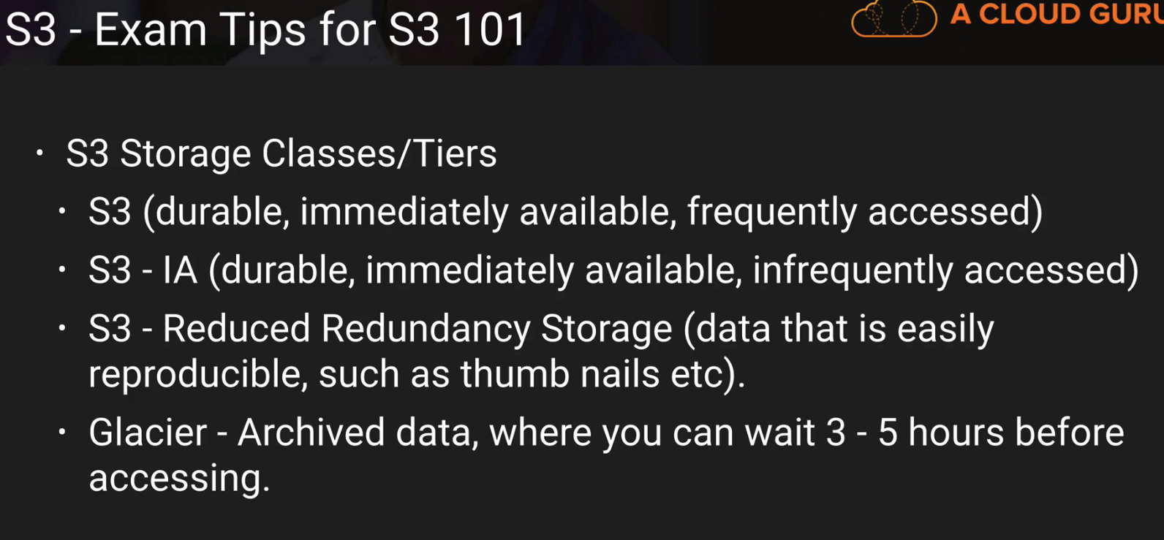

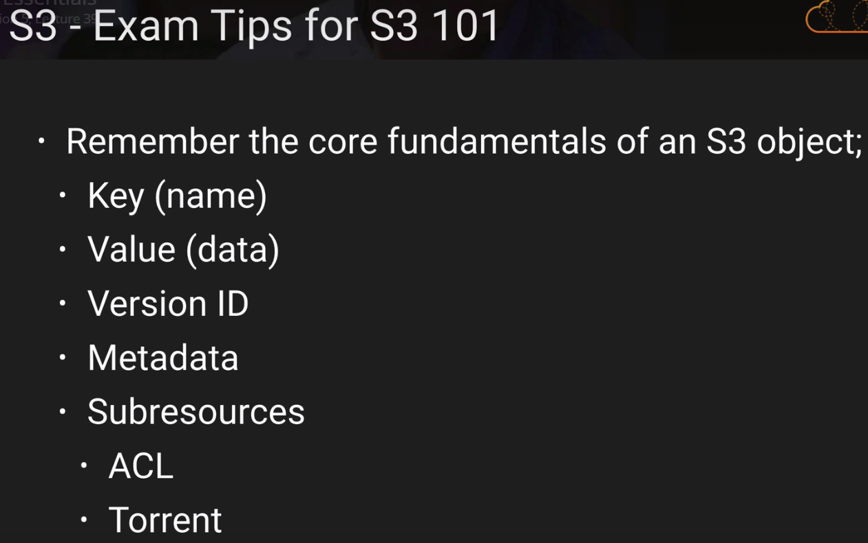

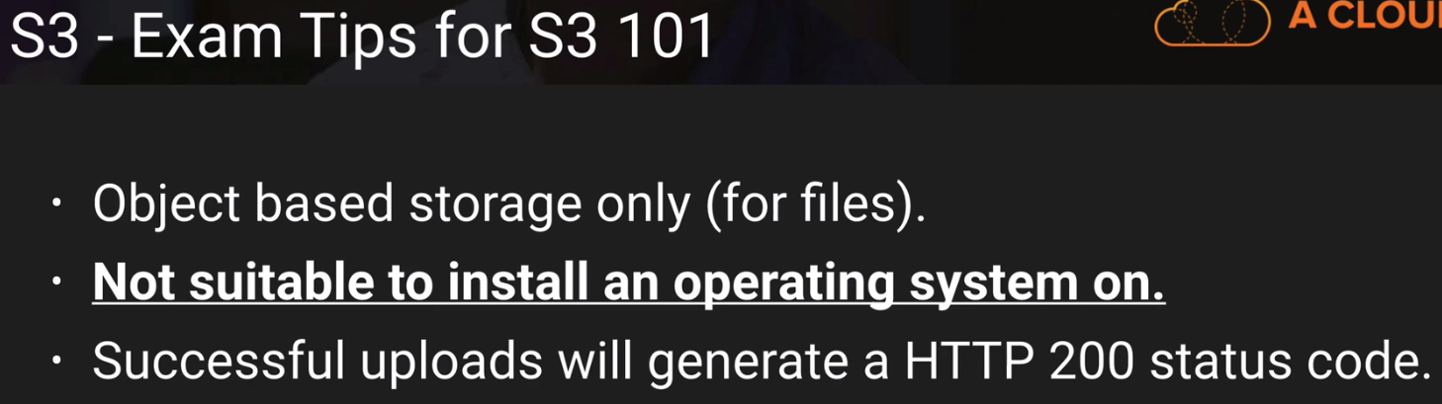

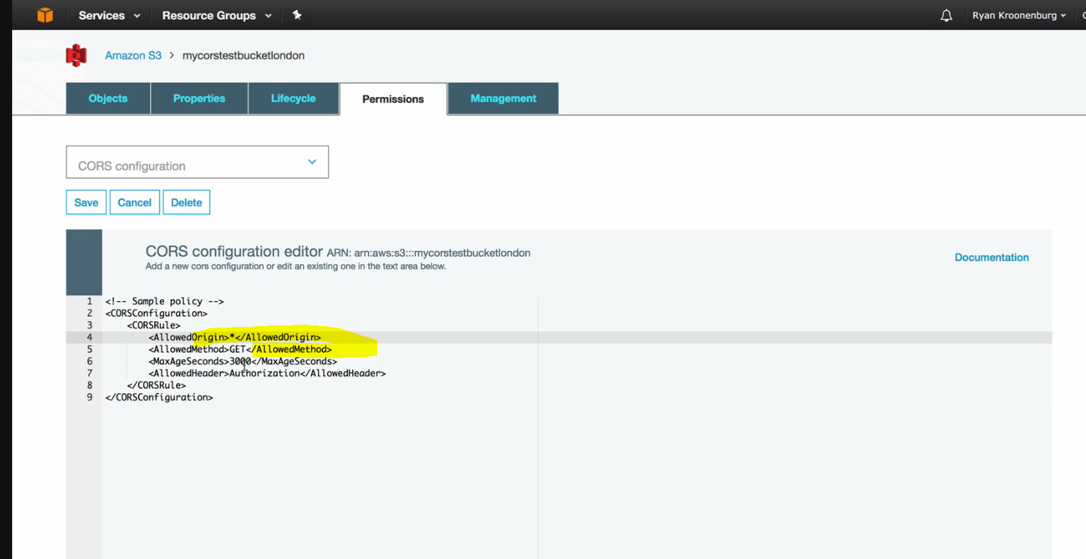

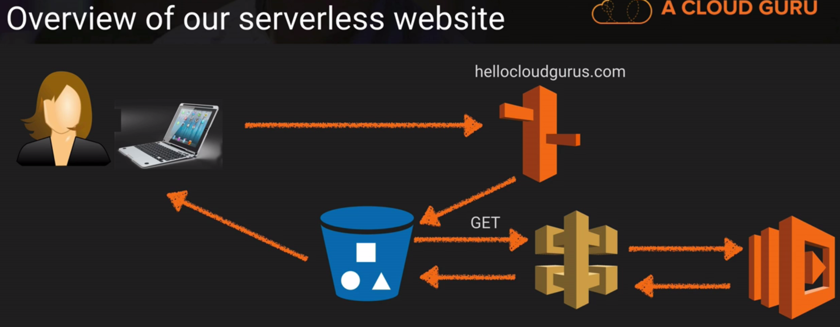

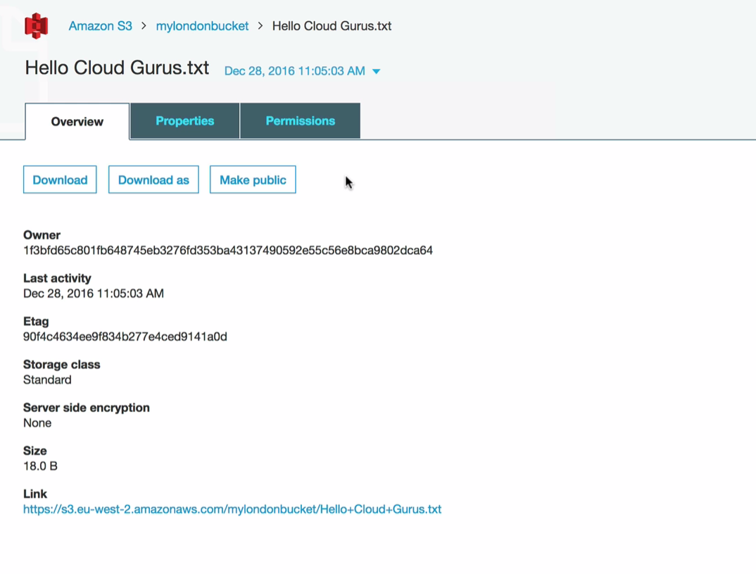

S3 Versioning is turned on. You have to be careful when working with the larger files. Without proper **life cycle management policies**, like there should be some kind of process for deleting or archiving the older data.

Storage Size 🡪 Sum of all the files in that S3 bucket.

Once u delete the file it will be placed as a delete marker, and it wont be showing the console. If you want to restore it back, delete the delete marker and you will be able to restore it back.

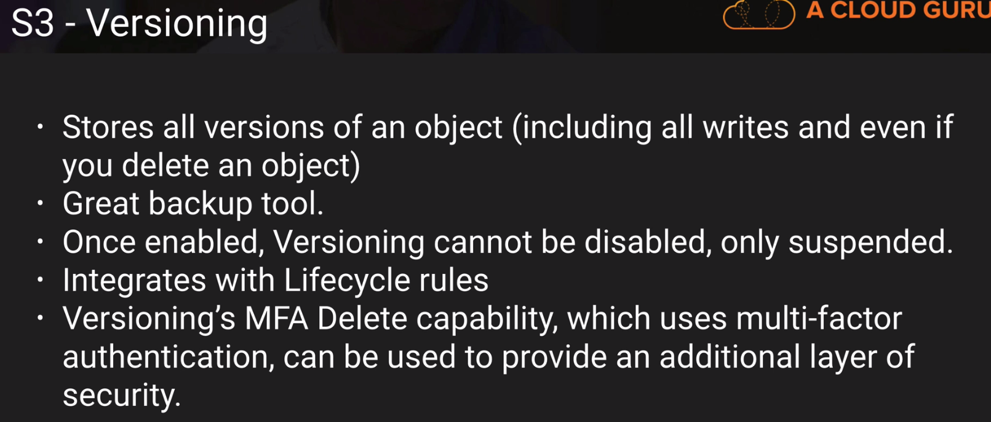

Below 1 is a popular EXAM topic.

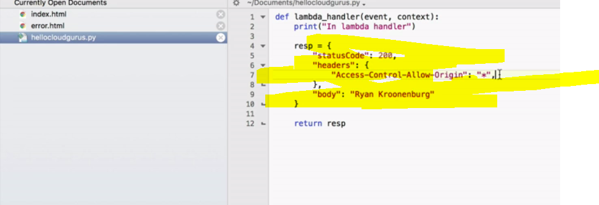

READ S3 FAQ’s before the EXAM:

CORS (1 or 2 Questions)

SLA: Service Level Agreement.

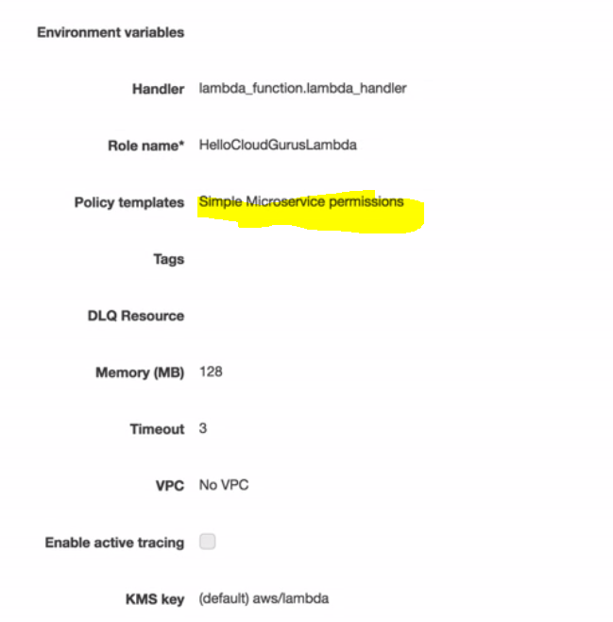

CORS 🡪 We can expect one-two question from that.

CORS 🡪 The concept is to get the content from one bucket and display it in the current website.

So for this we create Three HTML’s

1. Error
2. Index
3. Real Content-WebPage. (LOAD PAGE.HTML)

You have to enable the CORS,

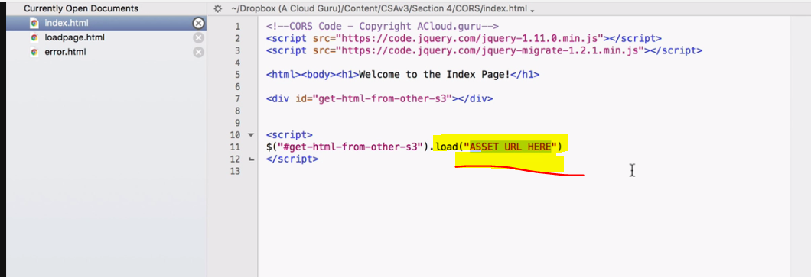

Get the content from another HTML, well This is the asset URL.

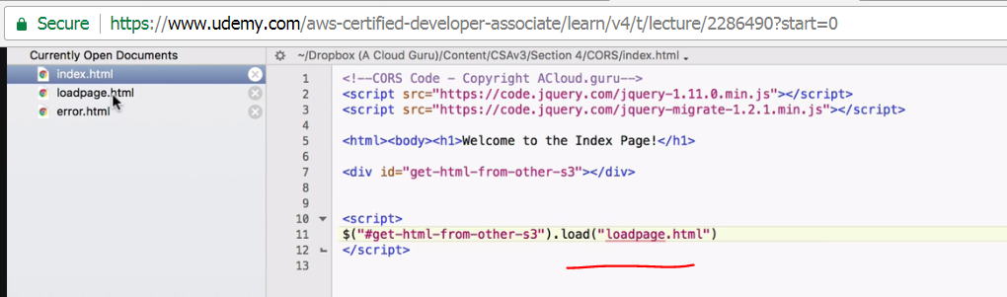

AWS - Regions, AZ Availability Zones, Service Limits, Edge Locations, CloudFront

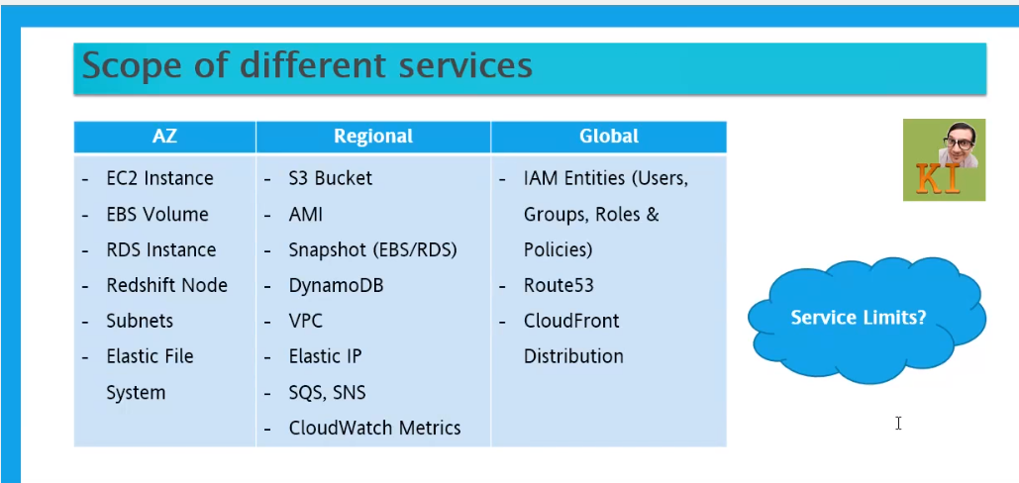

When you create a S3 Bucket, you specify in which region this S3 Bucket is should be replicated.

VPC is regional, but the various subnets with in the VPC are specific to AZ.

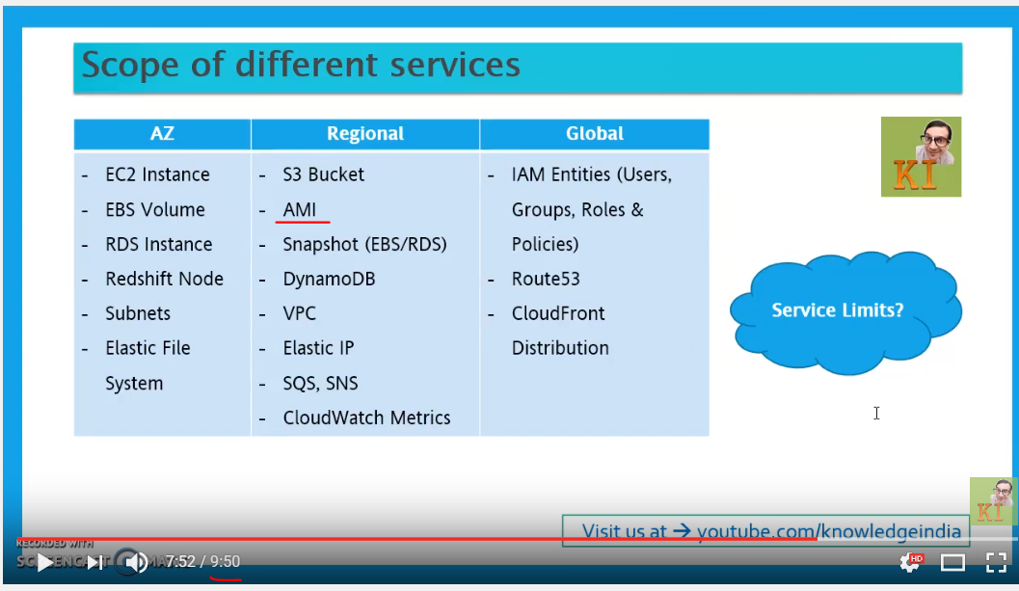

Important concepts here. You can access AMI with-in one region, but if you want to access the same AMI with-in another region you can not, you need to copy it.

AWS has a specific limit on the usages of the number of instances. Like you can create only 20 EC2 instances in that availability zone.

Why these limitations are there-> Because someone cannot go and abuse the AWS so that’s why they are setting up the limitations.

AWS - Difference between Elastic, Public & Private IP

Understanding the ip addresses

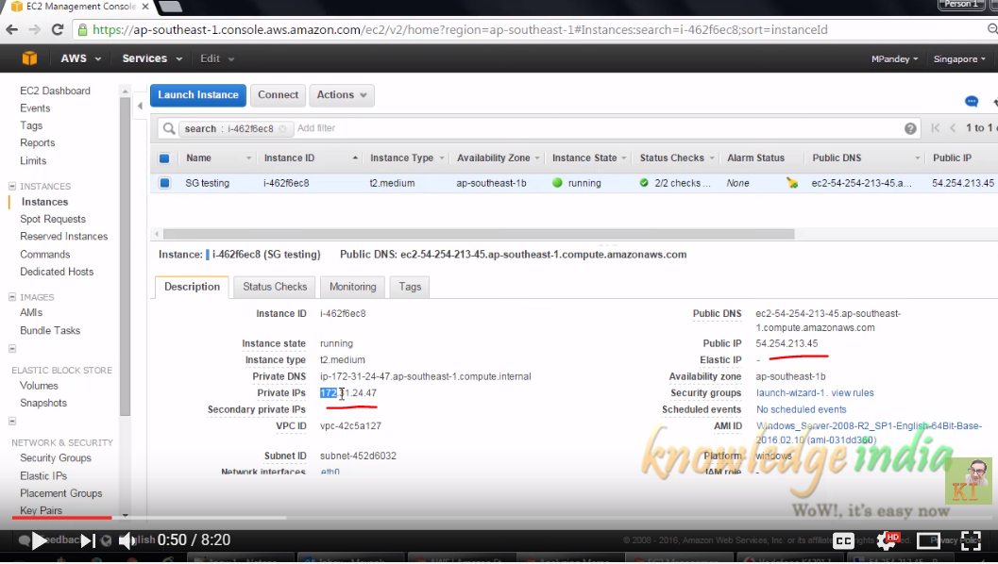

You will not find an EC2 without the PRIVATE IP. Private IP is mandatory for this machine to be reachable from any other instance with in that VPC.

In what way this private IP gets allocated?

That depends on VPC this EC2 instance has been launched & with-in that VPC in which subnet it has been launched.

SUBNET -> Has got a range of IP addresses and based on that it will get the PRIVATE-IP.

PRIVATE-IP scope is within the VPC.

PUBLIC-IP-> If you want to access this particular machine from outside, you need to have the public-ip.

**Scope of PUBLIC-IP is universal when the machine is running.**

So, there are two options

1. Stop-Start EC2 instance. 🡪 public ip will be released after stopping EC2 Instance & new public ip is allocated.
2. Reboot EC2 instance. 🡪 public ip remains the same, after rebooting the EC2 instance.

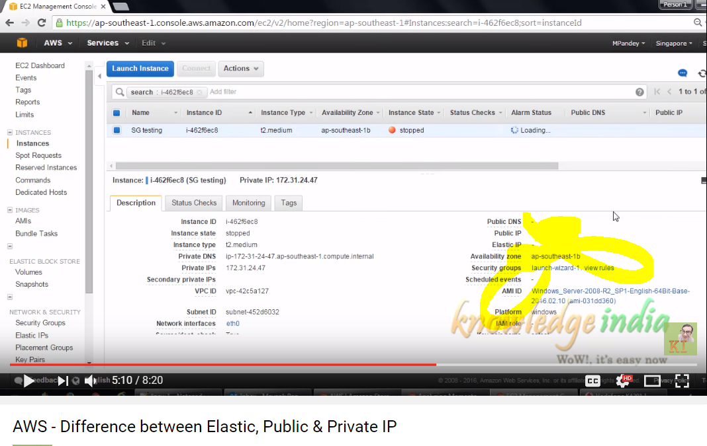

See here public-ip got released after stopping.

Private-ip is a logic-address within the VPC.

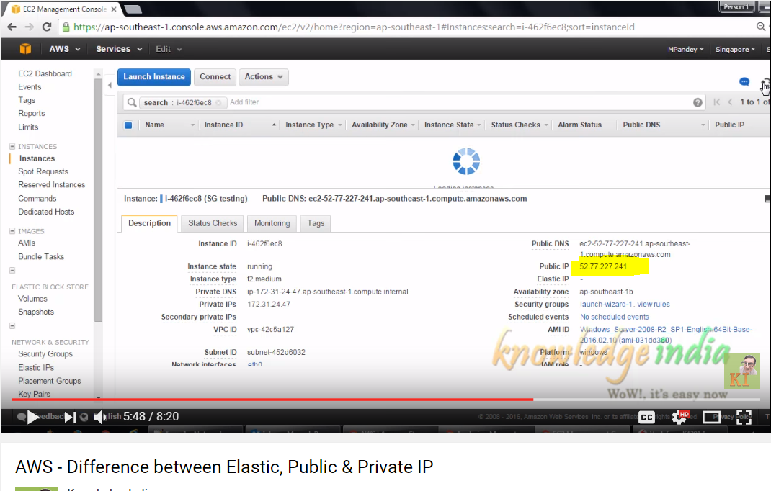

There are instances, where the public-ip allocated to your machine remains fixed. Because that particular IP address is known to lot of people. You can go a head with reserving a IP address and associate it with EC2 instance that is running.

Things you need to consider,

There is no change for the running, if the elastic-ip is idle then you will be changed.

AWS Storage - S3 vs EBS vs EFS - When to use?

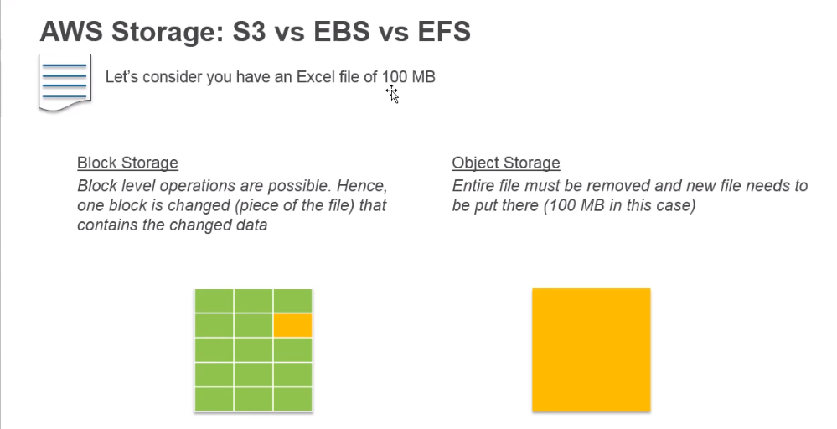

If you have to do very fast read/write operations, Block storage should be used.

If you are putting files once in a while, If the READ/WRITE operations

S3 🡪 Object level storage

EBS 🡪 Block level storage

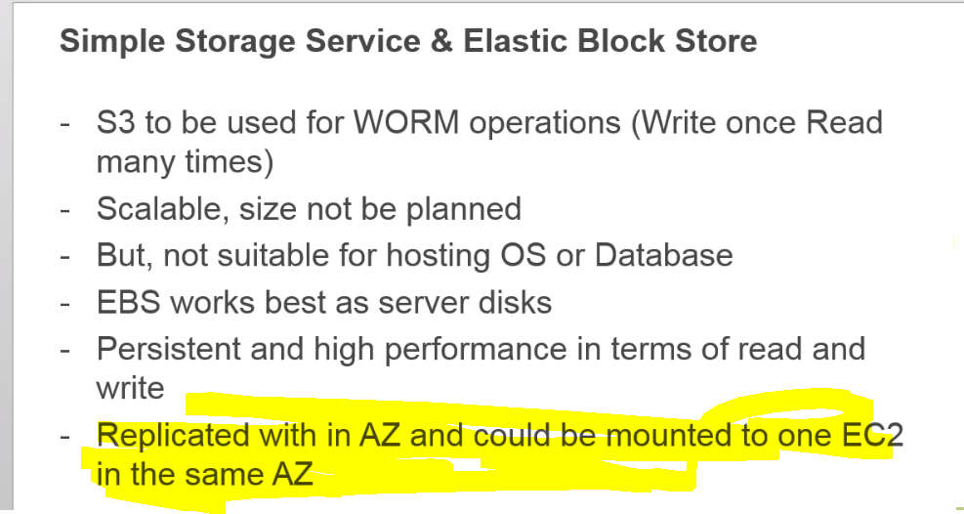

Static assets of your website.

S3 🡪 Unlimited storage.

The type of operations that can be performed in S3 is not suitable for hosting OS or databases. Because in case of OS, Databases faster read/writes happen in the disc.

EBS is persistent, suppose if you stop your EC2 instance your data will not be lost.

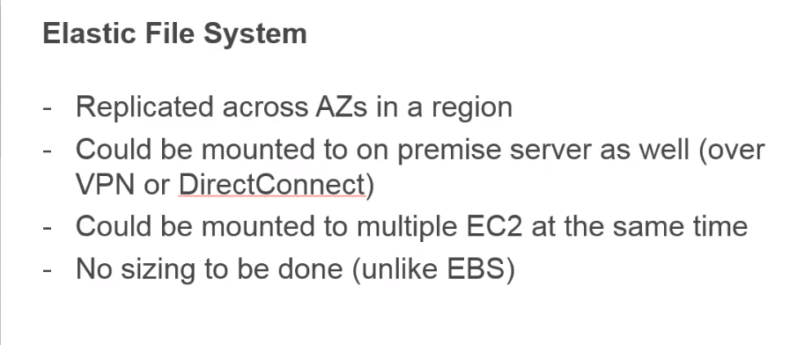

1 EFS volume is mounted to N number of different EC2 machines within a region.

When you create EFS volume, it gets replicated across multiple AZ’s.

You can have 1 EC2 in AZ-A, another EC-2 in AZ-B and you can mount them to the same EFS volume.

S3 is not meant for storing files.

AWS EFS - Create, Mount, Use, Secure, How to restrict - DEMO

AWS - Shared, Dedicated Instances & Dedicated Host - EC2 Tenancy Models

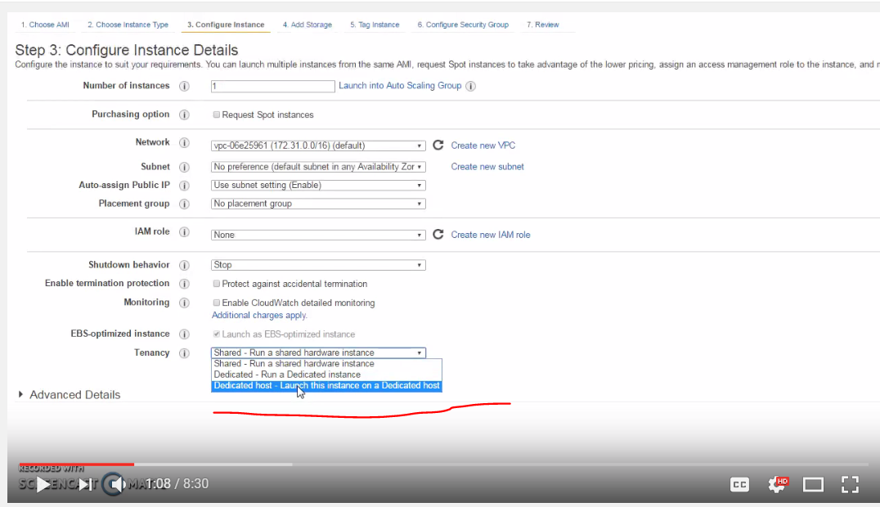

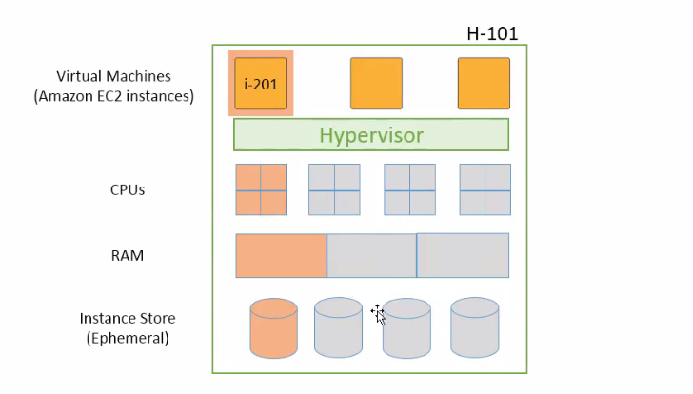

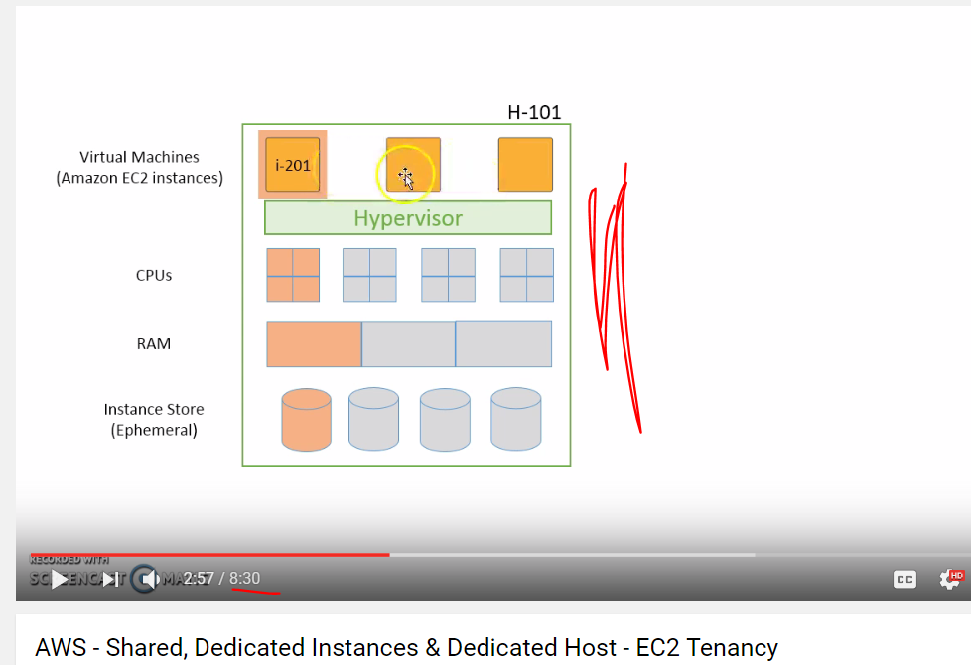

Shared tendency mode: Different instances from different customers share 1 instance host.

When you stop & start 🡪 Underlying Host might get changed.

When you reboot the instance 🡪 It’s a OS level activity, underlying host will not be changed, there is no change in the hardware.

**Dedicated Instances:** AWS ensures that your instance is launched on a physical hoist where only dedicates instances would run.

Ex: H105

So, No other instances from any other customers can run on this physical machine.

But if you start and stop the instance, the new instance will be started in another physical host like H-107 or someother machine.

**Dedicated Hosts:**

Advantageous than dedicated instances. Even after STOP/START the EC2 instance should be running on the same physical machine (H-101).

Ex: H-101 has the instance i-201 🡪 that should be in the same machines. This will help in maintaining the versions of the software in the machines. Suppose our SQLServer has the following version and we need to maintain that versions/licenses.

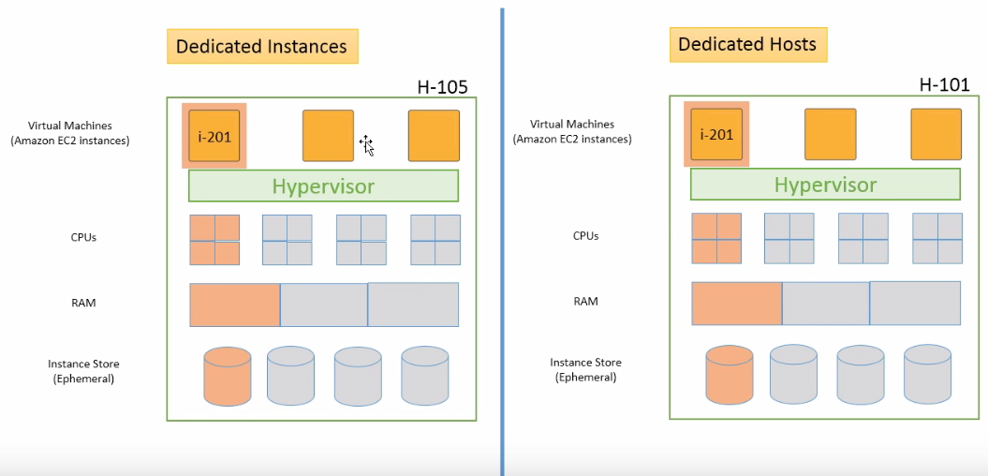

Each Amazon S3 object contains both data and metadata. Objects reside in containers called *buckets*, and each object is identified by a unique user-specified key (filename).

Buckets are a simple flat folder with no file system hierarchy.

you can have multiple buckets, but you can’t have a sub-bucket within a bucket

Keys must be unique within a single bucket, but different buckets can contain objects with the same key.

The combination of bucket, key, and optional version ID uniquely identifies an Amazon S3 object.

Amazon S3 provides both

**coarse-grained access controls** (Amazon S3 Access Control Lists [ACLs]), and

**fine-grained access controls** (Amazon S3 bucket policies, AWS Identity and Access Management [IAM] policies, and query-string authentication).

ACLs are a legacy access control mechanism, created before IAM existed.

MFA Delete can only be enabled by the root account.

Multipart upload is a three-step process:

* initiation,
* uploading the parts,
* and completion (or abort).